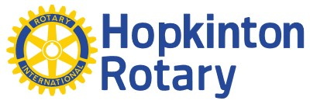
presents

The 2024 Banks Chevrolet Cadillac
Scholarship Golf Tournament

Friday, June 21, 2024
4 p.m. shot gun start
Beaver Meadow Golf Club, Concord, NH

Sponsorship Opportunities
GOLD - $1000 provides program credit, prominent signage, and display of your company banner with oral acknowledgment at dinner
Website recognition with logo and backlink Facebook/Instagram call outs
SILVER - $500 provides program credit, prominent signage, and display of your company banner with oral acknowledgment at dinner
Website recognition with logo Facebook/Instagram call outs

BLUE - $200 provides program credit and signage as a Tee sponsor on both the front and back nine
Website recognition Facebook/Instagram call outs

GREEN - $100 provides program credit, and signage as a Green Sponsor
Website recognition

Make checks payable to: Hopkinton Rotary, P.O. Box 243, Hopkinton, NH 03229.
Questions/email hi res logo: Ben Barton, BBarton@nhins.com

