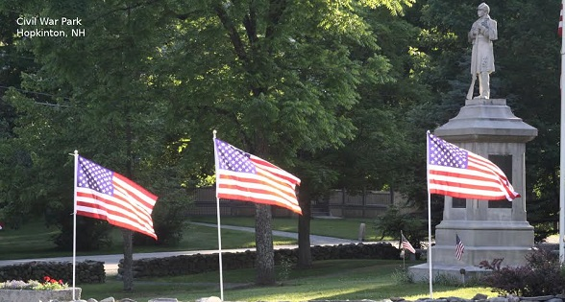

 2026 FLAGS OVER HOPKINTON
For just $45.00, one of our Rotary volunteers will place a flag at the end of your driveway over Memorial Day, Flag Day/Juneteenth, 4th of July, Labor Day/9-11, and Veterans’ Day holiday weekends.
Additional question, please contact: hoprotaryflags@gmail.com
To sign-up with credit card or ACH follow this link or use the QR code:
https://www.zeffy.com/en-US/ticketing/2026-flags-over-hopkinton

To sign up via payment by check, mail the below form and your check for $45.00 payable to Hopkinton Rotary to Hopkinton Rotary, PO Box 243, Hopkinton, NH 03229

------------------------------------ CUT HERE AND RETURN WITH YOUR CHECK PAYMENT ------------------------------------
Name _____________________________________________________________
Email _____________________________________________________________
Address ______________________________________________________
Special instructions (we will place your flag at the end of the driveway near your mailbox, unless you instruct us differently):

THANK YOU!

