Plastic Pick Up

• Transfer station pick up M, W and Saturday 8:00 am – 5:00 pm. Friday 1:00 – 5:00 pm. The plastic to pick up is inside where the offices are. You will see the Trex box back towards the hopper. There will be multiple bags that they have set aside because the Trex box fills up multiple times in-between pick ups. Ask for help if you are unsure.

Plastic Consolidation and Weighing
- Gathered plastic needs to be packed into bags (Rotary has some bags). .
- Double bag if needed to prevent breakage during the transfers
- Weigh the bags and record the weight. Please take picture of bags - send me the picture and weights
Plastic Drop Off
- Plastic can be dropped at Hannaford (Fort Eddy) M, Tu, Th, F and Saturday 7:00 am -12:30 no prior contact needed – drop off at left side of the building when facing the main door - ring bell (if you need to speak with someone the contacts at Hannaford are Justin and Taija Lowrey # 603-228-2060, dial 0 and ask for Taija or Justin.) and someone will let you in to drop off bags in trailer.
- They do not want more than 5 or 6 bags at a time
Shaw’s drop
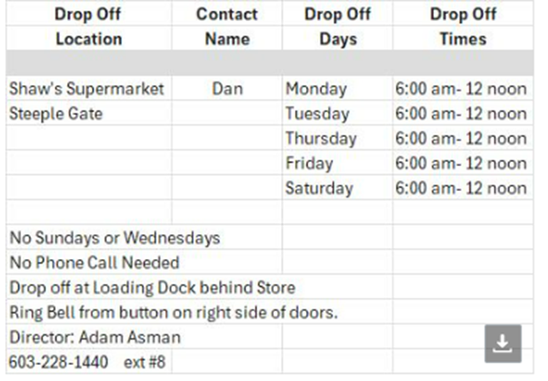
Weights are important as this is the accounting used for us to get more benches in the community as well as the numbers we will use to show the town how much money Rotary / Lions are saving but pulling this waste from the hopper waste stream.

