Historic moments -- Rotary mottoes
Rotary International News -- 7 July 2010
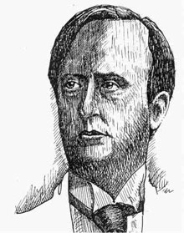
Arthur Frederick Sheldon, the Rotarian whose convention speech inspired Rotary's secondary motto, One Profits Most Who Serves Best.

Rotary’s official mottoes, Service Above Self and One Profits Most Who Serves Best, trace back to the early days of the organization.
In 1911, He Profits Most Who Serves Best was approved as the Rotary motto at the second convention of the National Association of Rotary Clubs of America, in Portland, Oregon. It was adapted from a speech made by Rotarian Arthur Frederick Sheldon to the first convention, held in Chicago the previous year. Sheldon declared that "only the science of right conduct toward others pays. Business is the science of human services. He profits most who serves his fellows best."
The Portland convention also inspired the motto Service Above Self. During a convention outing on the Columbia River, Ben Collins, president of the Rotary Club of Minneapolis, Minnesota, USA, talked with Seattle Rotarian J.E. Pinkham about the proper way to organize a Rotary club, offering the principle his club had adopted: Service, Not Self. Pinkham invited Paul P. Harris, who also was on the boat trip, to join their conversation. Harris asked Collins to address the convention, and the phrase Service, Not Self was met with great enthusiasm.
At the 1950 RI Convention in Detroit, slightly modified versions of the two slogans were formally approved as the official mottoes of Rotary: He Profits Most Who Serves Best and Service Above Self. The 1989 Council on Legislation established Service Above Self as the principal motto of Rotary, because it best conveys the philosophy of unselfish volunteer service. He Profits Most Who Serves Best was modified by the 2004 Council to They Profit Most Who Serve Best and by the 2010 Council to its current wording, One Profits Most Who Serves Best.

