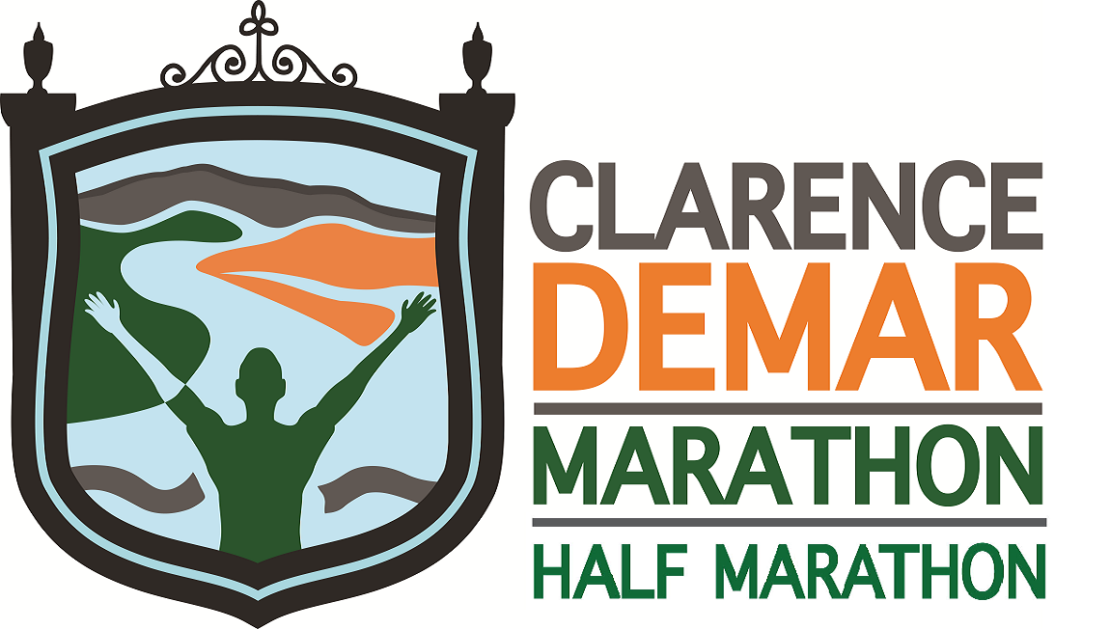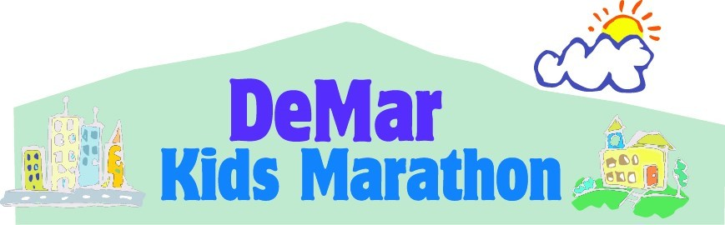
44th Annual - Clarence DeMar Marathon
And
8th ANNUAL DeMar Half Marathon

PLEDGE FORM
Keene Elm City Rotary Club is committed to keeping our kids and our community healthy and connected. We do this by providing time and resources to organizations, projects and events that make an impact. Our signature community event, the Clarence DeMar Marathon, is held on Sunday, September 25, 2022. On race day, not only will full and half marathons take place but also kids and “super seniors” who ran or walked 25 miles over the summer will complete their “marathon” by running or walking the last 1.2 miles of the course.

The event would not be possible without generous support from businesses and individuals. Please consider sponsoring the Clarence DeMar Marathon today!
Your sponsorship will help fund these projects: DeMar races, Follow ME (Move Everyday), Sneakers for 2nd graders, Thanksgiving in July, MUCH (Monadnock Understands Childhood Hunger), Unsung Hero Scholarships, Grants for local projects, Wheelchairs in Jamaica, and much more. Ask me for details.

Sponsor Name: ________________________________________________________________________________
Contact Name : ________________________________________________________________________________
Mailing Address: ________________________________________________________________________________
Phone: ______________________________________ e-mail: ___________________________________________
Rotarian who asked for your support: _______________________________________________________________
Sponsorship Level (please choose one by marking with “X” – details for each level on other side):

- DeMar $10,000
- Elite $ 7,500
- Qualifier $ 5,000
- Half Marathon $ 2,500
- Water Station $ 1,000
- Kids DeMar $ 600
- Course $ 300
- Other ______________
Please make your check payable to: Clarence DeMar Marathon and send with sponsor form to: PO Box 1786, Keene, NH 03431

Clarence DeMar Marathon is a designated 501C.3. Tax ID: 02-0454040
Email Logos to: Mary Delisle mdelisle@mfs.org
Early paid sponsorship earns longer website marketing for your company.
OUR COMMUNITY THANKS YOU!

