Waiver Form
BY SIGNING THIS FORM, YOU ARE WAIVING IMPORTANT LEGAL RIGHTS.
***Please read this form carefully***
- This Waiver covers my participation in the following Dragon Boat activities:
  - The Laconia Dragon Boat Festival on September 19, 2026, on Lake Winnipesaukee at the NASWA Resort, 1086 Weirs Blvd., Laconia, New Hampshire.
  - Practices at the NASWA Resort on September 17-18, 2026.
  - Any events involving dragon boat racing/practicing/instruction or dry-land training exercise where Laconia Rotary is involved.
- Participating in the above activities involves risks, dangers, and hazards. For example, a boat could capsize, or boats could collide in good or bad weather. All participants must always wear an approved personal floatation device (PFD) while on the water. By participating in the above activities, I am aware that I am risking personal injury, death, or damage to property. I accept and assume those risks.
- I release the following entities and individuals:
  - 22Dragons
  - Laconia Rotary
  - City of Laconia
  - The directors, officers, employees, agents, independent contractors, and volunteers of any of the above (all of whom are referred to as the Releasees in this Waiver Form) from any and all liability for any loss, damage, injury, or expenses that I may suffer as a result of my participation in the activity above, no matter how caused, including if caused by the negligence of any of the Releasees.
- If someone sues me for negligence, I agree not to claim contribution of indemnity from any of the Releasees. I release the Releasees from all liability that could arise from such a contribution or indemnity claim.
- I agree to hold harmless and indemnify the Releasees in respect of any claims, liability, or legal expenses that they incur arising directly or indirectly by reason of a claim brought any person or entity of loss, damage, injury, or expenses suffered by me. For example, if I sue a member of another team or my coach or a steersperson for negligence, and that person, in turn, claims contribution or indemnity from 22Dragons/Laconia Rotary/the City of Laconia, then I am agreeing to pay 22Dragons/Laconia Rotary/the City of Laconia for all liability claims and legal expenses that it incurs in connection with the contribution and indemnity claim.
- I confirm that I have attained the age of 18 years, or if not, my parent or guardian has signed this Waiver.
- I recognize and agree that I am not allowed to participate in the activity above unless I sign this Waiver. I agree that this Waiver is binding on me and my heirs, executors, administrators, and legal representatives.

LAST NAME, FIRST NAME TEAM NAME

ADDRESS: STREET, CITY, STATE, ZIPCODE

EMAIL CELL PHONE DATE OF BIRTH

EMERGENCY CONTACT EMERGENCY CONTACT PHONE NUMBER

SIGNATURE DATE
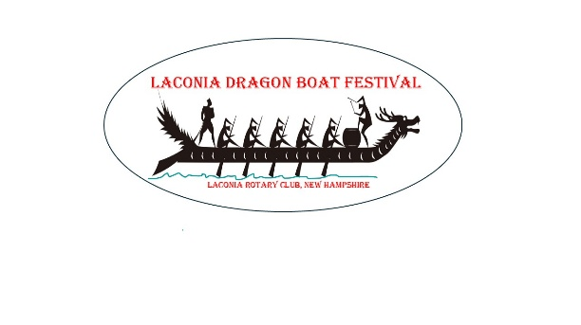
SIGNATURE OF PARENT/GUARDIAN (IF UNDER 18 YEARS OF AGE) DATE

