Press Release March 18, 2017 –
Rotary Club of Nashua and Rotary Club of Nashua West name winners of the Four Way Test Speech Contest
Rotary Club of Nashua and Rotary Club of Nashua West are pleased to announce the Winners of the Four Way Test Speech Contest. This event is a partnership between the two clubs, and was conceived as a means to support students in making healthy choices in the ethical issues that they face in everyday life as teens. The speech contest enables Rotarians to reward teens who not only set healthy and ethical life goals for themselves but who also seek to influence their peers in a positive way. The winners receive prizes and may go on to compete in the District wide competition in May.
This year’s winners and Rotary Committee Chairs are, from left to right, are
Helen Sajo, Bishop Guertin High School, First place;
Brandon Lee, Nashua North High School, Second place;
Helen Honorow, Rotary Club of Nashua West; Gary Clark-Pounder, Rotary Club of Nashua;
Maxwell Irwin, Nashua North High School, Third Place;
Madeline Scannell, Bishop Guertin High School, Honorable Mention;
Stephen Larkin, Nashua North High School, Honorable Mention

Prizes are $500 First Place, $300 Second Place, $100 Third Place, $50 Honorable Mention. 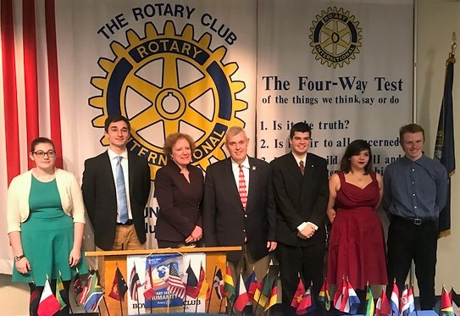
The Rotary Four Way Test is: Of the things we think, say or do
- Is it the truth?
- Is it fair to all concerned?
- Will it build good will and better friendships?
- Will it be beneficial to all concerned?

