June 29, 2017 Press Release – Rotary Club of Nashua

The following organizations were honored with donations from the
Community Grants Committee of the Rotary Club of Nashua

Boys and Girls Club of Nashua
Grant: $2,000
Program: Substance Misuse Prevention Through Positive Action

Girls Inc.
Grant: $2,500
Program: Nashua Girls Center : Field Trips & Meals

Harbor Homes
Grant: $1,000
Program: Safe Stations Initiative

Nashua Children's Home
Grant: $5,000
Program: Transitional Living Program

Nashua Police Athletic League
Grant: $2,000
Program: Nashua PAL Youth Safe Haven

YMCA
Grant: $2,500
Program: Summer Learning Loss Prevention Program at Dr. Crisp Elementary School

Southern NH Medical Center
Grant: $5,000
Program: Emergency Dept. Redesign for Behavioral Health Patients

The Front Door Agency
Grant: $5,000
Program: Victory House Renovation

Rotary Club of Nashua allocates grants totaling $25,000 annually, with 31 applications for this year’s program.

(Photo and names below)

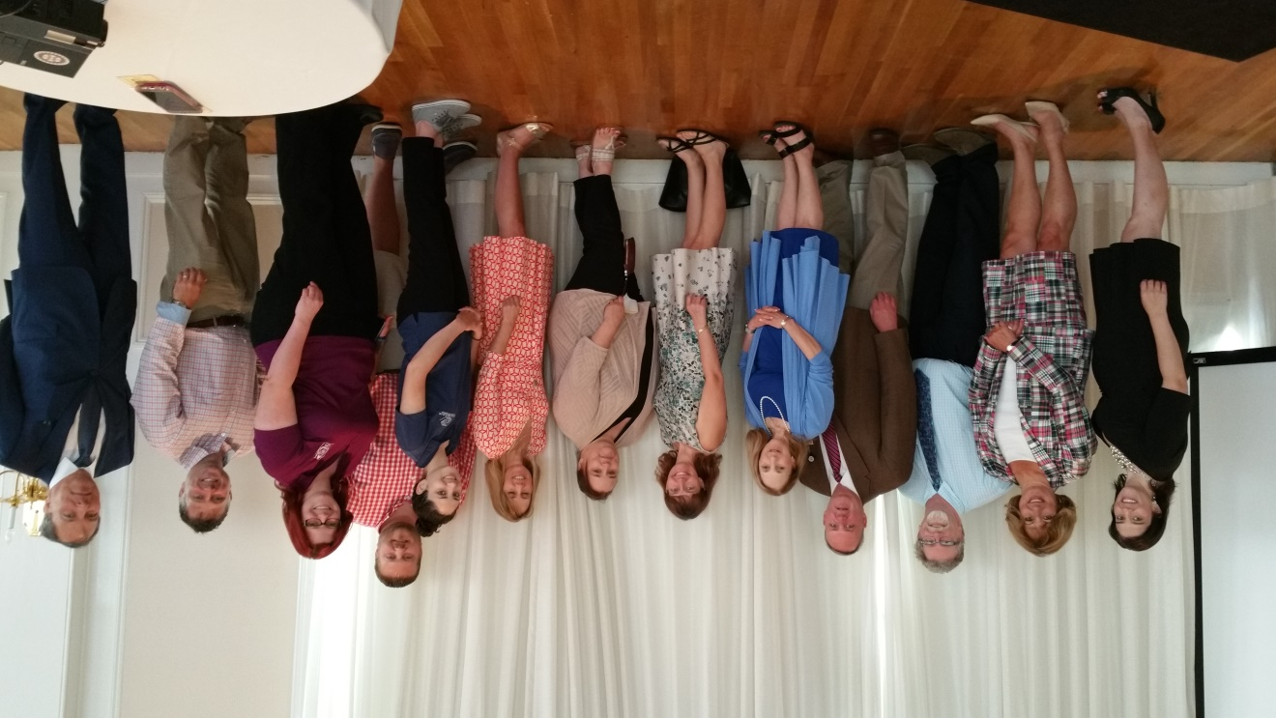

From Left to Right:
Shaunae Nolet, Rotary Club Grants Committee Co-Chair
Mary Tamposi, Harbor Homes
Scott Slattery, Harbor Homes
Scott Cote and Dr Stephanie Wolf-Rosenblum, Southern NH Regional Medical Ctr
Lea Reilly, Nashua Childrens Home
Jen Indeglia, Girls, Inc
Jean Perry, Front Door Agency
Bree Cosgrove, Boys and Girls Club of Nashua
Shaun Nelson, PAL
Jen Miller, PAL
Joe Manzoli, YMCA
Jebb Curelop, Rotary Club Grants Committee Co-Chair

