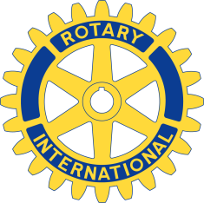
Press Release June 18, 2017 – Rotary Club of Nashua names winners of 2017 Scholarship Awards

Rotary Club of Nashua is pleased to announce the following scholarship awards for 2016 to deserving recipients in the Nashua area:
1. Olivia Montine, Nashua High School South: Faucher/Arsenault scholarship of $10,000 over 4 years. She will be attending Seton Hall University in New Jersey
2. Hailee Whitesel, Nashua High School South: $10,000 over 4 years She will be attending UNH studying animal science.
3. Yasmin Leite, Nashua High School South: $3,000 for 1 year, she will be attending Florday Gulf Coast University
4. Meagan Morelli, Bishop Guertin High School: $3,000 for one year, she will be attending Fairfield University
Every year Rotary Club of Nashua is pleased to be able to award scholarships to local students of at least $25,000, with this year’s awards exceeding that goal.

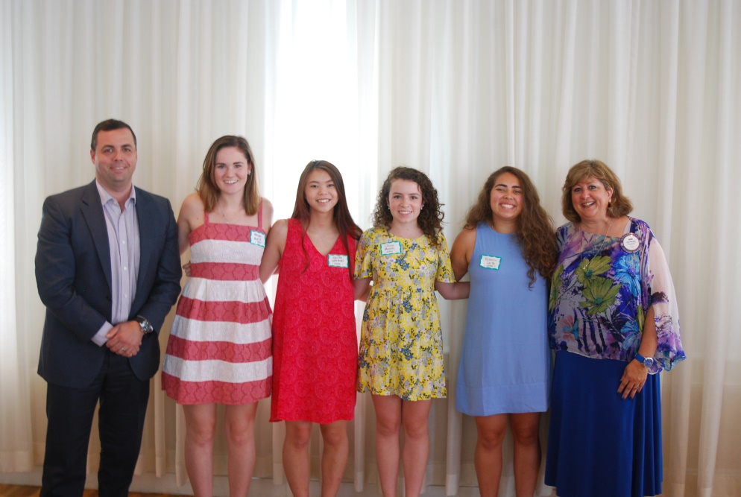

Left to right:
Michael Aquino (Rotary Scholarship Committee Co-Chair), Meagan Morelli, Hailee Whitesel, Olivia Montine, Yasmin Leite, Jane Marquis (Rotary Scholarship Committee Co-Chair

