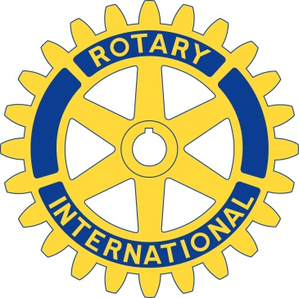
Press Release – February 27, 2017
Rotary Club of Nashua and Nashua Rotary West

Rotary Club of Nashua and Nashua Rotary West are pleased to announce the 2017 Rotary Four-Way Test Speech Contest for local area high school students.
Students will incorporate the Rotary Four-Way test into a speech illustrating the moral and ethical model of behavior and decision making using each of these principles:
- Is it the truth?
- Is it fair to all concerned?
- Will it build goodwill and better friendships?
- Will it be beneficial to all concerned?
The contest will be held on Thursday March 16, 2017 at 6PM at the Nashua Boys and Girls Club of Greater Nashua. Prizes of $500, $300, $100 and $50 will be awarded. Students enrolled in Nashua area high schools are encouraged to participate.
Details and registration form can be found at www.nashuarotary.org or by calling Garry Clarke-Pounder at 204-5000 or Helen Honorow at 833-0474.

