BARRY & HONOROW, P.L.L.C.
ATTORNEYS AT LAW
161 KINSLEY STREET
NASHUA, NEW HAMPSHIRE 03060
TELEPHONE: (603) 883-0474
FAX: (603) 886-8625
WILLIAM H. BARRY, III WILLIAM H. BARRY, JR.
Admitted in NH and MA 1930 - 2003

HELEN G. HONOROW
Admitted in NH
August 1, 2024

Via E-Mail Only

Re: COMMUNITY ORGANIZATION ASSISTANCE PROGRAM
Nashua Rotary West

The Rotary Club of Nashua West provides financial assistance to local 501(c) 3 community organizations in the greater Nashua area to aid them in providing the necessary services and programs that meet our community’s needs. We provide assistance for many reasons: a specific project or program, purchase of equipment or supplies, or to assist in repairs and maintenance of facilities. We usually do not make awards to the general operating fund of an organization.

As you have applied for Rotary West funds in the past, or have contacted us to participate in our program, an application for funding is attached. Please mail or deliver two (2) completed hardcopy application packages with attachments to:

Helen Honorow, Esquire
BARRY & HONOROW, P.L.L.C.
161 Kinsley Street
Nashua, NH 03060

Please also submit your application with attachments via email to
klaporte@barrylawoffice.com on or before September 2, 2024.

The deadline for applications for funds is September 2, 2024. Both the hard copies and email copy must be received by that date. All funds will be awarded on or before September 30, 2024, and each organization receiving an award will be asked to make a presentation to the Rotary Club so that the Club members understand how the awarded funds are used.

Thank you for your efforts for our community. Please reply to this e-mail so that we are aware that you received it.
Helen G. Honorow

Helen G. Honorow
Community Projects Chair
Attachment

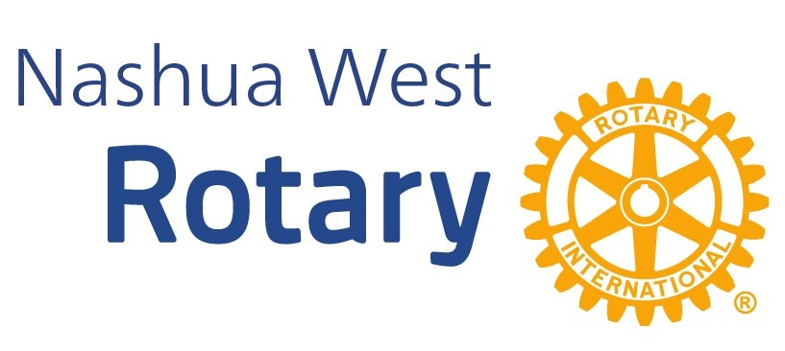

REQUEST FOR FUNDS APPLICATION
Submission Deadline is September 2, 2024
INSTRUCTIONS
Please complete this form with sufficient detail to enable the Community Projects Committee to properly evaluate your request. If a particular section does not apply, please do not leave it blank, but indicate N/A. You may attach other relevant materials that you would like the Committee to consider or submit a formal proposal to include the following information. You must submit two (2) hard copies of your application and attachments, as well as a complete copy with attachments via email to klaporte@barrylawoffice.com on or before September 2, 2024.

1. Name of Organization applying:

2. Address:

3. Contact person for this request, telephone number, and e-mail address:

4. Title of Program/Project for which funds are requested:

5. Briefly describe the Program/Project for which the funds are requested. Please describe in some detail how the requested funds will be utilized and the number of people who will be served with the requested funds. Please be sure that your description helps us to understand how your program is unique, or different, and does not duplicate the services of another agency. Please include the number of years for which the program has been in existence. If you are able to describe how you would measure success, please do so.

6. Amount requested:

7. Please identify any other organizations from which you have solicited the same request for funds and the amount you have received, or expect to receive (if any) to such solicitations:

8. Does your organization charge a fee to persons participating in your program? If so, please describe the fee structure. Also, please indicate whether scholarships, sliding scale fees, and/or free services are offered to program participants and the basis upon which reduced fees are offered:

- Does your organization receive state, federal, city, United Way, Rotary (or similar entity) funding for the Program/Project?

- Please indicate the approximate number of Nashua and Nashua area residents that this program serves or will serve.

- Please provide an income (identifying sources of income) and expense statement for your most recent fiscal year and attach it to this application. You may submit an operating budget if it also includes prior year actual financial results.

- Describe ways that you have partnered with Nashua West Rotary as a speaker, volunteer, or other.

- If you received a grant from the Rotary Club of Nashua West last year, please briefly describe how the grant was used and how many people benefited from that grant.

