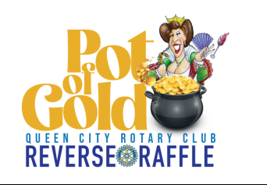

Sponsorship opportunities for the
Queen City Rotary Club Pot of Gold Reverse Raffle

Thursday, September 11th 6:00PM to 9:00PM, Doors open at 5:00PM
Auburn Pitts Bar & Grill
167 Rockingham Road, Auburn, NH

$1500 Leprechaun Level
- Three (3) entries to the big drawing (value $300)
- Entrance to the event for six people
- Reserved table in a premium location
- Company recognition at the front stage area
- Company logo on all print/social media
- Company name in the program/table tent
- Company mentioned in all public relations
- Company highlighted as a prime sponsor at the event

$500 Queen’s Gold Level
- Two (2) entries to the big drawing (value $200)
- Entrance to the event for four people
- Reserved table in a preferred location
- Sponsor name recognition in the main venue area
- Sponsor name in the program/table tent
- Company mentioned as contributing sponsor at the event

$300 Rainbow Level
- One (1) entry to the big drawing (value $100)
- Entrance to the event for two people
- Sponsor name in the program/table tent
- Company mentioned as contributing sponsor at the event

