ENGLISH (EN)

GLOBAL GRANTS COMMUNITY ASSESSMENT RESULTS

Use this form to report community assessment findings to The Rotary Foundation when you apply for a global grant.
Assessing the strengths, weaknesses, needs, and assets of the community you plan to help is an essential first step in designing an effective and sustainable global grant project. See Community Assessment Tools for full instructions and helpful tips.
This form will help you report the results of your community assessment, and it’s required when you apply for any humanitarian or vocational training team grant. Complete a separate form for each beneficiary community (e.g., school, health care system, or village), using information that is both current and specific to each community. Remember, you can’t use global grant funds to cover the cost of doing an assessment, but you can use district grant funds.
Beneficiary community or institution
Beneficiaries will be 225 impoverished female micro-entrepreneurs, and their families, living in Suchitepequez and Solola (Boca Costa), Departments of Guatemala. These women have very low education levels and require financial literacy skills and business advisory support to grow sustainable businesses. Training will be provided by Fundacion Namaste Guatemaya (FNG). The objective is to educate these women to help them develop their businesses and earn more money throughout their lives. This sustainable approach will empower formerly disenfranchised women to support themselves and provide food, shelter and education for their families.

Groups in the community that would receive a clear, direct, and immediate benefit from the project
This program will directly benefit women living in poverty, who face discrimination based on their gender, their economic status, and their race (the majority of women in this region are indigenous). This project addresses the need for financial literacy skills through CPP’s training, and also the need for ongoing business mentorship through the Business Advisors who implement the CPP. Also, this project will introduce Technology Skills to women who have the capacity and interest to benefit from the use of new business software. This project is divided in 3 different areas:

- 145 female micro-entrepreneurs who will participate in the CPP for the first time. These women can be in a solidarity group or they can be working as an individual and will work for 9 months on the CPP’s Financial Educational Training and Advisory Program.
- 80 female micro-entrepreneurs who have completed Cycle 1 of the CPP and are advancing to Cycle 2 or 3). These women can be in a solidarity group or they can be working as an individual and will work for 9 months on the CPP’s Advanced Financial Educational Training and Advisory Program.
- Technology Skills Training – 40 women from Cycles 2, 3 or 4 who have demonstrated an interest in improvement and have the capacity to read and write, will be trained to use Centro, a business software application, using a tablet.

Beneficiaries’ demographic information, if relevant to the project
According to United Nations Human Development reports (2018), (http://hdr.undp.org/en/countries/profiles/GTM) Guatemala´s HDI value for 2017 is 0.650 – which put the country in the medium human development category – positioning it at 127 out 189 countries and territories. Between 1990 and 2017, Guatemala’s HDI value increased from 0.478 to 0.650, an increase of 36.0 percent. Guatemala’s life expectancy at birth increased by 11.4 years, mean years of schooling increased by 3.4 years and expected years of schooling increased by 4.3 years. Guatemala´s GNI per capita increased by about 45.7 percent.

Despite this growth, approximately 60% of Guatemalans still live in poverty, and for the indigenous population in Guatemala, the poverty rate is 79%. Indigenous women are particularly vulnerable to poverty because they lack equitable access to education (48% illiteracy rate), family planning (maternal mortality rate is twice as high as the rest of the population), and fair employment (indigenous women are the lowest paid segment of workers in the country, earning only 54% of non-indigenous women).
Women in Guatemala do not have equal opportunity to acquire skills and experience needed to succeed in the workforce. Female participation in the labor market is 40.6 percent, however only 19% of the country's skilled labor force is female. The vast majority of indigenous female workers are in the informal sector, where they are vulnerable to discrimination and unfair pay. With few opportunities for traditional employment, entrepreneurship offers a proven way for Guatemalan women to realize self-sufficiency and economic security.
Still, according to the 2018 USAID Gender Analysis Report, female entrepreneurs in Guatemala face a number of challenges, the most pressing of which are lack of accessible information (related to finance and business skills) and lack of access to finance.
According to UNICEF, four of every 10 children (43.4%) under 5 years old suffer from chronic bad nutrition with the consequences of less height, less school retention, less productivity and a high tendency to get sick. Within the indigenous population, chronic bad nutrition affects eight of every 10 children (80%) https://www.unicef.org/guatemala/spanish/panorama_18467.htm
DEPARTMENT SUCHITEPEQUEZ DEPARTMENT SOLOLA
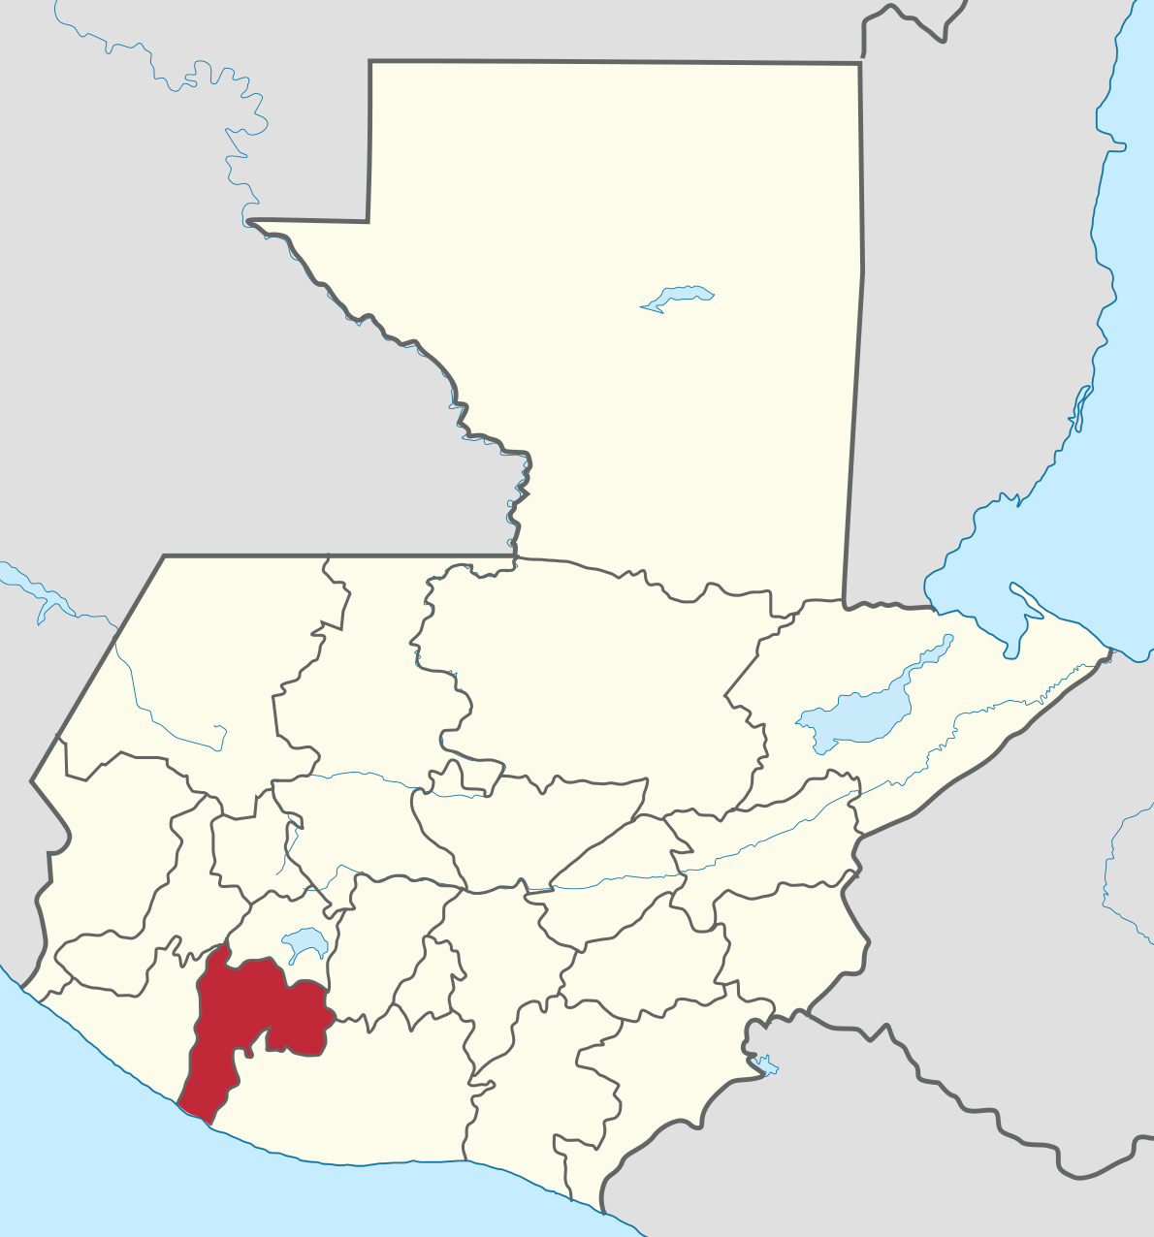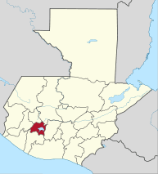
Guatemala´s population is 14.9 million; the departments of Suchitepequez and Solola have a total of 976,278 inhabitants. (see table 1)
61% of the total population in Guatemala is between 15-64 years old. 21.7% of the women population is illiterate compared to men´s which is 15%. In tables 2 and 3 detailed information by Department.

In Suchitepequez, 24.93% of the responsibility of the home depends in the woman, compared to Sololá where the home is responsibility of a woman by 21.86% https://www.censopoblacion.gt/mapas

Suchitepequez and Solola are located at the southwest of the Republic of Guatemala. Suchitepequez has a population of 554,695 inhabitants. The people work in agriculture and cattle, but due to its proximity with Mexico, commerce between both countries is high. A high percentage of the population works in crafts such as wood masks, leather products, totton fabrics, goldsmithing. The majority of the population speaks Spanish but Mayan languages k´iche, kaqchikel and tz´utujil are also widely spoken there.
Solola has a population of 421,583 inhabitants. Tourism is popular and the villages of the region each make unique crafts and clothing representative of their lineage. Agriculture, cattle and sheep farming are also popular in the region. The main languages of this region are Spanish, k´iche and kaqchikel. 96% of the population is Mayan and this is the main difference with the Suchitepequez Department, where 38% is Mayan and 61% is Ladina.
Both departments are around 3-4 hours to Guatemala City, but there are areas with no drinking water, electricity or health services. These communities are served by different NGOs to help the people with their basic needs.

WOMEN CLIENTS DEMOGRAPHICS
FNG, our cooperating organization, has trained 1,728 female micro-entrepreneurs from these departments over the last 10 years. Demographics of their clients shows:
The average age of a businesswoman is 42 years old, and she has 6.7 years of experience working in her business. 35% have a Mayan language as their mother tongue. Regarding literacy, approximately 33.4% do not know how to read and write. (Data from Qlikview September 23rd, 2019).
While women in the program have some business experience, they do not have the basic knowledge of how to do the finance work, keep inventories, keep records for their sales and expenses, competition, customer service, etc. and at the end give a good use to the profit. Women in general suffer from discrimination, machismo, violence and extortion. These can provide barriers in their development as women and business people.
Results from FNG’s CPP: Financial Education show that the profits for these 1,728 clients during the last 10 years increased 60%. This increase in earning power has helped these women to have a better life and be able to pay schooling for their kids, better housing and get health services.
To be accepted into the program, each micro-entrepreneur must:
- Be Guatemalan citizen and if not, be living in the country for at least the last 3 years
- Have a business for at least 1 year
- Be 18 years old
- Have personal ID issued by the government of Guatemala
- Have less than 30% of her Cash Flow already compromised to pay other debts
- Live in the regions established (Suchitepequez and Solola, Boca Costa)
- Work on a Business Plan together with the Business Advisor
- Have any type of business but agriculture
- Be interested investing in and improving their business through Financial Training and Advisory and to use a microloan to improve her business
BUSINESS OPPORTUNITIES IN THE REGION
Based on FNG’s client data over the last 10 years, the vast majority of women in their program start their business not because they like selling, but due to necessity. The types of businesses started by previous clients – and likely open to new clients – are:
Shoes and Clothing – 39%
Storefront – 33%
Prepared Food – 19%
Other – 8%
Crafts – 1%

Who conducted the assessment? (check all that apply)
x Host sponsor members
☐ International sponsor members
x A cooperating organization
☐ University
☐ Hospital
☐ Local government
☐ Other Click or tap here to enter text.
Assessment dates
Click or tap here to enter text.

What methods did you use? (check all that apply)
☐ Survey
☐ Community meeting
☐ Interview
☐ Focus group
☐ Asset inventory
☐ Community mapping
x Other Informed assessment and understanding of community needs, primarily by Host Rotary Club and FNG
Who from the community participated in the assessment?
Primary source of information was businesswomen entrepreneurs involved in the program. Also, potential clients interviewed by FNG; and families and associates of those involved in FNG program.
The members of the Host Rotary Club in Mazatenango have a strong knowledge of the local economy and needs, as they have done many projects in the area related to economic development.
The members of the International Rotary Club sponsoring the project have also confirmed the need for financial training and support.

List the community needs you identified that your project would address.
While women in the areas have some business experience, they do not have the basic knowledge of how to do the finance work, keep inventories, keep records for their sales and expenses, competition, customer service, etc. and at the end, give a good use to the profit. Women in general suffer of discrimination, machismo, violence and extortion.
This program will address the need for Financial Literacy Skills through training, and also the need for ongoing business advice and support through the Business Advisor. A new element will introduce technology skills to women who have the capacity and interest to use new technologies to improve their business skills.
In addition, this project will help create a new paradigm for Guatemalan women by empowering them with earning power, and thus, agency, over their lives. The women in this program serve as excellent role models in their families and communities.
List any needs you identified that your project would not address.
1. Health
2. Housing
3. Violence
List the community’s assets, or strengths.
1. Good to regular roads
2. Community schools for children
3. Economic opportunities
Considering the needs and assets you listed, explain how you determined the project’s primary goal.
The project’s primary goal is to alleviate poverty and support independence of women entrepreneurs and their families, through business training and support. The project aligns with the ongoing humanitarian and poverty alleviation efforts of Mazatenango Rotary Club and the mission of FNG.

How would your project’s activities accomplish this goal?
The project would achieve this goal through Financial Skills Training and Business Support.
Based on the results FNG has gathered for the last 10 years, clients have benefited from the Financial Training and Business Advisory program.

What challenges have prevented the community from accomplishing the project’s goals?
Lack of sources for financial education and business support.
How is the community addressing these challenges now?
They do not have the resources to address these challenges.

Why are the project’s activities the best way to meet this community need?
The CPP is culturally appropriate, and has proven success in empowering women who run small businesses in Guatemala to substantially increase their profits. This project will help 225 women build sustainable, profitable businesses that will continue to support them throughout their lives. Beyond the women who participate in this project, approximately 1125 people will benefit (average of 5 people per family).
The program to provide business software, a tablet and training to 40 clients will allow an assessment of the benefits of this to clients. It is hoped that this access to technology for the first time will increase their involvement and interest to have a better result (profit) consequently, have a better life and move from poor to middle –class.

TABLE 1 (Population Guatemala Republic)

Características generales de la población. Censo 2018
Cuadro A5.1 - Población total por pueblos, según departamento
Departamento | Población total | Pueblo de pertenencia
 |  | Maya | Garífuna | Xinka | Afrodescendiente / Creole / Afromestizo | Ladina(o) | Extranjera(o)
Total nacional | 14901286 | 6207503 | 19529 | 264167 | 27647 | 8346120 | 36320
Guatemala | 3 015 081 | 402 376 | 4 583 | 3 382 | 6 222 | 2 578 135 | 20 383
El Progreso | 176 632 | 2 627 | 184 | 46 | 86 | 173 441 | 248
Sacatepéquez | 330 469 | 132 762 | 428 | 206 | 486 | 195 101 | 1 486
Chimaltenango | 615 776 | 481 335 | 563 | 237 | 1 255 | 131 674 | 712
Escuintla | 733 181 | 37 100 | 933 | 259 | 1 466 | 691 936 | 1 487
Santa Rosa | 396 607 | 7 863 | 646 | 55 855 | 885 | 330 149 | 1 209
Sololá | 421 583 | 406 295 | 387 | 35 | 366 | 14 025 | 475
Totonicapán | 418 569 | 410 195 | 274 | 49 | 381 | 7 528 | 142
Quetzaltenango | 799 101 | 406 491 | 675 | 206 | 1 197 | 388 850 | 1 682
Suchitepéquez | 554 695 | 211 103 | 639 | 210 | 3 531 | 338 471 | 741
Retalhuleu | 326 828 | 48 871 | 258 | 58 | 684 | 276 576 | 381
San Marcos | 1 032 277 | 318 093 | 757 | 76 | 495 | 711 812 | 1 044
Huehuetenango | 1 170 669 | 760 871 | 884 | 44 | 1 305 | 406 836 | 729
Quiché | 949 261 | 846 500 | 556 | 59 | 1 690 | 100 150 | 306
Baja Verapaz | 299 476 | 179 746 | 244 | 63 | 542 | 118 660 | 221
Alta Verapaz | 1 215 038 | 1 129 369 | 1 136 | 147 | 1 288 | 82 505 | 593
Petén | 545 600 | 164 814 | 462 | 200 | 1 097 | 378 129 | 898
Izabal | 408 688 | 115 296 | 3 002 | 105 | 1 529 | 287 869 | 887
Zacapa | 245 374 | 4 769 | 349 | 46 | 791 | 238 987 | 432
Chiquimula | 415 063 | 111 368 | 797 | 49 | 771 | 301 454 | 624
Jalapa | 342 923 | 24 891 | 832 | 108 529 | 690 | 207 497 | 484
Jutiapa | 488 395 | 4 768 | 940 | 94 306 | 890 | 386 335 | 1 156
Fuente: INE, XII Censo Nacional de Población y VII de Vivienda - 2018

TABLE 2 (Population per age group Suchitepequez)

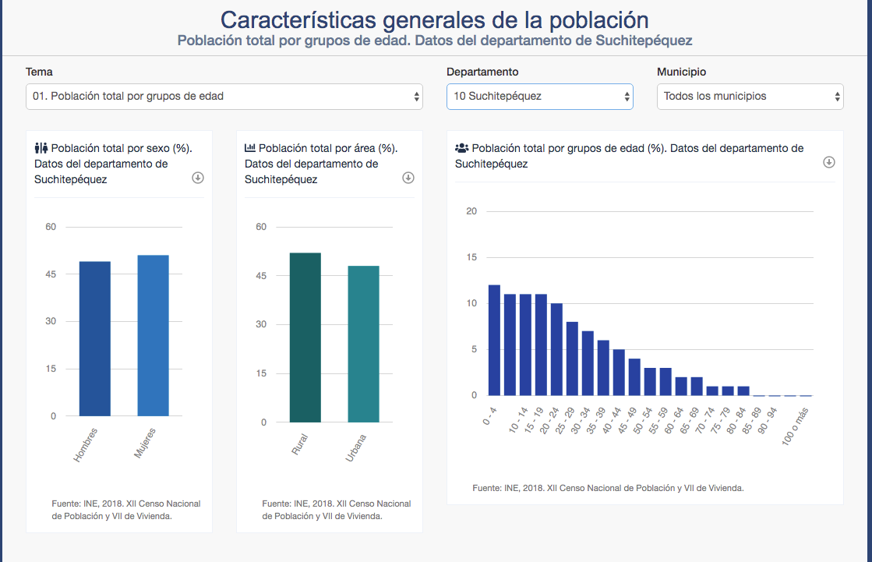

TABLE 3 (Population per age group Solola)

