April 2017

Dear Business Owner:

I am pleased to remind you of the 2017 Escalante Days Mountain Bike Race scheduled for Saturday, August 12, 2017. We are currently looking for passionate sponsors who are committed to helping their community as well as establishing their brand with philanthropic efforts to help make this event our best one yet.

The Rotary Club of Dolores is a completely volunteer-run non-profit organization, and we provide benefits and opportunities to a variety of local organizations including youth groups, charitable causes, local businesses, scholarship opportunities, and community events.

The Escalante Days Mountain Bike Race is one of our principal fundraisers, attracting more than 100 riders, along with all their friends and family from throughout the Four Corners region and beyond for the past 18 years. Your sponsorship will ensure the Rotary Club of Dolores remains a vibrant contributor to the local community, and you can be an essential part of promoting area tourism by helping us showcase our vast array of mountain biking trails and beautiful scenery.

The enclosed form lists details of the various levels of support your organization can provide, like donating money towards the top prize competitors, having your company name or logo featured on a T-shirt, contributing items for our goodies bags, refreshment stations and raffles, and sponsoring the finish line banner.

Thank you for taking the time to consider support of your community. If you have any questions, please contact me at (928)380-1871 or at slisak@hotmail.com. Please send in your donation via mail, or get in touch with me for personalized pick up and to discuss any details.

Respectfully,
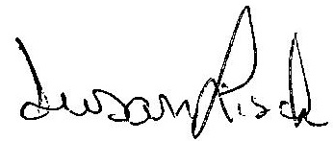
Susan Lisak Scott Cooper, Ed.D.
Public Relations Volunteer President-Elect
Rotary Club of Dolores Rotary Club of Dolores
Superintendent, Dolores School District RE-4A
Escalante Days Mountain Bike Race Sponsorship Form
August 12, 2017 – now the 19th Year
Principal Fundraiser of the Dolores Rotary Club
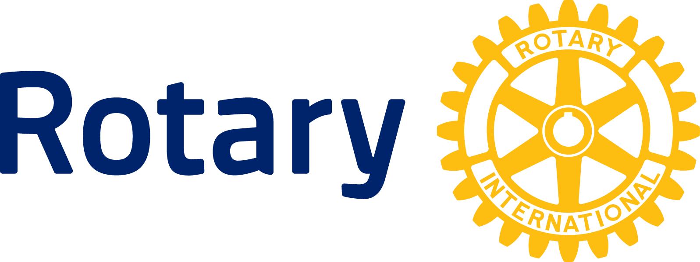
Serving Our Community Since 1941

Your choices for 2017 participation are:
$1000 or more:
Recognition of Your Donation Towards the Cash Prizes for the Top Competitors
Large Logo on a Racing T-shirt
Logo & Link on Our Website
Double Emcee Shout Outs at Race
Bike Rodeo Shout Outs
5 T-Shirts & 5 Bags
$500 Sponsorship: $100 Sponsorship:
Your Banner at Registration Company Name on Shirt
Logo on Sleeve of Shirt (or Large Logo) Name on Sponsor List on Website
Logo & Link on Website Emcee Shout Outs at Race
Double Emcee Shout Outs at Race Bike Rodeo Shout Outs
Bike Rodeo Shout Outs 2 T-Shirts & 2 Bags
4 T-Shirts & 4 Bags
$250 Sponsorship: $75 Sponsorship:
Your Banner at Course Station Company Name on Sponsor List on Website
Medium Logo on back of Shirt Emcee Shout Outs at Race
Logo on Website Bike Rodeo Shout Outs
Double Emcee Shout Outs 1 T-Shirt & 1 Bag
Bike Rodeo Shout Outs
3 T-Shirts & 3 Bags

Your payment must be received by July 1, 2017 to be listed on the event T-shirt!
Make checks payable to: Dolores Rotary Club, PO Box 1082, Dolores, CO 81323

Contact Name: ___________________________________________________________________________

Company Name: _________________________________________________________________________

Physical Address: _________________________________________________________________________

Phone No.: ___________________________ E-mail: _____________________________________________

Amount of Monetary Sponsorship: $ ____________
Additional T-shirts ($15 each): $ ____________
TOTAL ENCLOSED $ ____________
Mark quantity of each T-shirt size desired:
Mens  Small _____ | Mens  Medium ___ | Mens  Large ______ | Mens  X-Large ___ | Mens  XX-Large ____ | Mens  XXX-Large ____ | Mens  XXXX-Large ____
Womens  X-Small ___ | Womens Small _____ | Womens  Medium ___ | Womens  Large _____ | Womens  X-Large _____ | Womens  XX-Large _____

Non-monetary items of donation (please describe and list amount of items): __________________________
_________________________________________________________________________________________
Thank You!

