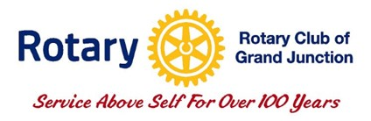
Grand Junction Rotary Club
Robin Hood Fund Request

2024 Theme: “The Power to Save Lives”
Date: _______________________

Name of Organization: _________________________________________
Contact Person: ______________________________________________
Address: ____________________________________________________
Phone: _____________________________________________________
Email Address: _______________________________________________
Tax-Exempt Number (not required but encouraged): ___________________________
Describe your organization:
______________________________________________________________________
______________________________________________________________________
______________________________________________________________________
______________________________________________________________________

Amount of funding requested: ____________________________________________

Specify the use of funds, how your project aligns with the Rotary’s The Power to Save Lives theme,
and the start date:
______________________________________________________________________
______________________________________________________________________
______________________________________________________________________
______________________________________________________________________
______________________________________________________________________
______________________________________________________________________
______________________________________________________________________
______________________________________________________________________
______________________________________________________________________
______________________________________________________________________
______________________________________________________________________
______________________________________________________________________

Who and how many will benefit from your project and how:
______________________________________________________________________
______________________________________________________________________

Please Submit the applications to grandjunctionrotary@gmail.com by November 1, 2024.
For information, contact Jack Connolly 970-250-5400 or Peter Booth 503-551-6117. If you receive funds, you will be expected to acknowledge and recognize the Rotary Club of Grand Junction using signage, advertising or a press release.

