**PUEBLO ROTARY #43**

**PRESIDENT’S MESSAGE 2019-2021**

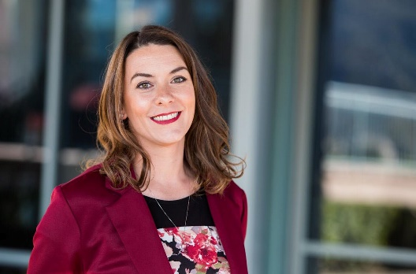This year’s Rotary International theme is “Rotary Connects the World”. As I think about what that means with regard to our local club I am reminded of our connections in Italy, Mexico and China. We are truly blessed in our club to have members who seek out such connections. But, it doesn’t end there. The mission in our own community is the same. It is inspiring to see each member; whether quiet or energetic, reserved or passionate; engage for the greater good in Pueblo or Beyond. They think beyond themselves and sacrifice much to thoughtfully display the model of “Service above Self”.

The vision for our local club echoes that of Rotary International this year.

“Together, we see a world where people

unite and take action to create lasting

change — across the globe,

in our communities, and in ourselves.”

It takes all kinds of people to make our organization strong, our community strong, and humanity strong. Unity is attainable. When we as Rotarians come together for a common purpose the lines that divide industries, class and nationalities become nonexistent. The diverse population in our club of business and professional leaders coming together to grow Rotary and grow our Impact on the World around us is something that binds us all together.

Rotary International President Daniel Maloney says “(Rotary) allows us to connect with each other, in deep and meaningful ways, across our differences”. “It connects us to people we would never otherwise have met, who are more like us than we ever could have known. It connects us to our communities, to professional opportunities, and to the people who need our help.”

The Goals in our club to enhance our business value, energize our committee work, and integrate our families are fostered by Rotary International as well. Our members enjoy fellowship, mutual support, and increased networking opportunities which aid them in their professional as well as personal goals. But, beyond that business value our culture is one that welcomes the family. We are ever adapting to the needs of our members; building goodwill and better friendships while offering opportunities to serve in our community and world. Rotary shares an enduring commitment to a sustainable world. As multimillion member organization, there is no better or more meaningful way to take action than by joining a Rotary club.

We invite and challenge you to engage fully in all that Rotary has to offer. Participate in committees. Come to our weekly meetings. Fellowship at the social events. Utilize our network. Help grow the club and our impact by inviting friends, family, and colleagues to join. With you…..

**"Rotary Connects the World”**