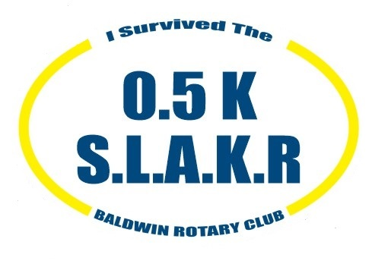

Saturday, June 19, 11am

Start at the Courthouse and

finish downtown!

How easy is that?

**GET A COOL RACE T-SHIRT WITHOUT**

**DOING TOO MUCH WORK!**

This run is only 546 yards (0.5K) long and we’ll feed you lunch afterward! This is a Slow, Lazy And Kicked-Back Run for SLAKRs.

Fun prizes will be awarded! Lunch includes BBQ Chicken and salads.

**$25/person. To receive a t-shirt and decal, register at**

**Racewire.com by June 10.**

Start training today! All proceeds go to the Baldwin Rotary Club.