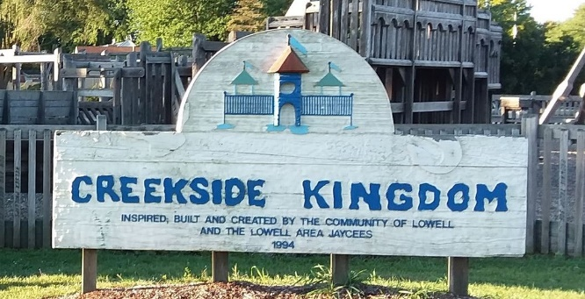
rebuildcreeksidekingdom@gmail.com
(616) 914-4918 – Theresa
Playground located at: 1550 Gee Dr, 49331

Fence Picket Order Form
Have you been waiting for an opportunity to get involved with the new park? Now is your chance to get your name on the playground for years to come! Fence picket sales are now live. You can use the QR code or complete this form. Each picket will be $150. They are solid, color-core and will be color matched to the motif of the playground. Color core means that whatever you choose to be engraved will pop with a contrasting color. With each picket sold your name will be on display for years to come and will help achieve our goal of providing a safe fun playground for future generations.
Please note that your order is not complete until you have mailed a check in the amount of $150 made out to the Lowell Rotary Club Foundation, at PO Box 223, Lowell, MI 49331

Name: _________________________________________________________________________________
Phone Number: ________________________________________________________________________
Email: __________________________________________________________________________________

Text to be put on Picket:

Standard Letters & Symbols Available:
A B C D E F G H I J K L M N O P Q R S T U V W X Y Z
1 2 3 4 5 6 7 8 9 0
! @ # $ & * ( ) - = + ; : ’ ” ? . ,

