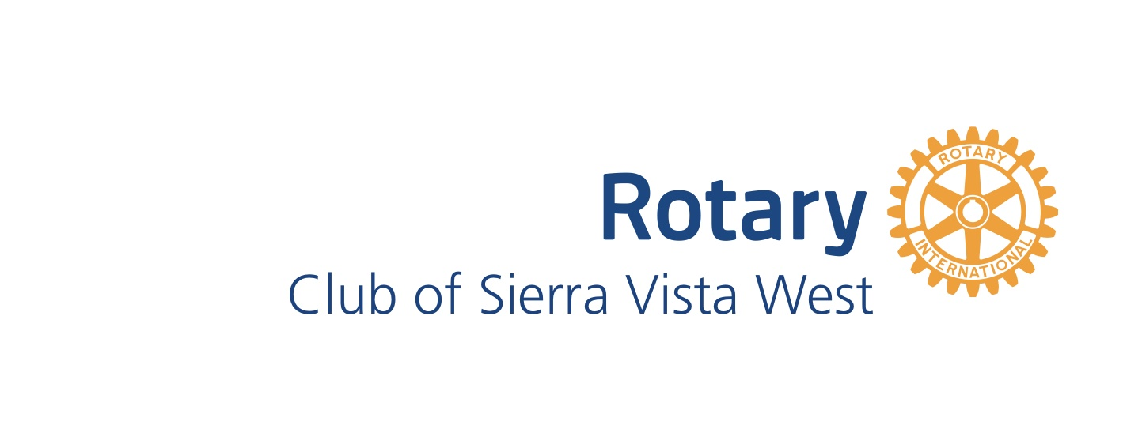

September 2021 Board of Directors Meeting
September 21, 2021
- Call to order
President Steve Johns called to order the September board of directors meeting of the Rotary Club of Sierra Vista West at 5:41 pm via Zoom.
The following board members were present:
President Steve Johns
President Elect Tom Reardon
Secretary Anita Farrow
Foundation Chair Tom Reardon
Membership Chair Jim Thompson

Absent:
Service Projects Chair DG Hank Huisking
Treasurer Kevin Farrow

Guests: None
- Approval of minutes from last meeting
Approval of August Minutes will be approved in October.
- Treasurer’s Report
Checking Balance: $12,214.51
Foundation Balance: $1232.78
TOTAL ASSETS: $13,447.29

- President’s Report
  - Steve has assigned Speaker Months as follows:
      - October Kevin
      - November Hank
      - December Renae
      - January Tom
      - February Jim

  - Member Milestones
      - September 29 Hank’s 16 Year Rotary Anniversary
  - Grants: Big ticket items have been ordered with delivery expected in December.
- Committee Reports
  - Membership (Jim)
Current membership count is 8.
  - Public Relations (Tom): Plaque has been ordered and received to honor Rebecca Colby for her dispatch work and saving a life. Presentation forthcoming with media coverage.
  - Club Administration (Anita)
      - Nothing to report.
  - Foundation (Tom):
(2) 1st quarter dues have been submitted and sent.

  - Fundraising:
      - Pickleball Tournament? Tom to get with city.
      - Other ideas welcome
  - Service Projects (Hank) nothing new to report
  - Upcoming Events: Sunrise club has asked us to collaborate on a basket for the District Conference. Tom made a motion we share the cost of the basket up to $75 as long as Sunrise does the shopping. Jim made the second. Call to vote was made by Steve and motion passes. Need address to send the $75.00.
  - Kevin will attend Michael Drake’s Council of Legislation on Saturday and vote.

  - Request to support SV Rotary for Naco Wellness Initiative motion was made by Steve and second by Tom to donate $500. Motion passes. Need address to send money. This will count as an International Project for us.
  - Programs
      - RYLA’s check has been sent to hold spot for one student.
President Steve Johns adjourned the meeting at 6:08 pm. The next board meeting is on October 19th at 5:30 PM via Zoom.

Minutes submitted by: Anita Farrow
Minutes reviewed by: Steve Johns

