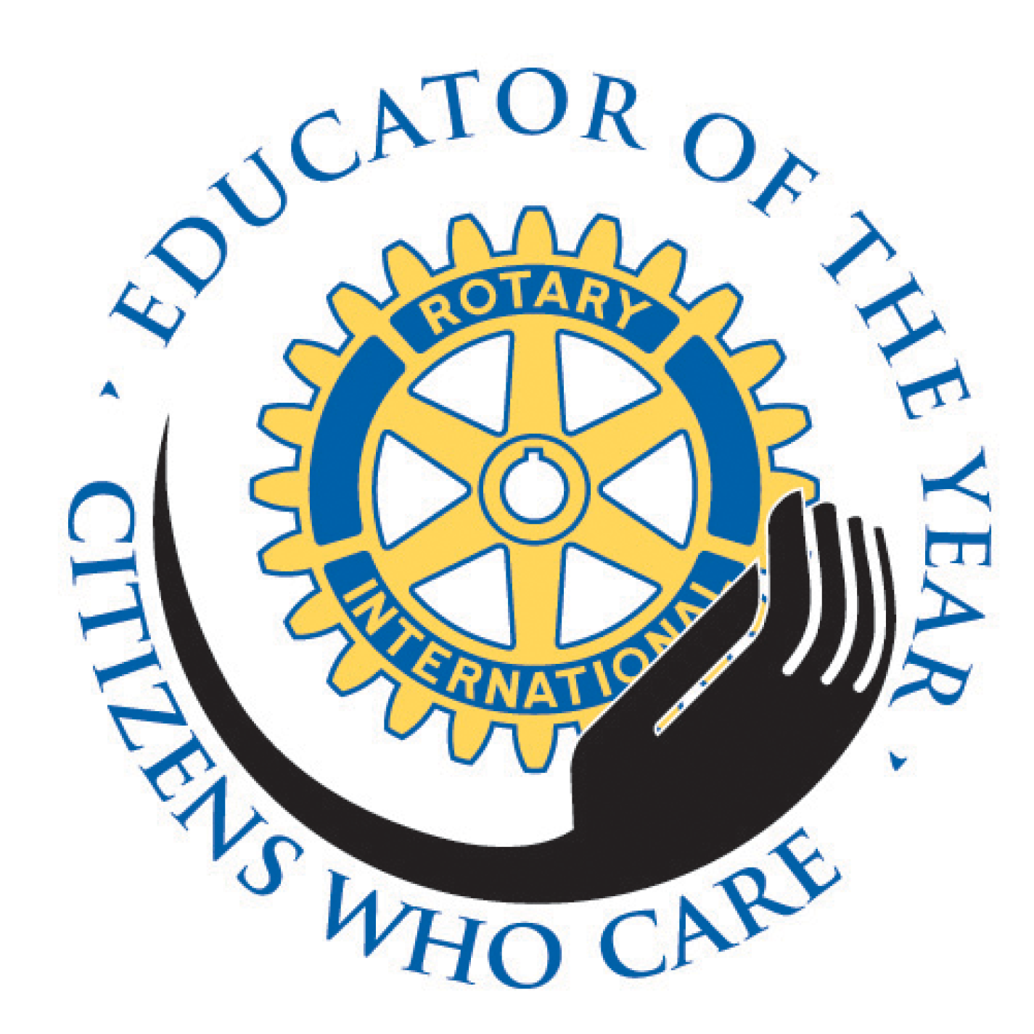
Citizens Who Care - Educator of the Year 2018

What is Citizens Who Care - Educator of the Year?
Citizens Who Care (CWC) is Andover's longest running program that honors outstanding
community volunteers. Since 1996 the Rotary Club of Andover has honored 10 people each year who have contributed to the local community through their extraordinary volunteer contributions. Those chosen exemplify what it means to be an "unsung hero." They come in all ages, professions and The Educator of the Year (EOY) started in 2009 and honors one exceptional educator chosen by his or her peers.
The recognition of the recipients is embodied within an exhibit of portraits and biographies that travels throughout the town. It can be found in the Town Offices, our library, CVS’s front window, Brickstone Square, and several banks too.
Each spring there is a large gala that draws town leaders, elected state officials, Rotarians, past recipients and friends and families of the recipients.

How are the recipients chosen?
Starting in January a Rotary committee sends out nomination forms to a large list of organizations and individuals that are in a position to nominate candidates. Any individual is welcome to nominate a worthy candidate. We receive about 50 nominations from which we choose 9 final recipients. We reserve the 1Oth slot for a high school student who is chosen from the Principal and his staff.

The Educator of the Year is selected from outstanding educators nominated by teachers, school administrators and/or parents.

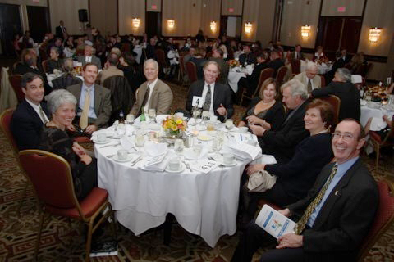
What makes the CWC-EOY Gala special?

The CWC-EOY gala is the Andover Rotary Club's signature event and fundraiser. This year it will occur on May 17, 6:00 pm at the DoubleTree by Hilton Hotel on Old River Road in Andover

The event draws our Selectmen, town manager, state senator, state representatives and many of the town's volunteer organizations. It is the only such event that draws so many groups that shape Andover's future.

The proceeds from the gala fund our
club's projects, including our contribution to end Polio across the globe, the anti-bullying
program in selected Andover schools, Thanksgiving turkey dinner collections, holiday toy collections, medical missions abroad, and our latest clean water project for a village in Kenya.

Why your sponsorship of the CWC-EOY gala is "good for all concerned."
We keep the ticket prices affordable to the families and friends of each year's recipients, and sponsorship helps to cover these costs, along with supporting the charitable causes noted above. There is arguably no other event that draws such a diverse and community-minded group of people to which you have a chance to make a statement of your company's good citizenship. The attached sheet shows the levels of support from which you can choose.

