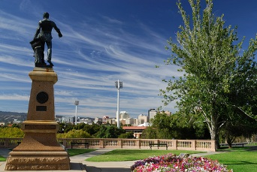 | Rotary Club of Adelaide Light  eNewsletter  Meeting No. 1404, 20 February 2014

Tue Feb 18, 2014 | Home

Editor Di Lane  If you have any comments or questions, please contact the editor.  Speakers  Feb 20, 2014  Mark Bickley  Adelaide Football Club  Feb 27, 2014  Mary Legoe  to be confirmed  Mar 06, 2014  Ian Williams  Scrambled reptiles  Mar 13, 2014  Simon Blight  Life and recent times  View entire list...  Club Events  Lawn Bowls NightBeaumont Bowling CLub  Feb 28, 2014 06:30 PM - 09:30 PM  Latin American Fiesta!!Linde Reserve  Mar 23, 2014 11:00 AM - 04:00 PM  2014 District ConferenceMcCracken Country Club  Mar 27, 2014 05:00 PM - Mar 30, 2014 01:00 PM  2015 District ConferenceNot disclosed at this time  Mar 26, 2015 05:00 PM - Mar 29, 2015 01:00 PM  Directors  President Richard Jarrett  President Elect Yvette Reade  Treasurer Bruce McDonald  Secretary Fred Field  Community Service Rohan Richards  Vocational Services Peter Briscoe  International Service Kym Pedler  Rotary Foundation David Riggall  Membership Geoff Bell  Club Administration Yvette Reade  Public Relations Tony Reade  Sergeant Terry Rodoni  Rotaract Liaison John Karran  Fundraising / Fellowship Andrew Black  Youth Service Peter Briscoe  Public Officer Fred Field  Bulletin Editor Di Lane  Club Webmaster Richard Jarrett  Child Protection Officer Fred Field |  | Welcome to our Club!  Service Above Self We meet Thursdays at 7:15 AM Naval, Military and Air Force Club 111 Hutt Street Adelaide, South Australia 5000 Australia  Venue Map Duty Roster District Site  Stories  From the President's pen  Posted by Dean Sullivan on Feb 18, 2014  Last week's speaker was our own, and one of our newest members, Ray Cullen.  Ray, with his extensive knowledge of the Internet, gave us a great insight to Facebook, Twitter and Email and how we can use these mediums for Advertising and Promotion as well as socialising.  With the "Latin Fiesta" fast approaching these mediums will assist us to promote the event, and Ray has already tweaked the system whereby over 1000 Facebookers have been given positive "Fiesta" feedback. It was of interest, that up to 50% of our members operate Facebook".  Ray has been booked to give a follow up.  Lawn Bowls Night  Posted by Andrew Black on Feb 09, 2014  We are holding a lawn bowls evening on Friday 28th February at 6.30pm at the Beaumont Bowling Club (corner of Hay Road and Devereux Road, Linden Park), where Fred Field, their current President, will be our host.  Bring your partners and friends to a fun evening. Please bring a chop and a snag for the BBQ and a salad to share. Our hosts will be available to serve on BBQ and at bar.  You should also bring your flat soled shoes and $10.00 green fees. No bowling experience required. Experienced bowlers will provide coaching.  Could you please let Andrew Black know whether or not you are able to join us.  Exciting LATIN AMERICAN FIESTA returns to Stepney!  Posted by Yvette Reade on Feb 01, 2014  Capture the sights, sounds and excitement of Latin America through a fascinating and electric mix of dance and entertainment while indulging in cuisine that delivers robust, flavourful and inventive food choices.  Following last year's successful event, the Rotary Club of Adelaide Light will again hold the Fiesta on Sunday 23 March from 11am-4pm on the Linde Reserve (access through Dunstone Grove) off Nelson Street Stepney (opp Avenues Shopping Centre). Admission $10 adults, $20 family.  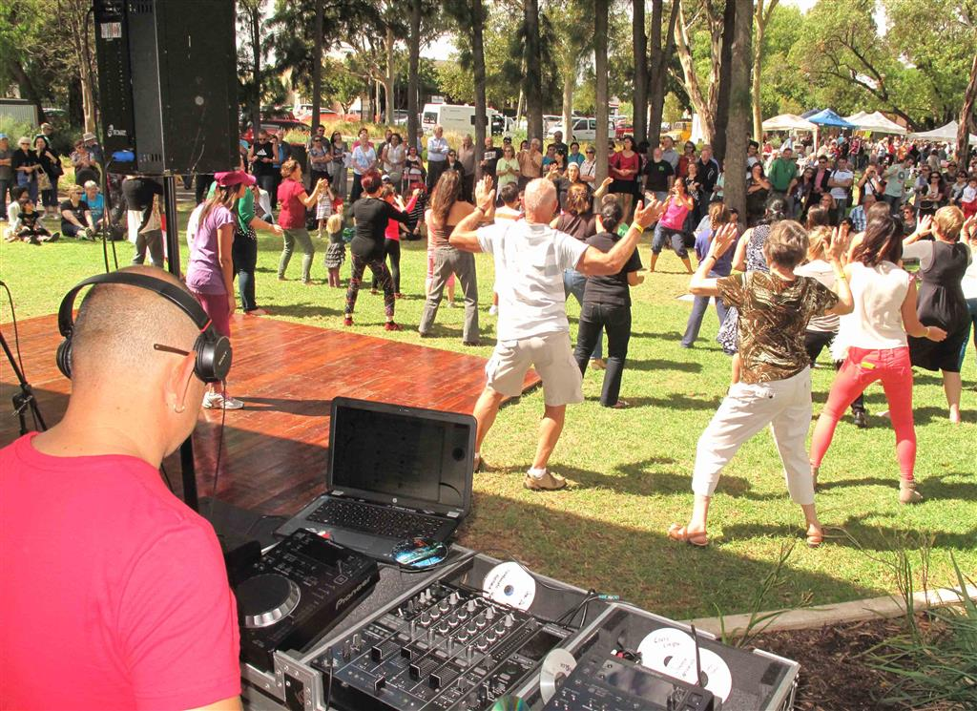  Funds raised by the Fiesta will provide living expenses for underprivileged adult students undertaking their studies in Colombia's Bogota-Suba district (an area of extreme poverty).  Entertainment includes Aloysius Leeson Flamenco Guitar, Latino Grooves, SaSamba Drummers, Toco Madera Colombian Guitar Group, Tango dancers, Zumba for children and adults, and Daniel Larcombe. Children can experience the different cultures and traditions of Latin America while enjoying jumping castles and face painting.  Website link: www.LatinAmericanFiesta.com.au  51st Golf World Championship, Adelaide - 18 - 24 May 2014  Posted by Andrew Black on Jan 20, 2014  Rob Motteram, from The Adelaide Rotary Club, is chairing the committee running  the International Golfing Fellowship of Rotarians.  Dates 18 - 24 May 2014  Registration - $1,000  All information in the tabled flyer  Duty Roster  Posted by Di Lane on Feb 17, 2014  For the benefit of members, we will aim to give the Duty Roster a few weeks ahead - see below.  Responsibility 20 February 2014 27 February 2014 6 March 2013  Chairperson Dean Sullivan Rohan Richards Geoff Bell  Attendance Feisar Joya David Riggall Andrew Black  Attendance Di Casey David Rowe John Karran  Hosting Tony Reade Carolyn Wigg Dalice Kennedy  Furniture Paul Richardson Bob Buckerfield Rob McLennan  Furniture Chris Dibden Tony Reade Carolyn Wigg  Invocation Geoff Bell Deborah Wotherspoon Chris Dibden  Bottles/cans Dean Sullivan Fred Field Bob Angove  Rotaract roster  HouseInt Uniting Church  Bread Roster David Riggall Rohan Richards Terry Rodoni  Members' Corner Yvette Reade John Wotherspoon Angus Tuck  Birthdays: Terry Rodoni 23 February, Helen Angove 26 February  Chairman: meets/ greets speaker for the meeting; introduces and thanks speaker preparation:- find details about the speaker prior to the meeting.  Attendance: set up reception table (attendance sheet; members list – re -payments; guest welcome sheet; money; wine raffle sheet; ticket books); register member payments/ apologies/ guests.  Hosting: set up name badges display; welcome all at the door; ensure speaker and guests are introduced to appropriate persons.  Furniture: flags; banner display; raffle balls; collection boxes; Rotary theme banner; S-A gong and hammer; lectern position before and returned after the meeting. Toshiba laptop set up – Connect to projector. Switch on. Hold function key & press F5 twice.  Invocation: reciting Rotary or other invocation relating to Rotary and fellowship.  Bottles/cans: collect bags of bottles/cans at meeting and take to recycle centre for refund, pass refund and empty bags to David Rowe at next meeting  Members’ Corner: write for the Newsletter on a topic of your choice, particularly during the 3 weeks you appear here on the roster, but also anytime you have something to say.  Rotaract, House International Uniting Church, Bread roster: Roster is for the Sunday/Monday after the meeting date.  Members rostered for duty are asked to be in attendance by 6.45 a.m.  If you cannot attend, please arrange a substitute  Meeting No.1403Details  Posted by Bob Buckerfield on Feb 16, 2014  Meeting Number 1403 13 February 2014  Membership 37 Visiting Rotarians Apologies  + Honorary 2 Don Tindale in Sydney  Present 19 + 1 Bob Angove in Melbourne  Attendance 59.38% Barry Grear at Melrosei(Fire Committee)  Apologies 8 Katina Jones in Sydney  Leave of Absence 4 Club Guests Angus Tuck on holidays  Make-ups 4 Julie Campbell Richard Jarrett in Tasmania  Absent 7 Di Lane at work  Fines $36.55 Dalice Kennedy  Wine Raffle $20.00  Cans & Bottles YTD $648.20 Makeups Leave of Absence  John Campbell at Modbury, Golden Grove, Rob Brooke  Playford, & walkerville Peter Veitch  Feisar Joya  Di Casey  For apologies, please phone Fred Field, Club Secretary 8339 2065, or Bob Buckerfield on 8278 7615. Makeups count 13 days either side of each meeting.  Club Bank Account details: BSB 085-458, Account Number 20-505-9719  The Four Way Test  Posted by Richard Jarrett on May 29, 2013  The Four Way Test  Of the things we think, say or do:  - Is it the Truth?  - Is it Fair to all concerned?  - Will it build Goodwill and better Friendships?  - Will it be Beneficial to all concerned?  Invocation  For good food, for good fellowship and the opportunity to serve through Rotary, we give thanks  Rotary Club of Adelaide Light Mission Statement  To be recognised as the Service Club of Choice in the Eastern Precinct of Adelaide because we are a Friendly Breakfast Club that appeals to a broad range of busy people who want to make a difference to local and international communities.  Jokes Corner  Posted by Di Lane on Feb 17, 2014  Drummer  A musical director was having a lot of trouble with one drummer. He talked and talked and talked with the drummer, but his performance simply didn't improve.  Finally, before the whole orchestra, he said, "When a musician just can't handle his instrument and doesn't improve when given help, they take away the instrument, and give him two sticks, and make him a drummer."  A stage whisper was heard from the percussion section: "And if he can't handle even that, they take away one of his sticks and make him a conductor."  *********************************************************************************  Valentine  Attending a wedding for the first time, a little girl whispered to her mother, "Why is the bride dressed in white?"  "Because white is the color of happiness, and today is the happiest day of her life."  The child thought about this for a moment, then said, "So why is the groom wearing black?"  *********************************************************************************  The Greatest  A lion, a gorilla and a chicken were bragging in a bar.  "I am the greatest," said the gorilla. "When I beat my chest everyone backs away respectfully."  "No, I am the greatest," said the lion. "When I roar everyone in earshot runs away screaming."  "Ha!" said the chicken. "You should see the worldwide media reaction if I so much as sneeze..."  *********************************************************************************

© 2002–2014 ClubRunner. All rights reserved. Privacy Statement | Online Help | System Requirements

