Bergen Highlands/Ramsey Rotary Club
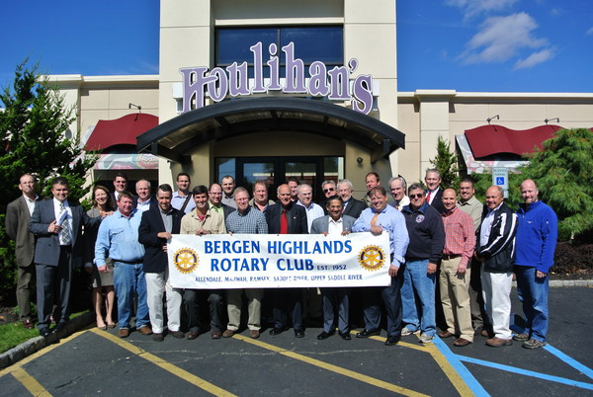

Membership Booklet 2014-2015
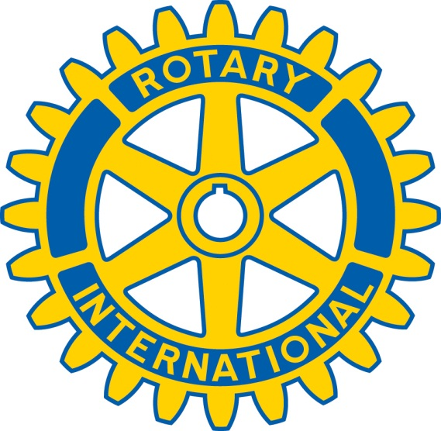
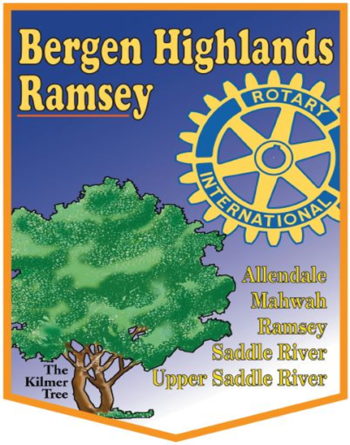

Revised 8/10/13

Table of Contents

Page 1 What is Rotary?
The Rotary Four Way Test

Page 2 The Object of Rotary
Five Avenues of Service
-Club Service

Page 3 Five Avenues of Service (continued)
-Club Service
-Vocational Service
-Community Service

Page 4 Five Avenues of Service (continued)
-International Service
-New Generations
Some Bergen Highlands Rotary Club International Projects
The Bergen Highlands/Ramsey Rotary Club

Page 5 The Mission of Bergen Highlands/Ramsey Rotary Club
Club Officers for 2012-2013
Board of Directors for 2012-2013

Page 6 Paul Harris Fellow
Bergen Highlands/Ramsey Rotary Club Foundation
Membership

Page 7 Becoming a Rotarian
The Benefits of Rotary
Recruitment

Page 8 Paths to Membership
Helpful Websites
Membership Classifications for Professional Representation

Page 9 Member Responsibilities
Membership Financial Obligations

Page 10 Past and Present Rotary Projects & Activities
Bergen Highlands/Ramsey Rotary Club - Quick Reference

Page 11 Notes

What is Rotary?

From its very small beginnings at the turn of the 20th Century, Rotary is now the world’s largest service organization with more than 1.2 million members in over 32,000 clubs located in more than 200 countries.

It was founded in 1905 in Chicago, Illinois, when a young lawyer named Paul Harris proposed to three other men his idea of meeting together periodically to discuss common business problems and to consider ways to serve the community. They decided to “rotate” their place of meeting, thus the name “Rotary.”

Additional clubs were formed in the U.S., then in Canada, and eventually all over the world. The general objectives of the Rotary clubs in every country are the same – the development of fellowship and understanding among the business and professional men and women in the community, the promotion of community and betterment endeavors of high standards in business and professional practices, and the advancement of international understanding, goodwill, and peace.

Rotary clubs everywhere have one ideal – the “ideal of service,” which is thoughtfulness and helpfulness to others.

This ideal is proclaimed in Rotary’s motto:

“Service Above Self” and is further set forth in:

The Rotary Four-Way Test

This message should be known and followed by all Rotarians all of the time:

Is it the TRUTH?

Is it FAIR to all concerned?

Will it build GOODWILL and BETTER FRIENDSHIPS?

Will it be BENEFICIAL to all concerned?

Page 1

The Object of Rotary

The Object of Rotary is to encourage and foster the ideal of service as a basis of worthy enterprise and, in particular, to encourage and foster:

FIRST: The development of acquaintance as an opportunity for service;

SECOND: High ethical standards in business and professions, the recognition of the worthiness of all useful occupations, and the dignifying of each Rotarian’s occupation as an opportunity to serve;

THIRD: The application of the ideal of service in each Rotarian’s personal, business, and community life;

FOURTH: The advancement of international understanding, goodwill, and peace through a world fellowship of business and professional persons united in the ideal of service.

The “Object of Rotary” is the basis for Rotary’s Five Avenues of Service:

- Club Service
- Vocational Service
- Community Service
- International Service
- New Generations

The Five Avenues of Service

Club Service

The purpose of club service is to foster a sense of commitment to Rotary, strengthening fellowship and ensuring the effective functioning of the Club. When ”Club Service” is functioning effectively and well, we are successful at fostering a sense of commitment to Rotary and individual member pride in being a member of the Bergen Highlands/Ramsey Rotary Club.

Continued next page

Page 2
Club Service focuses on the well-being of our members and their families. Our primary activities include:

Smooth-Functioning Weekly Meetings.
Scheduling interesting speakers.
Pledge to Flag.
Introduction of Guests.
Press Releases.
Website Information.
Arranging for raffle prize and selling raffle tickets.

Making sure that every member knows the “what, where, and when” of all Rotary meetings, fundraisers, community projects, and social activities. Family members are always welcome at club meetings and members are encouraged to bring their families to all community service projects, fundraisers and social events.

Vocational Service

Rotary recognizes the worthiness of all useful occupations as an opportunity to serve society. The purpose of the Vocational Service Committee is to encourage club members to serve others through their vocation and to practice high ethical standards. This is done by:

1. Educating other members about our own vocations.

2. Recognizing and encouraging ethical business dealings among club members and in our community as described in the Four-Way Test.

3. Helping youth to consider what vocation they might choose.

4. Recognizing the free enterprise spirit as an opportunity for establishing worth-while service.

Community Service

Community Service gives every member the opportunity to be actively involved with their home community, the regional community and other areas of need in the United States. It reflects a personal commitment to help our neighbors in need, no matter where they live.

Page 3

International Service

Rotary is recognized as one of the premier international service organizations. With over one million members in clubs throughout the world, it uses a network of regional community leaders and substantial financial resources to implement projects to improve the well being of people throughout the world. The purpose of this committee is to expand Rotary’s humanitarian reach around the globe and to promote world understanding and peace. Through matching grant programs an individual club can develop a meaningful project with significant impact.

New Generations

Every year, thousands of talented and dedicated young people, ages 12-30, have an incredible experience in a New Generations program. As Rotaractors and Interactors, they serve in communities at home and abroad. Through Rotary Youth Exchange, they explore new cultures. And as Rotary Youth Leadership Awards (RYLA) participants, they learn skills that will help them succeed as future community leaders.

Some Bergen Highlands/Ramsey Rotary Club International Projects

Managua, Nicaragua Water and School Project
Gift of Life - ongoing
Kenya School Project – Benjamin Moriaso

The Bergen Highlands/Ramsey Rotary Club

The Rotary Club of Bergen Highlands was chartered in June 1952. The club meets every Monday at 12:15pm at the Houlihan’s on Route 17 North in Ramsey, New Jersey.

Although every Rotary Club is a part of Rotary International, whose headquarters is located in Evanston, Illinois, each club is run by its own officers and board of directors elected by the members. The Bergen Highlands/Ramsey Rotary Club also has a committee structure set up, to implement the Five Avenues of Service.

Page 4

The mission of the Bergen Highlands/Ramsey Rotary Club is to enhance the quality of life for people in the community and the world by:

1. Developing and bringing to fruition annual club goals that exhibit the Rotary motto “Service above Self.”

2. Insuring that members exhibit their values to the community by adopting and adhering to Rotary’s Four-Way Test;

3. Encouraging and reinforcing the ideals encompassed in Rotary International’s Object of Rotary in the lives and activities of our club’s members, and;

4. Supporting and celebrating the attainment of individual member’s goals in life, by fostering close, long-term friendships based on trust, loyalty, and respect.

Club Officers for 2014-2015
Club President Mike DiLella
President Elect Kevin O’Rourke
Vice President Rob Parker
Secretary Jeff Fulton
Treasurer TJ Spizzo
Sergeant at Arms Christian Kasparian
Immediate Past President Howard Schreiber

Board of Directors for 2014-2015

Howard Schreiber Rob Parker
Bob Baron Roy Polizzi
Tom Napolitano Kevin O’Rourke
Jeff Fulton Tim Shaffer

Page 5
Paul Harris Fellow

Named in honor of Rotary’s founder, the Paul Harris Fellow is awarded to honor an individual who has donated $1000 to the Rotary Foundation. The donation can also be made on behalf of an individual or family member who embodies the principals of Rotary. There are over one million Paul Harris Fellows internationally. The funds donated are the major funding source for the Polio Plus Program.

The Paul Harris Fellow Award is accompanied by a certificate, medallion and pin. It is usually given by the Club President with special recognition at a club meeting. The Bergen Highlands/ Ramsey Rotary Club is proud of its 24 Paul Harris Fellows!

Bergen Highlands/Ramsey Rotary Club Foundation

The Foundation was formed by the members of the Bergen Highlands/Ramsey Rotary Club with a view towards better serving the same charitable purposes as have been served by the Rotary Club for over 50 years. More specifically, the Rotary Club is a non-profit service organization, but some of its activities do not meet the IRS rules for a “charity”. As a result, donations to the Rotary Club are not tax-deductible. It was felt that formation of a separate corporation was needed for purely charitable purposes, which would operate as per the IRS regulations for charitable organizations and would encourage greater donations.

Membership

The very essence of a Rotary Club is its members! With a well-rounded membership, everything that a Rotary Club stands for and provides becomes better for those in need, the community and each Rotary member. The goal for a Club’s membership is up-to-date and progressive representation of the community’s business, vocational, and professional interests. Every Rotary Club member is responsible for membership – their own, for existing members and for recruiting new members!

The Bergen Highlands Rotary Club Membership Committee has a Chairperson (who is a member of the Board) with three to five committee members. Their focus is keeping existing members active and contributing and to develop activities that will attract new members. They are a part of the whole Club effort to create genuine excitement and goodwill that generates a recruitment momentum.

Page 6

Becoming a Rotarian

With an association of 32,000 autonomous clubs in over 200 countries, Rotary International is the world’s largest service organization. Membership is vital to a Rotary Club’s operation and community service activities. It is important and necessary for a Club to continually expand its membership with committed individuals who have the interest and ability to get involved in service and humanitarian projects.

The Benefits of Rotary

Becoming a Rotary member provides the opportunity to:

Learn about and become connected to your community.

Work alongside others in addressing community needs.

Interact and network with other professionals in your community.

Assist with Rotary International’s Humanitarian Network of Professionals.

Develop and use leadership skills.

Involve your family and friends in promoting service efforts.

Have a lot of fun and make new friends!

Recruitment

A Rotarian may, and will likely, invite a potential new member to the Club for a meeting and talk to the person about the benefits and attributes of Rotary. It is the Club that often invites individuals to become members but anyone can contact the Club to discuss potential membership.

Prospective members should live or work within the towns that the Club represents; Allendale, Mahwah, Ramsey, Saddle River or Upper Saddle River. They should have the capacity to meet the Club’s weekly attendance and community project participation requirements. (See Member Responsibilities on page nine.)

Page 7

Paths to Membership

- Sponsorship – A Rotary Club member becomes aware of an individual who represents the interests and ideals of Rotary and meets the three conditions listed above. The member invites the person to the Club to either introduce them to the Club, or provide them with the opportunity to learn more about the Club and becoming a member. The member continues to invite the person to the Club’s meeting as a prospective member, i.e. as a Guest of the Club and becomes the prospective member’s sponsor.

- Contact a Member – An individual becomes aware of Rotary in general or of the Club and contacts a member to express his or her interest. The member then uses the contact opportunity to talk about the Club and benefits and rewards of being a Rotarian. The member invites the person to a meeting which may result in additional invitations as a Guest of the Club and a sponsorship of the new member.

Helpful Websites

Bergen Highlands/Ramsey Rotary Club
http://www.bergenhighlandsrotary.org/

Rotary District 7490
http://www.rotarydistrict7490.org/

Rotary International
http://www.rotary.org/en/AboutUs/Pages/ridefault.aspx

New Generations http://www.rotary.org/en/studentsandyouth/youthprograms/pages/ridefault.aspx

Membership Classifications for Professional Representation:

Rotary uses a classification system to encourage a vibrant cross-section or representation of the community’s business, vocational and professional interests among members and to develop a pool of resources and expertise to successfully implement service projects. The classification system is not used to limit membership.

A classification describes either the principal business or the professional services of the organization for which the Rotarian works or the Rotarian’s own activity within the organization. Examples of classifications include dentistry, banking, non-profit, insurance, travel industry, attorney, medical professional, local government, retail, communication and so on.

Page 8
Member Responsibilities

Rotary Club Membership carries with it certain responsibilities:

One of the unique characteristics of Rotary is the attendance commitment. Meetings of the Bergen Highlands/Ramsey Rotary Club are held each Monday at 12:15 pm and conclude at 1:30 pm. Members are asked to maintain at least 50% attendance at meetings – either at the home club or by “make-up” attendance at some other Rotary Club, in fact at any Rotary Club in the world.

Members are responsible for their annual dues, the cost of their weekly luncheons and other assessments voted by the Board of Directors and the membership. The total annual financial cost of membership in the Club runs approximately $1,000 - $1,500. Some of this is invoiced on a quarterly basis (see below).

Each member is expected to participate in local or international activities or projects of the Rotary Club. Members are expected to aspire to and volunteer for leadership positions such as officer, project chair, and committee member or board director.

Membership Financial Obligations

Approximate Minimum Annual Cost of Membership, billed quarterly:

Lunches - ($16 x 48) $ 768.00
Dues - ($26 per quarter) 104.00
Installation Dinner 50.00
------------------------------------------------------------
Total $ 912.00*

*In addition to the above costs, members are offered the opportunity to purchase 50/50 tickets at $1 each at all lunch meetings. They can also declare a “happy dollar” donation of $1 to commemorate an important event at the lunch meetings as well. Both of these are optional and at the discretion of the member, although we do encourage participation.

From time to time, our Rotary Club organizes social events that the members are welcome to attend. For example, golf outings, baseball games, progressive dinners, etc. There are varying costs associated with these events. Attendance is entirely optional, but encouraged.

Members have the opportunity to make voluntary tax deductible donations to the Rotary International Foundation as well as the Bergen Highlands/Ramsey Rotary Club Foundation.

Page 9
Past and Present Rotary Projects & Activities

Projects: Managua, Nicaragua Water Project, “Gift of Life”, Capital Fund of the Center for Food Action, Blood Drives, Habitat for Humanity, Dictionary Project and the Schoharie County NY Rehabilitation Project.

Programs: Interact Club, High School Scholarships, Rotary Youth Leadership Awards, World Affairs Scholarship, and many local charities and non-profits.

Activities: Blood Drives, Annual Town Days (Mahwah/Ramsey/Allendale/Upper Saddle River), Annual District Conference, Rotary International United Nations Day Event, and the Annual Installation Dinner.

Club Fundraising Events:
Annual Town Days (Mahwah/Ramsey/Allendale/Upper Saddle River), Golf Outing, and 50/50 Raffles.

Bergen Highlands/Ramsey Rotary Club - Quick Reference

Mail: PO Box 39, Ramsey, NJ 07446

Website: www.bergenhighlandsrotary.org

Meets: Every Monday, 12:15pm

Where: Houlihan’s Restaurant
706 Route 17 North
Ramsey, NJ 07446

Membership
Contact: Bob Baron 201-934-1222

Page 10
Notes

________________________________________________

Page 11

