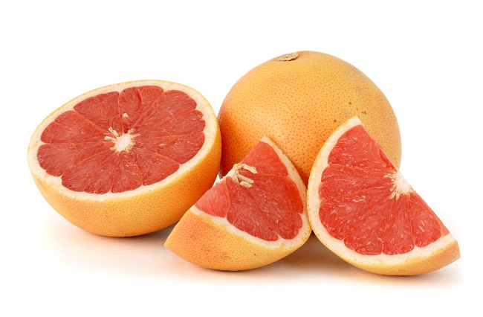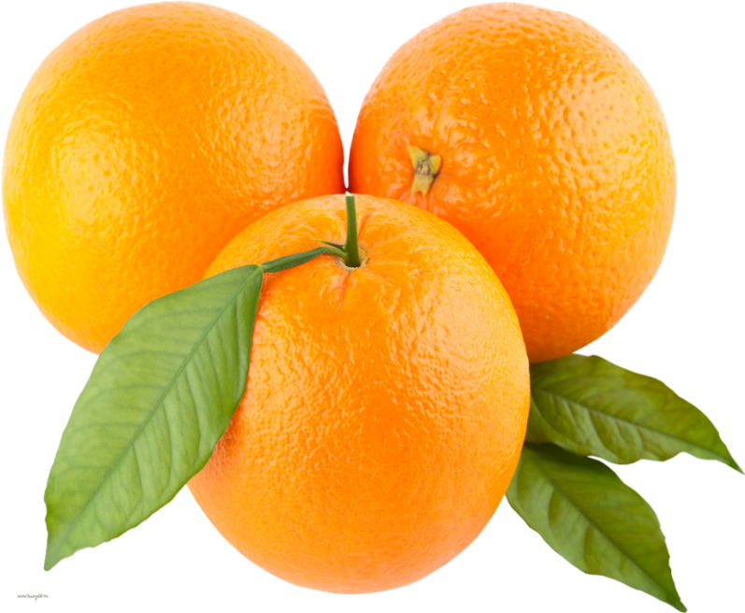
Rotary Club of Springfield Annual Citrus Sale
John Montgomery Memorial Citrus Drive
Nearly $1.4 million in grants have been provided to local charities through this annual event
We obtain fresh-picked Seedless Navel Oranges and Ruby Red Grapefruit from the Indian River Groves in central Florida and bring them to you for the Holiday Season. These Grade A Oranges and Grapefruit are a favorite for gifts to friends, employees, and business associates.
Donors can designate a gift of oranges to the Central Illinois Foodbank through this program.
Fruit can be ordered through a member of the Rotary Club of Springfield, by phone or internet.
Phone Orders: 217-566-4326
Internet Orders: www.rotarycitrus.com
Ordering Deadline is November 13. Citrus Pickup/Delivery Dates are December 8-9.
40 Lb. cases of Oranges, Grapefruits, or mixed fruit are $50 per case. 20 Lb. cases are $30 per case. Gifts of oranges to the Central Illinois Foodbank or Food Pantries may be for either size.

