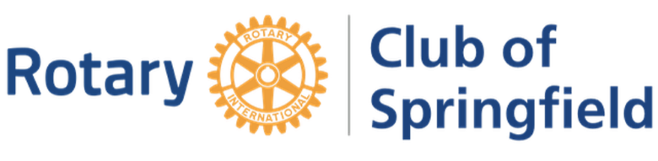

FACT SHEET
The Rotary Club of Springfield, PO Box 615, Springfield, IL 62705

Rotary is a service organization that provides professionals in business, government and other organizations the opportunity to network with their peers, improve their own skills, and give back to their community and the world-at-large.

Meetings Financial
Every Monday at 5:30 p.m.
Maldaners Upstairs Meal Charge - $15
222 South 6th Street Quarterly Dues - $90

- Founded 1913

- Current Membership – 45

- Weekly Rotary Club Meetings:

  - Typically, featuring speakers on current local and regional issues;
  - Occasionally, special off-site meetings around the Springfield Community; and
  - Including Social Nights – every 4-6 weeks – designed strictly for entertainment and fellowship purposes

- Community Projects focusing on Literacy and Food Insecurity:

  - Volunteer at Central Illinois Food Bank warehouse; and donate 2.5 tons of fresh citrus annually;
  - Support Ridgely Elementary School (Springfield) by providing school supplies and providing tutoring/mentoring;
  - Maintain a Food Pantry at Ridgely School; and
  - Maintain a Little Library at Ridgely and Other Locations.

- Fundraising Activities to support Rotary scholarships and local community organizations

  - Annual Flag Service, providing flags to subscribers during national patriotic holidays, to fund grants to nonprofits and other entities
  - Annual Citrus Sale to fund grants to nonprofits and other entities
  - Lake Springfield Fishing Tournament to support literacy projects
  - St. Louis Cardinals Baseball Ticket Sales to support literacy projects
  - Springfield Rotary Clubs Chicken Dinner Fundraiser to support Rotary International Polio Eradication; and

- Service Projects supporting local non-profit organizations

  - Annual Holiday bell-ringing for Salvation Army
  - Scholarships for youth participation in leadership programs and local colleges
  - Support for inbound and outbound exchange students
  - Financial literacy mentoring for underprivileged youth
  - Painting and Fix-Up days benefitting local non-profits
  - Clothing Drives for the families in need
  - Adopt/Clean-a-Street campaign
  - Providing Meals and Other Necessities for Homeless Individuals
  - Collecting Donations for Alzheimer’s Association
  - Annual Holiday Angel Tree Gifts for underprivileged youth

- International Projects (present and past)

  - End Polio Now – Rotary International polio-eradication project
  - Clean Water projects in India and Mexico
  - Disaster Relief and Water projects in Nepal
  - Disaster Relief projects in Haiti
  - Agricultural Modernization in Zambia
  - Meal-packing projects for Stop Hunger Now
  - Medical Supplies for Ukraine

