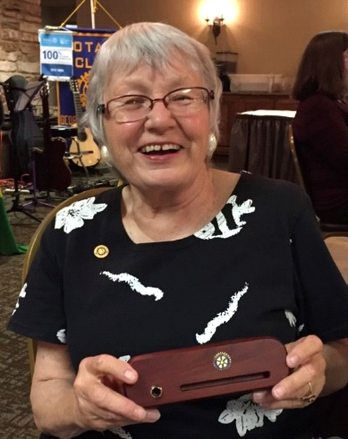

Carola Meister
May 26, 1943 – February 20, 2023

Carola Meister, 79, passed away on February 20, 2023, at Georgetown St. David’s Hospital after a brief illness. She was born in occupied Poland to German parents on May 26, 1943.
She immigrated to the United States in 1953 along with her mother and stepfather and settled in Los Angeles County, California. Her education was through public school, and she graduated from Temple City High School with honors, earning membership in the National Honor Society and the California Scholastic Federation.
After high school, Carola worked in Los Angeles, California and had a long career with Allianz Insurance Company, a multinational insurance carrier with headquarters in Germany. She took great pride in her career as a Commercial Liability Umbrella and Excess Liability Underwriter. She was a member of the Insurance Woman of Los Angeles. In “LaLaLand” she was often mistakenly for a television celebrity named "Dr. Ruth" because of her similar in looks, stature, and German accent.
During the 1990s, she was also involved with Habitat for Humanity in Los Angeles, supporting and guiding a deserving family to receive a home. Over the years, she remained in contact with the family and returned to LA to participate in the graduation of their son from law school in 2018.
In 1998, Carola suffered a heart attack that resulted in triple bypass surgery. After this health episode, she was not able to continue her career at Allianz and retired from her position as an Assistant Vice President.
On March 1, 2002, Carol joined the Rotary Club of Hollywood and was sponsored by her former Allianz colleague Silke Kohler. Soon after joining this club, she went on a humanitarian trip to El Salvador with other members of Rotary District 5280. She said that her experience on this trip was a life changing event after her own health and personal struggles. She was so touched personally by her experience that she said it restored her full energy for life.
In 2005, she decided to sell her house in Altadena, California and move to Georgetown, Texas. With her numerous pets in tow, she moved to an unfamiliar area without knowing anyone or having any established contacts. She started this new chapter in her life with her usual courage, enthusiasm, and resilience.
Carola never met a dog or cat that she didn’t love. This passion motivated her to start her own pet sitting business, serving many clients in the Central Texas area. She treated all the pets in her care as if they were her own. This dedication and caring spirit turned her clients into loyal and close friends.
Carola possessed a servant heart and was an active member of the Rotary Club of Hollywood, California before joining the Rotary Club of Georgetown Sunrise. She served in many club leadership positions and was the Rotary Club of Georgetown Sunrise club president for the year 2011-2012. She showed a particular passion for the Rotary Foundation and was a tireless champion of its mission to promote peace and humanitarian relief around our world. For over twenty years, she embodied the Rotary motto, “Service Above Self.”
As a Rotarian, Carola never missed an opportunity to participate in community service events like the Red Poppy Bicycle Ride, the Rotary Youth Leadership Award camp and the Field of Honor which recognized the contribution of our active-duty service members and veterans of the country’s armed forces.
Carola also honored her German heritage by teaching German language classes through the German-Texan Heritage Society in Austin, Texas, introducing her students both young and old to German culture.
Carola was a faithful member of Christ Lutheran Church and acted out her faith in her daily acts of caring and respect to her fellow human beings. She had a passion for the arts and loved to attend musical performances in formal and informal venues. She loved her friends, all of God’s creatures and her community. She lived a full life of courage, kindness, and cheerfulness. Her big smile and puckish personality will be missed by all.
Carola was predeceased by her parents and many dear friends. She will be laid to rest in the private ceremony Our Lady of the Rosary Cemetery in Georgetown. A “Celebration of Life” and memorial service to honor her properly is planned in early June.
Those who wish to honor Carola’s memory may send a donation to a memorial fund established by the Rotary Club of Georgetown Sunrise. You may visit the club’s website at www.georgetownsunriserotary.org and click on the PayPal button to contribute to the fund using your credit card. If you would prefer to make your donation by check, please make it payable “Carola Meister Memorial Fund” and mail c/o Rotary Club of Georgetown Sunrise, PO Box 2025, Georgetown, TX., 78627.
The fund will make contributions to various charities that Carola supported in her lifetime.

