Pinion from The Rotary Club of Bernardsville
29 March 2016
Lavinia gave the blessing for our food, today’s meeting, for Rotary, and for the energy and commitment to offer better service as Rotarians. Our guests were Congressman Leonard Lance, Eileen Leoni, Ben Gordon, and Montessori speaker Hannah Ferris.
Brad won the 50/50. Twenty one attended.
P1 President-elect Eric’s updates
P2 Montessori school and education Honorable Leonard Lance on Congress today
P3 Track meet update The Rotary Foundation (TRF) and some of its history
P4 Happy Dollars Membership Club Officers Meeting assignments
P5,6 Service Work Officer nominations Queen of Hearts Four-Way Test

Rotary’s Four-Way Test
Of all the things we say or do –
- Is it the truth?
- Is it fair to all concerned?
- Will it build good will and better friendships?
- Will it be beneficial to all concerned?
President-elect Elect Eric’s remarks and updates
- Eric led the meeting, as Al was recovering from exertions at a late night concert. Eric reported that the President Elect Training School [PETS} was recently conducted and benefited Rotary officers and invited guests who were there.
- Brian – Today is Dictionary Day at Bedwell. Cheryl, Jessica, Bill,Terry, and Will visited the the third-grade classes. Dictionary Day at St. James will be 26 April. St Elizabeth will be 19 April.
- Trash cleanup of our mile of US 202 will be 2 April. Meet at 8 AM in the King’s parking lot. Contact Justin if you need training on the safe protocol to pick up trash beside a major highway. Still room for you on the team.
- George reported that sports-related items for our club basket at the Conference must be collected by 12 April. We are hopeful of having football gear, hockey items, signed baseball, golf stuff, and perhaps photo or replicas of championship rings. Al Lynn later reported tha he had a signed football and a signed hockey jersey – great start.
- Brad reminded us that The Rotary Foundation relies on annual donations from Rotarians. Each club member is encouraged to donate annually; suggested donation is $100.
- Will has boosted our web site with borrowed and original ideas. We can brief personal bios, head shot pictures, and Rotary memories for each member. Will is efforting the picture-taking. Site also offers advertsing – max of ten sponsors – to club members and then community members. Madison has found this to be a robust fund source.
- Louise – All are invited to the District Conference – golf, fellowship, learning, fun, and fund-raising. Clubs prepare theme baskets which are then bid on by the attendees. If you are able and so disposed, write a $25 check for the attendess [we’ll probably have 6-10 members there] to go to the basket bidding. Proceeds from the baskets go to The Rotary Foundation. Also you can advertise with small items for the give-away bags. Tees from Paul Duffy were very popular last year as were pens from Brian Wallace.
- Track meet will be 19 May. This will be the 66th year for the track meet. Plan to be there.

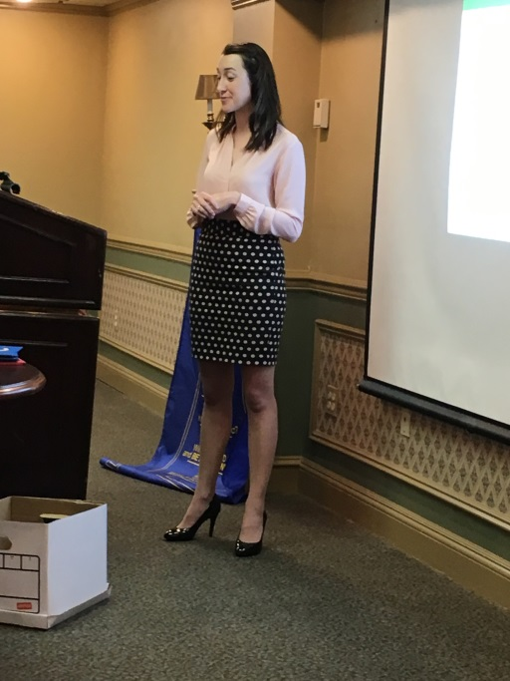
Hannah Ferris was invited to speak about the Montessori School by Terry. Dr.Marie Montessri founded the first school that now bears her name and the educational principles she knew to be both needed and effective for young children. As the first female doctor in Italy, she had ample opportunity to treat moms and kids and to hear about their learning triumphs and defeats. The defeats were noted, reasons for those hurdles noted, and improved learning processes substituted.
Hannah Ferris spoke to us of her grade and high school years at St E’s in Florham Park,her undergraduate yeasrs at Flagler College, her volunteer year in South Africa at Montessori School, and her matriculation at the highly competitive London School of Economics. So she knows education and can compare the Montessori offering with her own traditional school pathway.
Montessori’s hallmarks are Practical, Sensorial, Mathematical, Language, and Culture.
- Practical teaches kids as young as 2 ^{1/2} to close buttons and engage buckles. Think hand-eye coordination.
- Sensorial encourages isolation of senses; a child focuses on each task as it’s being approached and done.
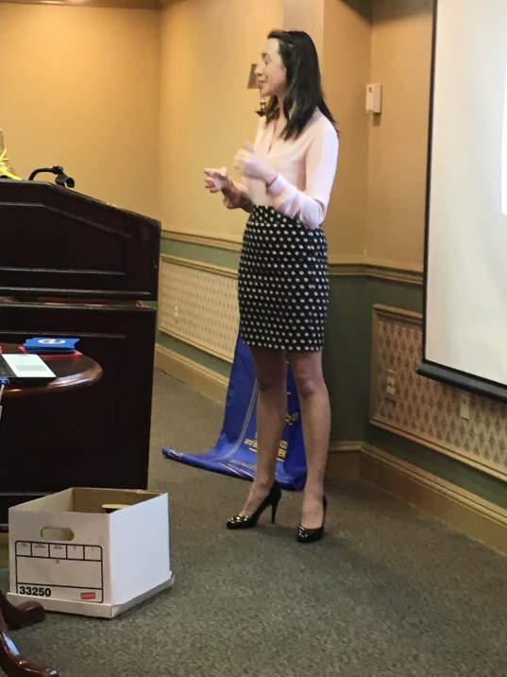
- Math engages the child wih tangilble sense of what numbers mean and look like. Pick up some number of maple dowels and put the correct number in the numbered counting box.
- Language starts by tracing large alphabetical letters, each with a sandpaper surface, to feel how that letter is printed. These kids are learning to print not to text.
- And Culture puts maps with older kids so the outline and shape of their country or state is seen and known. Elementary science labs are offered.
Each child works at her own pace; the teachers are observers and will nudge the child to give reasonable effort to all five hallmarks themes. Classrooms are of mixed ages; bigger kids can help the younger ones learn. All students are expected to be tolerant, show grace to classmates, and be curious in class and at home. The Montessori Academy in Morristown has students of 3 to 6 years old.

Leonard lance spoke about Congress. He’s the Congressman from our district and is home for ‘spring break’ from Washington.
- There are 75 municipalities in the district that includes the whole of Somerset and Hunterdon Counties and bits of Morris and Union.
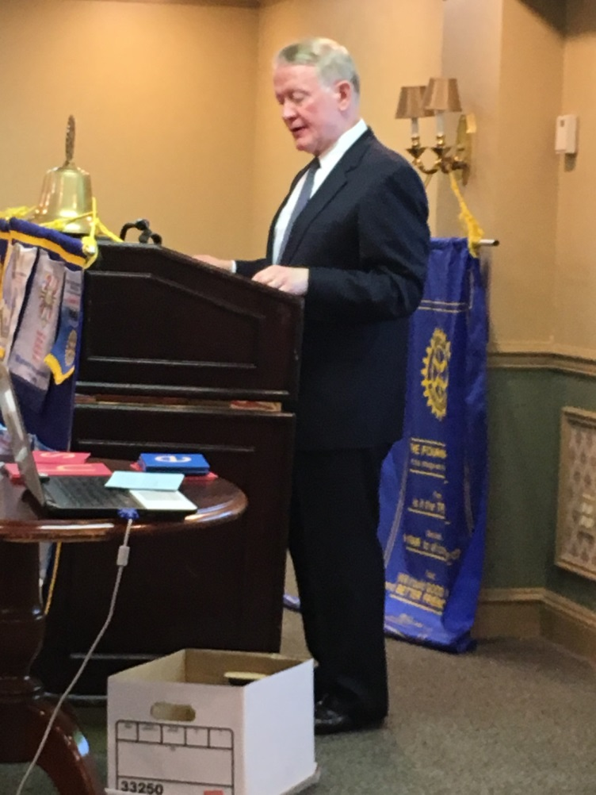
- Congress sees the economy as the primary issue this year, closely trailed by international issues. Curiously some key themes of both businessman Trump and Senator Sanders are resonating with citizens demanding an improved economy.
- When Mr. Lance entered Congress in 2009, the annual deficit was 1.4 Trillion $; now it is 0.4 Trillion $. But the national debt continues to soar.
- New Jersey is usually irrelevant in the nomination process as candidates are across the finish line in amassing delegates, but this year New Jersey and California, both with primaries on 7 June, can likely push the Republican convention to a contested vote, with no candidate having secured the majority of 1237.
- Leonard gave Rotary praise for serving communities and making them better. His twin brother, James, is a Rotarian in Hunterdon, so Leonard knows of Rotary’s role and work.

RERUN -- Track meet update by Terry Berger
The committee met and discussed plans for Rotary’s 66th annual Middle School Track Meet. We expect 10 schools and about 250 athletes to attend the meet on 19 May. Terry discussed some ways the ad book and the meet could be improved:
- Submit all ads early; publish book soon after meet; deliver book NLT first week of June.
- Electronic version of ad book will be on club’s website and offered to each school’s web site
- Schools will be invited to pay an admission fee; school parents can place TY ad.
- All ad information should be submitted to Tim; Rotarians should solicit ads from their contacts of last year; ask merchants with whom you do business to support the meet.
- Ad sales/solicitation pages were provided – see attached.
- Matt will procure shirts and format the ads for meet-shirt sponsors; ads will be one color.
- Meet officials will again to hired to conduct each track event.
- A thank you page will be added to our club website.

- RERUN -- Election of officers – The nominating committee has proposed an officer slate for the next Rotary year-=- see below. President Al has agreed to perform a second term. John Carpenter will run for VP and replace Jeff Rogers. Terry will run as Director and replace George Burd. Tim, Brad, Cheryl, Rosemary, and Bill are returning.
- RERUN -- Bernards Township Recreation Department and Rotary will collaborate to host a concert (Recreation Dept) and an Antique Car Show (Rotary) on 5 July 2016. Pleasant Park is the venue for the regular concert series; 3-500 people attend; this will be the first concert of the season. So, we have a fine opportunity to stage the car show and execute a successful fund-raiser. We will sell food and are open to other ideas for raising funds that day. All who attended the first planning meeting tagged this as a win-win and are happy to be working together on it. Put this date on your calendar, phone, tablet, and refrigerator. Al updated last week with – planning for 50 cars to be shown – preference will be given to local car owners – Township is preparing the banner – about 3-500 people are expected at the concert and another 200 attracted to the car show – Dave and Joel Shenman are collaborating on the trophies for the winning car/truck in each category. Rotary has the food concession; this is our chance for major success raising funds. All hands will be needed on deck to help organize and conduct this event.

- Adopt-A-Highway -- see the sign on US Route 202 -- first roadside clean-up 2 April -- wish for good weather.
If you want to pick up road debris and trash, you need to receive safety training from Justin. Call him.
Heard During Happy Dollars I’m happy –
To welcome spring and spice bushes 3 x To be here
9 x To enjoy our two speakers To have taken my first flight lesson last week
To report that my daughter just got a full-time job that she’s thrilled to have
To offer a signed hockey jersey and signed football for our club basket
To have gotten a signed Nascar certificate for the basket To have enjoyed a pleasant and blessed Easter
To have played seven days of gold during the last week To learn that I am becoming a grandma
Club Updates
- Rotary Shirts are available at $25.00. Wear yours at Rotary events.
- Remember the tip box at The Olde Mill Inn for our waitress, Blanca.
- If you do a makeup meeting or attend via E-meeting makeup, let Tim know of your attendance.

HISTORY OF THE ROTARY FOUNDATION
At the 1917 convention, outgoing RI President Arch C. Klumph proposed to set up an endowment “for the purpose of doing good in the world.” In 1928, it was renamed The Rotary Foundation, and was a distinct entity within Rotary International.

GROWTH OF THE FOUNDATION
In 1929, the Foundation made its first gift of $500 to the International Society for Crippled Children. The organization, created by Rotarian Edgar F. “Daddy” Allen, later grew into Easter Seals. When Rotary founder Paul Harris died in 1947, contributions began pouring in to Rotary International, and the Paul Harris Memorial Fund was created to build the Foundation.

EVOLUTION OF FOUNDATION PROGRAMS
1947: The Foundation established its first program, Fellowships for Advance Study, later known as Ambassadorial Scholarships.
1965-66: Three programs were launched: Group Study Exchange, Awards for Technical Training, and Grants for Activities in Keeping with the Objective of The Rotary Foundation, which was later called Matching Grants.
1978: Rotary introduced the Health, Hunger and Humanity (3-H) Grants. The first 3-H Grant funded a project to immunize 6 million Philippine children against polio.
1985: The PolioPlus program was launched to eradicate polio worldwide.
1987-88: The first peace forums were held, leading to Rotary Peace Fellowships.
2013: New district, global, and packaged grants enable Rotarians around the world to respond to the world’s greatest needs.
Since the first donation of $26.50 in 1917, the Foundation has received contributions totaling more than $1 billion.
https://www.rotary.org/myrotary/en/rotary-foundation/history-rotary-foundation
RERUN -- The Rotary Foundation and EREY – PDG Brad Jenkins
Rotary’s purpose is Doing Good in the World. Our Mission is to promote world understanding, good will, and peace. Grants are regularly developed and awarded to further the six focus areas:
Peace and conflict resolution Disease prevention and treatment
Maternal and child health Clean water and sanitation
Basic education and literacy Community and economic development

MEETING ASSIGNMENTS
Set-Up Greeter Invocation Sgt@ Arms Clean-Up
Officer Nominations for 2016-2017 year
President Al Swider
President-Elect Eric Zalis
Vice President John Carpenter
Treasurer Brad Jenkins
Foundation Treasurer Al Olsen
Secretary Tim O’Donovan
Immediate Past-president Cheryl Delgado
Director Terry Berger
Director Bill Deem
Director Rosemary Goodman

Membership
We have some prospective members interested in our club. Membership is being emphasized by President Al.
=======================================
Club Officers for 2015-2016 year
President Al Swider
President-Elect Eric Zalis
Vice President Jeff Rogers
Treasurer Brad Jenkins
Foundation Treasurer Al Olsen
Secretary Tim O’Donovan
Immediate Past-president Cheryl Delgado
Director George Burd
Director Bill Deem
Director Rosemary Goodman

Bernardsville Rotary’s Service Work in the Works
- Appear and do the meeting assignments we receive from President Al. Can do better here.
- Help with food distribution at God’s Co-op Food Pantry. Doing this at 100%.
- Track meet will be 19 May. This is a fun day. Don Ellis and Fred Waziak are invited should either be in the area.
- Help develop and execute our next Fund Raiser. Excellent progress on Car Show by President Al, John Carpenter, and Dave Reiley.
- Adopt-A-Highway project. We have Mile 37.5 to 38.5 of US 202 south. We’ll advance north [facing traffic] as we clean the shoulder areas. Mile 38.5 is just north of The Vine; mile 37.5 is opposite the PNC bank in Bernardsville.
- We have open nominations for local ‘sweat equity’ service projects. Bring ideas to Board meeting or Club meeting.

Continuing Business
- John Carpenter heads the Program Committee; alert John and Al Swider when you find a speaker for our meeting.
Our club serves
Basking Ridge Bernardsville
Far Hills Liberty Corner
Peapack-Gladstone
Rotary’s Four-Way Test
Of all the things we say or do –
- Is it the truth?
- Is it fair to all concerned?
- Will it build good will and better friendships?
- Will it be beneficial to all concerned?

