Pinion from The Rotary Club of Bernardsville
6 September 2016
Brad offered the invocation -- Be mindful of Rotary’s goals and objectives. Seek and take advantage of the opportunities to do good and further Rotary’s goals
Thirteen attended including our guest Andrea Testa. Andrea is the Director of Events and Lodging at the Bernards Inn. Andrea lives in Bridgewater and is interested in meeting more Rotarians and learning more about Rotary. Introduce yourself to Andrea and welcome her at the next meeting. Cheryl won the 50/50.
P1 President Al’s updates Induction of new member David Noyes
P2 Happy Dollars Membership Club Officers Membership
P3 Meeting assignments Service Work Queen of Hearts Four-Way Test
Ravi Anna, Al Swider, and District Governor Margit Cahill

Rotary’s Four-Way Test
Of all the things we say or do –
- Is it the truth?
- Is it fair to all concerned?
- Will it build good will and better friendships?
- Will it be beneficial to all concerned?
Visit our club web site. http://www.bernardsvillerotary.org

President Al’s remarks and updates
President Al and Rosemary inducted David Noyes. He is the Director of Finance at Couch-Braunsdorf Insurance in Liberty Corner NJ, Dave is a neighbor of Jeff Rogers, and we thank Jeff for bring Dave to Rotary. Dave is a Finance major from Dartmouth, has worked as a banker in Boston and New York, in finance with AIG, and is now with Couch-Braunsdorf. Dave’s other interests include Liberty Corner Presbyterian Church, numismatics club, and Dartmouth Alumni association.

We received two thank you notes.
- The first was from Evelyn Bigini who departed for the University of Pittsburgh this weekend. Evelyn was one of our scholarship winners from Basking Ridge. She will study nursing and take graduate work to qualify her for neonatal nursing.
- Camp Merry Heart thanked us for donating money to their Easter Seals campaign. Our donation was enough to purchase a IPad for use by camp attendees.

27 September is our next evening meeting at The Claremont Tavern.
5 October is Vocational Assembly at Pine manor in Edison.

9 October is WalkFest at Loantaka Park in Morristown.

5 and 19 October is God’s Co-op food bank ‘duty’ at Bernardsville Presbyterian Church.

12 November is UN Day for Rotary. A limited number of tickets are available and are quickly selling out. Join Brad and Rosemary and visit the UN with Rotary.

Heard During Happy Dollars I’m happy

5 x To be here and to meet David and Andrea
To have moved into a new house and to have the special someone in my life.
To continue to make plans for my trip to Zimbabwe and to see my daughter there.

2 x To offer a sad dollar that summer is over
5 x To meet David and welcome him to our club.

Club Updates
- Remember the tip box at The Olde Mill Inn for our waitress, Blanca.
- If you do a makeup meeting or attend via E-meeting makeup, let Tim know of your attendance.

Rotary’s purpose is Doing Good in the World. Our Mission is to promote world understanding, good will, and peace. Grants are regularly developed and awarded to further the six focus areas:
Peace and conflict resolution Disease prevention and treatment
Maternal and child health Clean water and sanitation
Basic education and literacy Community and economic development

MEETING ASSIGNMENTS

SET-UP GREETER INVOCATION SGT-AT-ARMS CLEAN UP
Sept Deem Berger B. Jenkins Lynn Duffy
Club Officers for 2016-2017 year

President Al Swider
President-Elect Eric Zalis
Vice President John Carpenter
Treasurer Brad Jenkins
Foundation Treasurer Al Olsen
Secretary Tim O’Donovan
Immediate Past-president Cheryl Delgado
Director Terry Berger
Director Bill Deem
Director Rosemary Goodman

Membership
Two persons have applied to join our club. Below is the required posting of the names and professions
- Jessica Chiaravallo---Branch Manager; Fulton Bank Bernards Office; Basking Ridge NJ. Jessica has attended several meetings and wants to continue doing service and volunteer work.

================================
Bernardsville Rotary’s Service Work in the Works
- Appear and do the meeting assignments from President Al. Today we were again three for five – OK effort.
- Help with food distribution at God’s Co-op Food Pantry. Doing this at 100%.
- We have open nominations for local ‘sweat equity’ service projects. Bring ideas to Board meeting or Club meeting.

Continuing Business
- John Carpenter heads the Program Committee; alert John and Al Swider when you find a speaker for our meeting.
Our club serves
Basking Ridge Bernardsville
Far Hills Liberty Corner
Peapack-Gladstone
Rotary’s Four-Way Test
Of all the things we say or do –
- Is it the truth?
- Is it fair to all concerned?
- Will it build good will and better friendships?
- Will it be beneficial to all concerned?

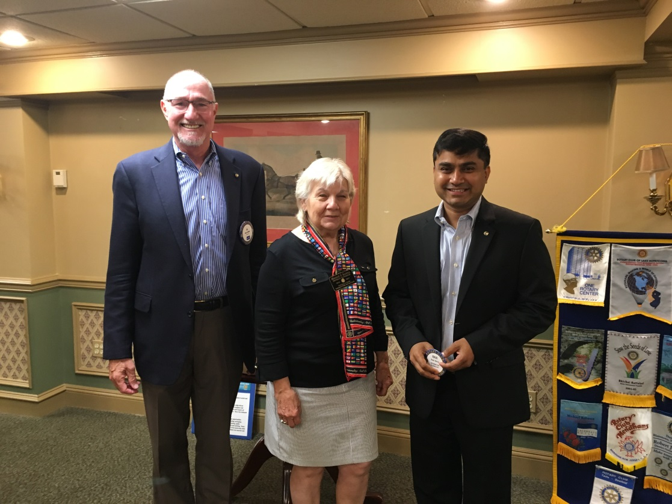
President Al Swider, District Governor Margit Cahill, and Ravi Anna

