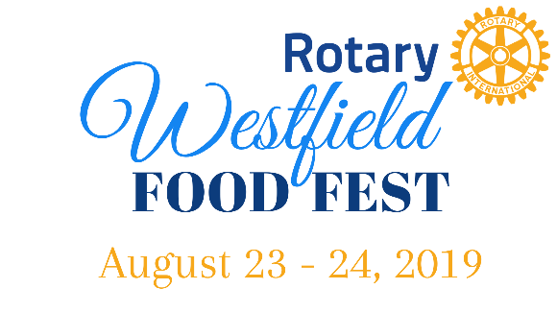
2019 Non-Food Vendor Opportunities
Please select the dates you wish to participate:
□ Friday, August 23, 2019 5:00-10:00pm
□ Saturday, August 24, 2019 12:00-9:00pm

Payments:

$0 – Nonprofits
$0 - Vendors demonstrating their craft (art demos, etc.) or offering a free service
$25 per day: Vendors selling products or services

Vendor name: ________________________________________________________________

Address: ____________________________________________________________________________ _____________________________________________________________________________

Phone: ______________________________________________________________________

Email: _______________________________________________________________________

Website: ______________________________________________________________________

Description of services: __________________________________________________________
________________________________________________________________________________________________________________________________________________________________________________________________________________________________________________________________________________________________________________________

Total amount enclosed: $____________
Please attach Hawker’s Permit

Please make checks payable to:
Rotary Club of Westfield
Attn: Food Fest
PO Box 754
Westfield, MA 01085

Thank you for your participation!

