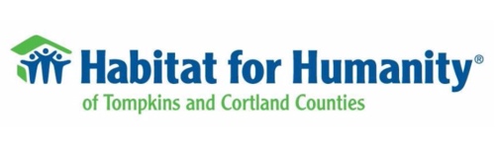

Dryden Holiday Celebration Gingerbread House Display
Hosted by Habitat for Humanity of Tompkins & Cortland Counties and Dryden Rotary!
Community groups are invited to build a gingerbread house to be displayed in Habitat’s office windows at 14 West Main Street. Houses will be displayed from Sunday December 1st thru Saturday December 7th.
On Saturday the 7th the community will be welcomed in from 10:00 until 4:00 for a closer look and to vote for their favorite! Formal judging will have taken place prior. The ‘Community Choice’ and ‘Judged’ winners will be presented awards at the Dryden Community Center Café after the tree lighting.
Any Dryden community group; service organizations, youth groups, churches, businesses, may enter. Due to space limitations we are only able accept the first 12 entries.
Registration forms can be found at: rotaryclubofdryden.org
Completed forms must be received by Friday 29 November. The $10 entry fee can either be sent with completed form or brought with the house at drop-off. All fees and any donations will go to Habitat.
Houses must be dropped off at Habitat’s office (14 West Main Street) between 4:00 and 7:00 PM on Sunday 01 December and picked up between 4:00 and 5:30 Sat 07 December.
Houses must be on a sturdy base no larger than 12” x 20”. Any information regarding the house, such as who made it, what it represents, etc. must be incorporated within the base
Questions? Send an email to: 7170drydenrotary@gmail.com

Registration
Complete the below and return by email to 7170drydenrotary@gmail.com or print it and mail to Dryden Rotary, PO Box 1007, Dryden, NY, 13053. Checks should be made out to ‘Dryden Rotary’
Community group name _______________________________________________________
Gingerbread House Theme _______________________________________________________
Contact name & phone # _______________________________________________________
$10 Fee (please circle one) Enclosed Will be delivered

