News Both Fit and Unfit!

Guest Speaker

Dan Smith, Fund Development & Volunteer Officer – YMCA, Binghamton Branch
Dan helps scholarship people have programs & services at the Y. A graduate of Vestal, Dan was a scholarship recipient himself and learned to swim at the Y.

Give over $527,000 in financial services
The Y is not just ‘gym & swim – youth sports, nutritional education, senior population, largest shelter in Broome County (87 rooms downtown) 100% occupancy year round.

Community Partnerships – prehab & rehab with Lourdes for Hip & Knee replacements

470 Volunteers

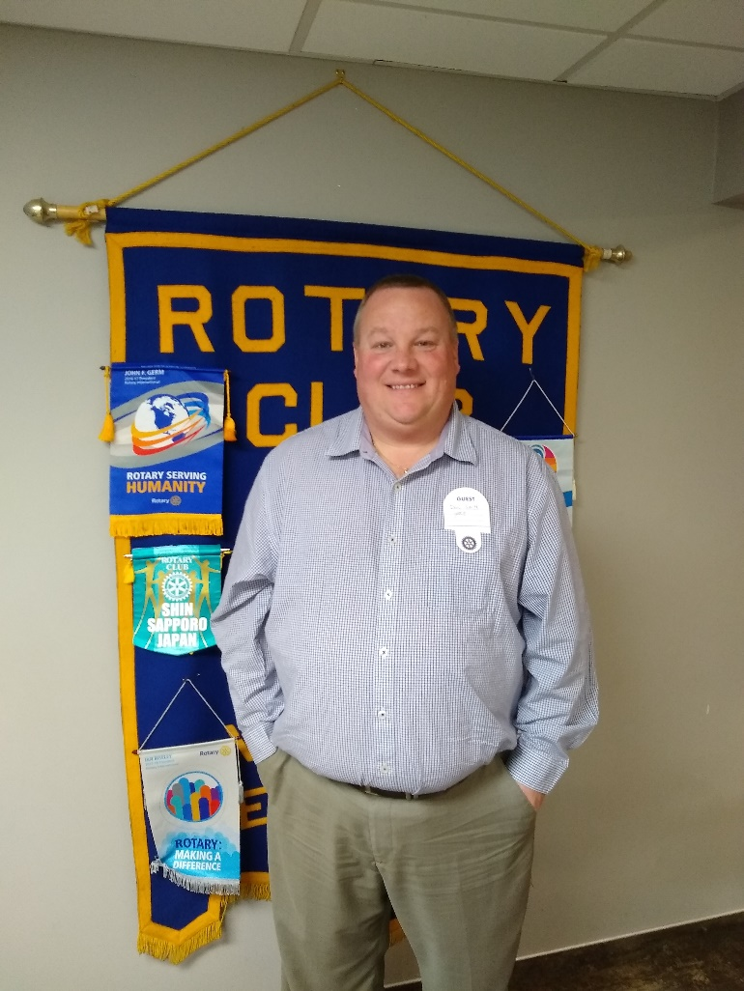

Guests:

Jash
Dan Smith, YMCA

Upcoming Speakers:
12/17/2018 Eldad Einav, MD
1/14/2019 Club Assembly

50/50

Jash, $19.00

Fine Master:

Aaron Martin, $40.00

Announcements:
12/24 – NO MEETING
1/7/19 No Meeting

Upcoming Events
- 12/17 Can Collecting #3
- 12/19 Can Packing 5:30 @ Town Water Barn
- 1/5/19 Kohls for Kids 10:30 North Entrance
Upcoming Celebrations
Birthdays:
12/19 Chambers, Julie
12/24 Conlon, Matt
12/31 Griffiths, Pete
1/1 Cordero, Roy
Mercincavage, Mike
1/7 Guiles, Neil I.
1/12 Costantino, Michael
J1/22 Welch, Lori
1/23 Myers, Kim
1/24 Nesbit, Nikki

Anniversaries:
None in December or January
CONGRATULATIONS TO ALL
Don’s Joke Corner:

"What would you get if you crossed a gorilla with the sixteenth U.S. president?".........Ape Lincoln!

Quote of the Day:

"If you work just for money, you'll never make it, but if you love what you're doing and you always put the customer first, success will be yours."

VESTAL ROTARY

2017-2018 Leadership Team
President Matt Conlon
1st VP/Fund Raising Siobhan Davey
2nd VP Vacant
Treasurer Teri Mahonski
Secretary Mark Capobianco
Programs Kevin Webb
Sgts-at-Arms Mike Mercincavage
International Service Siobhan Davey
Community Service Aaron Martin
Vocational Service Andy Papaleo
Club Service Jim Ward
Rotary Foundation Danielle Bulger
Interact Club Siobhan Davey
Vigilant Editor Rick Pedro
Dick’s Open Roy Cordero & Andy Papaleo
Holiday Food Drive Carol Belva
Membership Pete Griffiths
House Committee Ted Wolf
Public Relations Andy Papaleo
Member Relations Ed Budnikas
Club Historian Mark Capobianco
Coats for Kids Rob Flanders
Webmaster George Schwarztrauber
Immediate Past President Ted Wolf
Vestal Rotary Foundation George Schwarztrauber

ROTARY CLUBS FOR MAKE-UPS
MONDAY
Hillcrest | 12:15- Villa Tuscana in Chenango Bridge (Red & White/Lower Level).
Vestal | 12:15 – California Grill
Conklin | 7:00 PM – Maines Community Center
TUESDAY
Binghamton | 12:15 – Holiday Inn Arena
Endwell | 12:15 – Brother’s 2
Owego | 12:05 – Owego Treadway Inn

WEDNESDAY
Binghamton B-fast | 7:15 am – The Binghamton Club
Greene | 8 am – Varies
Colesville | 6:15 pm – Hitchin’ Post Rt. 7

THURSDAY
Endicott  Johnson City  Whitney Point | 12:15 – Nirchi’s Washington Ave.  7:30 am – Davis College  6:15 pm –Northern Broome Senior Center, 12 Strongs Place

FRIDAY
Nimmonsburg | 12:15 – Chenango Town Hall

2018 -2019 Theme

The Vigilant:
News, Notes and Nonsense of the Vestal Rotary Club
Club # 4903
www.VestalRotary.org
Monday, December 17, 2018
Reporting: Julie Chambers
Jashraj Chorawala Exchange Student

District 7170: District 7170
District Governor – Jeff Smith
International Zone # 29
National Rotary: www.Rotary.com

