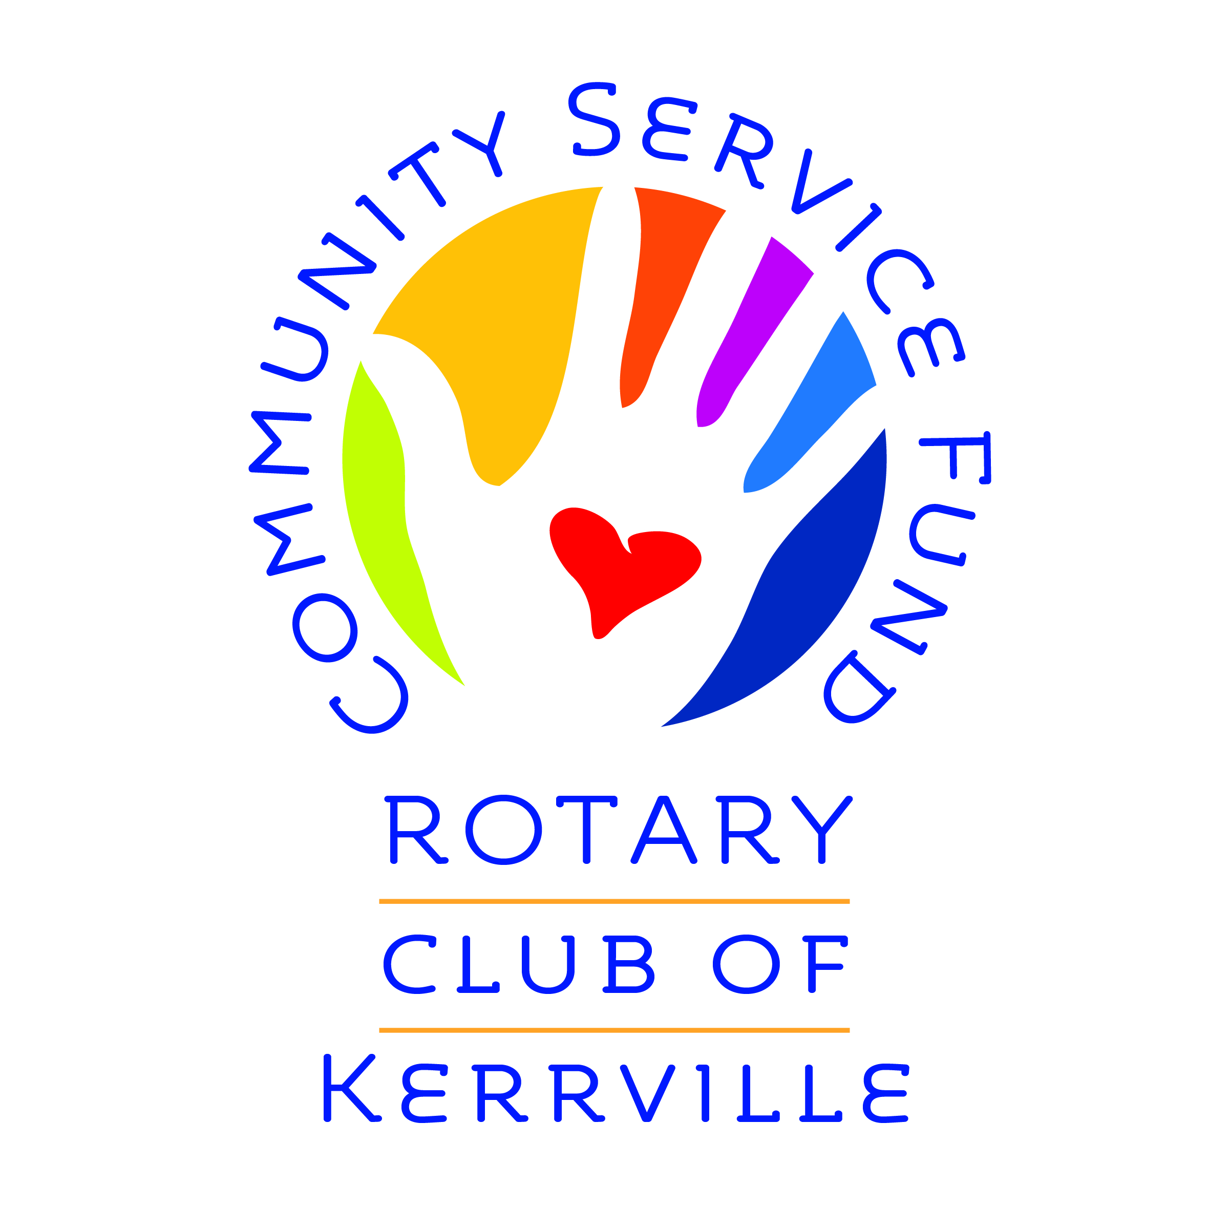

CORPORATE PARTNERSHIP AGREEMENT
The Rotary Club of Kerrville, TX invites _______________________________ (Corporate Partner Name) to participate in a new opportunity for club membership. Corporate memberships give local businesses, nonprofits, government entities, and corporations the chance to give back to the community while developing their employees’ personal and professional skills through Rotary. At many businesses, the CEO and other top executives may want to add Rotary membership to their resumes because they recognize Rotary’s reputation for combining business networking with community service. A corporate membership will allow your busy executives the chance to learn about the needs of their community so they can serve it well, while experiencing the personal satisfaction of knowing they’re helping others. Younger professionals will enjoy the flexibility of our corporate membership, which requires a smaller time commitment. Membership in Rotary provides young executives invaluable opportunities for taking on leadership roles while providing networking opportunities, mentoring and free online leadership training modules. By offering the perk of Rotary membership, you show young executives that your business cares about their personal and professional growth.
How Corporate Memberships Work
Several employees join together as members of the Rotary Club of Kerrville. Depending upon the number desiring Rotary Membership, each will be considered a member, with encouragement to send at least one person per week to the regular luncheon meeting. Although the business entity cannot be a Rotary member, it typically pays the dues for its employees’ Rotary membership and may be eligible for a tax deduction where permissible by law. Here are some other advantages of corporate membership:
- Flexible Schedule. Any of the members who joined together can attend a meeting — or all are welcome at the same meeting — adding tremendous flexibility and reducing the time commitment of any one member.
- Cost Savings. The price of membership is discounted for multiple members.
- Community Awareness. Executives can meet and socialize with other business leaders in the club, expanding their understanding of the community’s needs and wants, and get an insight into how businesses are addressing common concerns.
- Global Connections. Members of Rotary have instant access to our global network of 1.4 million members in 42,000 clubs around the world. Wherever you’re traveling, there’s likely a Rotary club with local business and community leaders who will welcome you.
- Networking Opportunities. Through Rotary, business leaders can make important contacts that can result in profitable business ventures in the future.
- Commitment to Service. Employees of the business recognize and appreciate the company’s commitment to serving others. Even if employees don’t join the Rotary club, service becomes part of the corporate culture.
- One Stop Source. Rotary is a productive use of an executive’s time. Instead of joining a variety of boards, each with their own unique focus, time commitment, and cost, Rotary is a comprehensive source where members can learn about many of the social issues and concerns in the community.
- Personal Satisfaction. Members experience the gratification of knowing that they’re helping people who may not have the means to help themselves.
Join us!
The Rotary Club of Kerrville meets on Wednesdays at noon at the Kerrville KROC. Join us as our guest to see if an individual or corporate membership is right for you. Call our Membership Chair, Brenda Thompson, at 830-377-7810 or email: brendathompson@dietertcenter.org.

Corporate Partners Application

Name of Corporate Partner: ___________________________________________
Address (#, Street, City, Zip): __________________________________________
Members: Name E-Mail Contact Phone
_____________________________________________________________
_____________________________________________________________
_____________________________________________________________
Type of Membership:
Corporate Partnership $3K Silver Corporate Partnership $5K
Gold Corporate Partnership $10K Platinum Corporate Partnership $15K
_____ Please Bill for Entire Amount
_____ Please Bill for Sponsorships & Other Expenses Separately

On behalf of _______________________________________, we agree to enter into a Corporate Partnership Agreement with the Rotary Club of Kerrville as stated above. We understand that the individuals we select as members will be full members of Rotary International, with the rights and responsibilities of membership. Dues for membership, club & international support and sponsorship should be emailed to: (Name) ______________________ (E-Mail):
___________________________________ (Individual selected for this purpose).

____________________________________ _____________________________ ___________
Name Printed Signature Date

For the Rotary Club of Kerrville:

____________________________________ _____________________________ _________
Name & Position Signature Date

