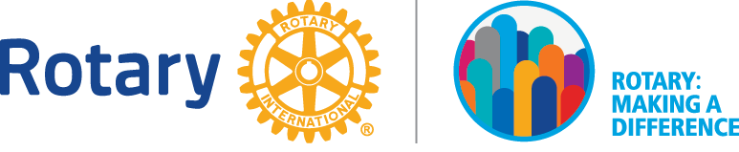

Dear Friend,

I am proud to be a Rotarian. As a Rotarian, our motto is “Service Above Self” and I am calling on you to help with South Tyler Rotary’s largest event of each year, our 26th annual Spaghetti Supper, April 26th, 2018. Traditionally, from this event, we raise over $30,000 from sponsorship sales from local individuals and organizations. With these funds, we support numerous non-profit organizations and causes. For example these are just some of the organizations South Tyler Rotary has helped with operations and projects:

Adult Protective Services Royal Families Kids Camp
Azleway, Inc. Salvation Army
CASA (Court Appointed Special Advocates) Samaritan Counseling
Children’s Advocacy Center of East Texas Sight.org
Christian Women’s Job Corps Smith County Champions for Children
Discovery Science Place Smith County Historical Society
East Texas Crisis Center, Inc. Texas Asthma Camp for Kids
JuniorAchievement United Way of Smith County
East Texas Cornerstone Assistance Network North Tyler Day Nursery

Please consider being a sponsor for this year’s event, to be held from 5:00 to7:00 on Thursday evening, April 26th, 2018 at the First Christian Church Family Life Center (Loop 323 @ South Broadway). The sponsorship levels are as follows:

Regular Sponsorship $100
(Includes 10 supper tickets and your name on printed material at the event.)
Silver Sponsorship $200
(Includes 20 tickets & enhanced recognition on printed material plus recognition by KTBB’s Bill Coates on his live broadcast of the event.)
Gold Sponsorship $300
(Includes 30 tickets and special recognition on printed material, at the supper, and on-air with KTBB’s Bill Coates on his live broadcast of the event.)
Platinum Sponsorship $500
(Includes up to 50 tickets and exclusive recognition on printed material, at the supper and on-air with KTBB’s Bill Coates on his live broadcast of the event.)
Diamond Sponsorship $1,000
(Includes up to 100 tickets and all the above plus a scholarship will be given to a local high school student in your name.)

The attached invoice form gives more details regarding tax deductibility of the contribution and the distribution of sponsorship proceeds. If you are a former sponsor, thank you for your previous support! If you are a first time sponsor, please call or e-mail me with any questions. I would be more than happy to discuss the project with you. Additionally, please consider becoming part of Rotary. Our club is a great organization that does a great amount of good not only locally, but around the world. I would love to have you attend one of our meetings to see what Rotary membership is all about. We meet each Monday at noon at the First Christian Church.

