Tanzania Wheelchair Project – A Potential Life Changing Gift
In early 2017, the Wheelchair Foundation UK, founded by Rotarian Milton Frary, initiated a project to send a container full of wheelchairs for use by disabled people in Tanzania. The Tanzanian Consulate in London supported the project by adding 20% to every donation made by a Rotary club.
Working once again with the Rotary Club of Moshi, a town in the shadow of Mount Kilimanjaro, Milton assembled contributions from 25 clubs, including Jersey RC and the Rotary E-Club of London Centenary to fill the container. Together with a grant from District 1130, London Centenary was able to contribute £2,000, which together with £400 from the Consulate, was enough to fund 33 wheelchairs.
Jo Ann Ross, a London Centenary RC member living in Harare, Zimbabwe, travelled to Tanzania in early November to be present for the handover of 110 wheelchairs by a Tanzanian government commissioner in Moshi on 11 November 2017. The impressive ceremony was attended by a good crowd, several radio and TV crews as well as journalists.
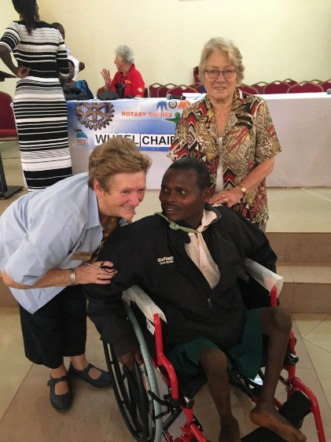
A delighted recipient with Elaine Frary and club member Jo Ann Ross (standing).
This man, (Michael) came in wearing a pair of well- known branded trainers on his knees to enable his getting around. His knees had been locked back for so long – it took some adaptation to make him comfortable!

There were many emotional stories that morning when recipient adults were carried into the presentation area with stories of how they could not go with their families to Church or children to school or participate in out-side activities. Many were confined to their bedside - rarely to even go outside.
Receiving a wheelchair is not only life-changing for the recipient, it is also a relief to the family members and others who help the disabled to get about, often over difficult terrain.
Wheelchairs funded the by E-Club of London Centenary are identified by having the name of the club embroidered on a badge sewn to the wheelchair.
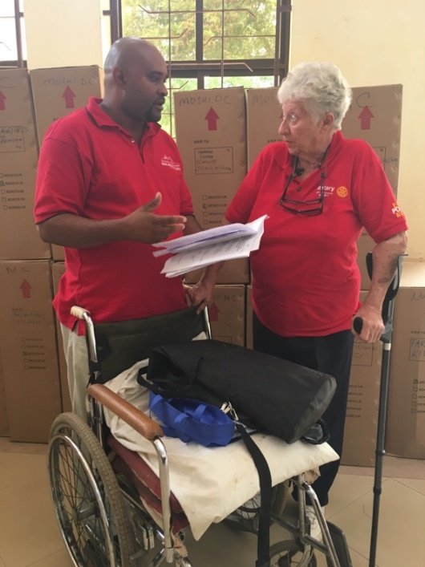  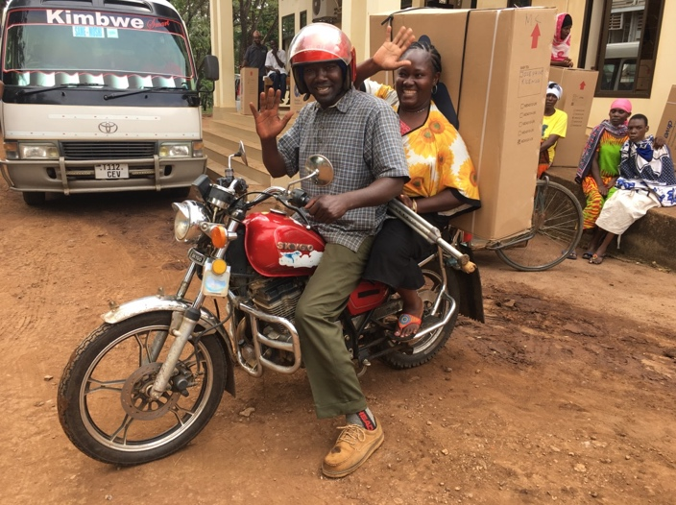 | Pic shows Rtn Faye Cranswick seen here discussing procedure with Asst. Governor Amon William responsible for the Kilimanjaro Zone, District 9211 (includes Tanzania and Uganda).  Faye not only spearheaded and managed the whole operation, but hosted Milton, Elaine and Jo Ann for a few days! She is widely known and is fondly referred to as ‘Mama Kuku’ as she has three chicken farms  Bottom left shows the one of the delighted recipients being taken home on her husband’s motorbike with the huge box tied to the back.  All boxes are clearly identified with size and name. Boxes are often put to good use as mattresses in some areas.  


