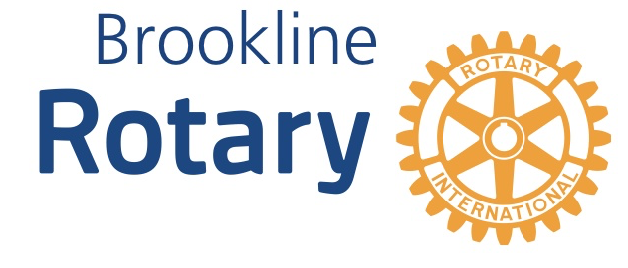
Rotary Club of Brookline 26th Annual
Pancake Breakfast, March 30, 2019
8:00 am-12:00 noon, Brookline High

Sponsorship Form
In support of the Rotary Club of Brookline and its many charitable activities, I wish to be a Sponsor for the 2019 Pancake Breakfast, BHS Cafeteria, 115 Greenough Street, 8:00 am-12:00 pm.

Please circle (checks made out to Brookline Rotary Club)

$400 Celebrity Chef Sponsor
- One chef hat with company/organization name and the rights to serve pancakes for 30-60 minutes. This spot has the highest visibility in the event. Chefs are free to roam the cafeteria when not serving.
- Table/chair for literature in the hall leading to the cafeteria.
- 3 individual posters with company/organization name and logo hanging in the in the cafeteria.

$250 Silver Sponsor
- Table/chair for literature in the hall leading to the cafeteria
- 3 individual posters with company/organization name and logo hanging in the cafeteria.

$200 Bronze Sponsor
- 3 posters with company/organization name and logo hanging in the cafeteria.

Business Name/Contact Name: _____________________________________________________________

Address: _____________________________________________________________

Phone ________________ E-Mail:_____________________________________________
Please make checks payable to Brookline Rotary Club, and mail to Brookline Rotary, PO Box 136, Brookline MA 02446. Thank you for your generosity and support!
After March 15, 2019, please also send this form via email to brooklinerotary@gmail.com to make sure you are acknowledged at the breakfast.

