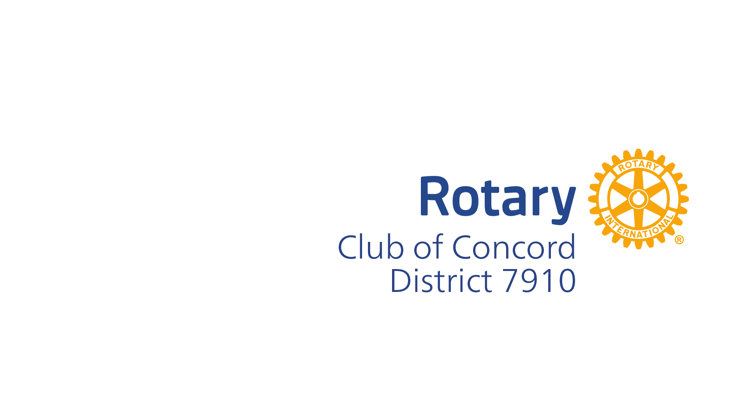
How do I become a member? The Rotary Club of Concord accepts new members by invitation, but first we need to know that you are interested. Simply come to a meeting (time/place available on our website), contact us via email (Thereseoliver@kw.com) or ask a friend who is a member to bring you to a meeting. Becoming a Rotarian connects you with a diverse group of professionals who share your drive to give back. As a member of the Rotary Club of Concord you will:
• Change lives: You’ll learn about your community’s needs and discover creative ways to meet them.
• Invest in yourself: Expand your leadership and professional skills through workshops, conferences, speakers offered by Rotary.
• Connect with other passionate people: Catch up with good friends and meet new ones creating meaningful relationships that last a lifetime.
Get in touch to learn more. We would love to meet you. Therese Oliver- Membership Chair
Rotary Club of Concord MA www.rotaryclubofconcord.org

