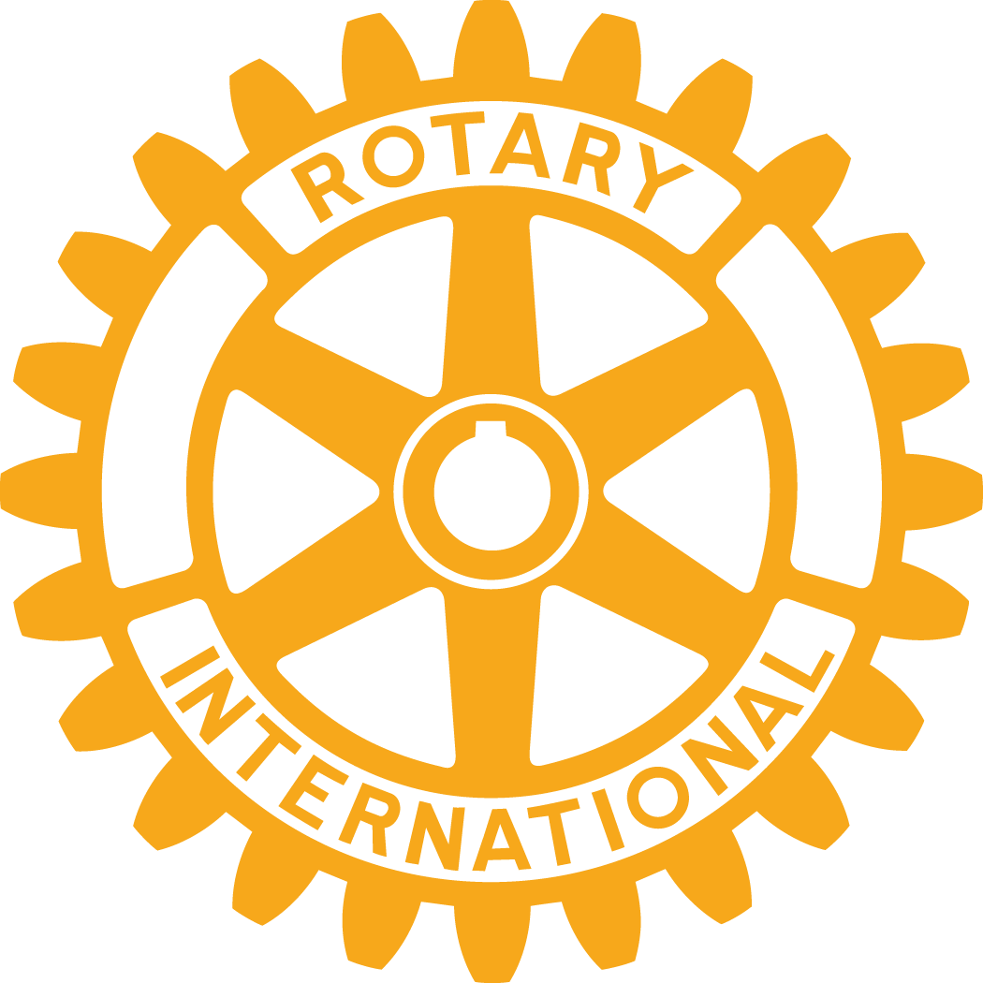
Rotary Club of Concord
Box 451, Concord, MA 01742
www.concordmarotary.org

Rotary Club

Contact: June Grace
Telephone: 978-697-3666
E-mail: junergrace@comcast.net

Date: Sept 4, 2015

On Aug. 24 the Rotary Club of Concord held the 27th Annual Golf Tournament to support scholarships through the Concord Carlisle Scholarship Fund. The Rotary Club, a community affiliate of CCSF, appreciates its support. Since becoming an affiliate in 2006 Rotary has awarded 96 scholarships totaling $149,300. Proceeds from the 2015 tournament will increase that total considerably.

The weather and the course at the Concord Country Club contributed to a spectacular day of golf. The tournament’s first place winners comprised the team of Kevin Balboni, Gary Berlam and James Kallfelz. Second place went to Tom Godwin, Jared Malladi and Ed Bloom. Closest to Hole #6 were Sheila Watts and James Kallfelz. Sheila Watts won again in the women’s category, making the longest drive on #18, while Jed Niemand claimed that honor for the men. A challenging contest on Tee #1 was “Whack the Quack” claimed by Gary Berlam who hit a rubber ducky farther than most ducks can fly!

Rotary credits the tournament’s success to the support of sponsors, golfers and volunteers. We would like to thank our Platinum Sponsors, Emerson Hospital, Deaconess Abundant Life Services, and Spaulding Management LLC. and Lunch Sponsor Hammond Residential Realty for their generous support. Tee and Green sponsors included Adesa/Concord, Acorn Deck House, Barrett-Sotheby’s Real Estate, Benchmark Senior Living in Lincoln, Birchwood Hills Townhouses, Brookside Square Apartments, Cambridge Savings Bank, Cambridge Trust Co., Colonial Chevrolet, Colonial Inn, Concord Flower Shop, Concord Funeral Home, Concord Optical Company, Concord Teacakes, Dolphin Insulation, Dow Law Group, Dunkin Donuts, Ed and Debbie Fitzgerald, Edward Jones Investments, Electrical Dynamics, Inc., Engel & Volkers, Enterprise Bank, Fenn School, Frank Maurer Co., Gerald Paolilli, Good School Realty, Idylwilde Farms, In Memory of Bill Bott, Bill Eaton, and Tom and Vicki Huckins, Lyon-Waugh Auto Group, McWalter-Volunteer Insurance, Middlesex Savings Bank, Middlesex School, Midnight Painters & Carpenters, Minuteman Arc Human Services, Nashoba Paving Co., the Newell Family, Period Realty Trust, Phillips Fine Paint & Design, Rosario Mario F. Rizzo Law Offices, Sierra Nevada/Craft Brewers Guild, Rotary’s Sunrise Satellite, The Sharing Foundation, West Concord 5&10, Wicked Wines, and Woodman and Eaton, P.C. Additional supporters included Dee Funeral Home and Cremation Services who sponsored the hole in one contest, and Action Unlimited, Ken Anderson, Colonial Florist and Gardens, Colonial Motors, June Grace, Richard Nelson, Frank Rigg, Salem Five Bank, James Tabner, John Taylor, Vincenzo’s Restaurant, and West Concord Wine & Spirits.

An online and silent auction added fun to the evening, and more scholarship dollars. Donated auction items included: breakfast with Concord’s Firechief, jewelry from Artinian Jewelry, a tour of the Kennedy Presidential Library, fishing with Capt. Kirk’s Fishing Charter, and a Tuukka Rask autographed puck and photo. Bidders vied for gift certificates to Waxy O’Connors, Colonial Gardens, Busa Wine and Spirits, Kings Bowling, Northeast Technology, Comellas, Starbucks, Tavern in the Square, Not Your Average Joes, Concord Cookware, Comina, Rocky’s Hardware, Burton’s Grill, Café Luigi, Firebox BBQ, Flatbread Company, Kohls, Lexxx Restaurant, II Casale Restaurant, Saltbox Kitchen, Boston Red Sox, The Discovery Museums, Concord Flower Shop, Twin Seafood, Nashoba Bakery, Edge Sports Center, Kennebunkport Inn, Orchard House, and the Holiday Inn Boxborough. Golfers bid on chances to play a variety of venues including Concord Country Club, Maynard Country Club, Nashawtuc Country Club, Pine Meadows, Stone Meadow, and Stow Acres There were baskets of wines donated by West Concord Wine and Spirits, and an especially popular Evening of Wine Tasting at West Concord Wine and Spirits with dinner at Vincenzo’s Restaurant.

The tournament was chaired by Joe Saia, Phyllis Maurer, Dick Nelson, and Rick Beers with help from an active committee and many Rotary members. Sharon Spaulding and Ann Trudeau spearheaded the online auction and Phyllis Maurer, Hilary Taylor and Steve Levitsky promoted the onsite auction.

Rotary is an organization of business and professional leaders united worldwide in humanitarian service with more than 1.2 million members in more than 33,000 clubs in over 200 countries. In Concord, Rotary is a great club of over 75 members, men and women. To make attendance convenient, members and guests may choose from one of two meetings each week…breakfast on Tuesdays from 7:30 until 8:15 a.m. and lunch on Thursdays from 12:15 until 1:30 p.m. Both are held at the Colonial Inn. The Rotary Club of Concord’s projects, like the golf tournament, focus on giving back to the community both here and beyond. Learn more…Attend a meeting. Visit the Rotary Club of Concord website, rotaryclubofconcord.org. Find us on Facebook and Twitter.

