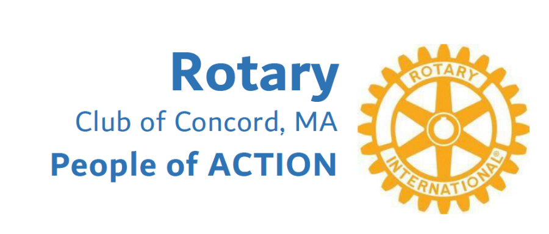

Serving Concord and Surrounding Communities
for 95 years!

The Rotary Club of Concord is a vibrant group of people who actively seek to better the world through humanitarian service. We are local business owners and civic minded citizens who work together to support our community and people in need around the world.

Our Club is part of the Rotary International global network with 1.4 million members in 46,000 Clubs in 180 countries. We meet three times a month in hybrid meetings featuring local speakers, and frequently sponsor Rotary service projects. We enjoy the fellowship of working together in support of other non-profits including Open Table Food Pantry in Maynard, the Concord Council on Aging, the Boys and Girls Club of Assabet Valley and Habitat for Humanity.

Each year we raise money for youth scholarships. We support Interact Clubs at Carlisle Middle School, Concord Middle School and Concord Carlisle High School. Interact clubs are Rotary-sponsored youth clubs that provide an opportunity to participate in fun and meaningful service projects while developing leadership skills and making new friends. The basic principle of Rotary Interact is to help others. Students create their own service projects and raise money to carry them out.

As a member of Rotary District-7910, covering central Massachusetts, the Concord Club has access to resources around the world. A service project begins with a member and is funded through donations to the Concord Rotary Charitable Endowment (501c3) or the Rotary Foundation, a 501c3 non-profit. If you would like to create positive change in the world, please contact us at info@rotaryclubofconcord.org We would like to invite you to attend a meeting and get to know how we make a difference in the world.



