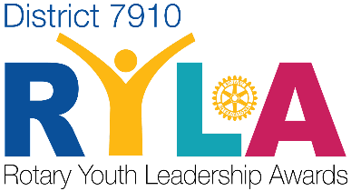
Where Leaders Emerge
RYLA Application .
At RYLA, a specially designed three-day student conference, sophomores are given the opportunity to develop their leadership potential. Through interactive leadership sessions with peers, inspirational speakers, and challenging mental and physical activities, students will learn vital skills to grow into leadership competency. While having fun, attendees will actively practice: critical thinking, decision-making, effective communication, how to adapt to change, how to develop and show empathy, and motivate others to act in the name of community service.
RYLA is June 21,22, 23, 2024 Fitchburg State University
Submit to:
Name: Sherrie Whittemore Email: SherrieWhittemor@aol.com Due Date: March 29, 2024
M Marcg 12, 2024
www.RYLA7910.org is the site for additional information
Attention Applicants:
- The entire cost of attending RYLA will be paid by your Framingham Rotary Club.
- Successful applicants will be required to provide a medical history and liability waivers.
- Attendees are REQUIRED to ATTEND the ENTIRE CONFERENCE and must remain on campus until the end of the program on Sunday. Exceptions will not be made.
Complete this application and submit it according to the instructions by the due date. March 29, 2024
All applications received will be confirmed by email.
You may fill out this application by editing this document digitally or ask your representative how you can fill out a google form for easy submission.

First Name:
Last Name:

Age:
Gender: ___ Female ___ Male ___ Other

Street Address:
Town/City:
State:
Zip:
Phone:
Email:

High School:
Grade:
School Reference
Name:
Phone:
EMail:
Personal Reference
Name:
Phone:
EMail:

Tell Us About Yourself

For the remaining questions you may provide information and examples from your school and non-school activities. Also, please extend the sections to provide as much detail as you would like to include.

Interests/Talents/Hobbies(music, sports, acting, writing, debating, etc.):

Extra-curricular activities:

Service activities:

Leadership positions:

Awards(school and civic):

What profession(s) are you considering exploring/pursuing after high school?

Signed (digital): Date:

This area for Admin Use Only:
Interview Date: Time:
Att / Alt Club Interviewer(s):
Notes:

