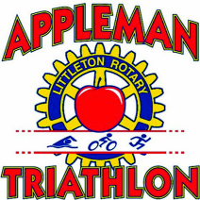
Littleton Rotary
AppleMan Triathlon
July 19, 2015
Sponsorship Rates

Gold -- Logo on Banner across Route 2A, Logo on Poster & T-Shirt, Corporate Banner at Event, Event Program, Table at Event & Webcast Exposure $1,500.00

Silver -- Logo on Poster, T-Shirt & Corporate Banner at Event, Event Program,
Table at Event, & Webcast Exposure $500.00

Bronze -- Logo on T-Shirt, Event Program, Table at Event & Webcast Exposure $250.00
Company Name
Contact
Mailing Address
City State Zip
Phone # E-mail ______________
Rotarian __________________ Amount $______

Any questions please contact:
Roger Hartley at: rhartley48@gmail.com 978-490-4273
Logos must be in electronic format (jpeg/tif), size 2"x3
Make check out to: Littleton Rotary Club and return to:

Littleton Rotary Club
P. O. Box 313
Littleton, MA 01460

