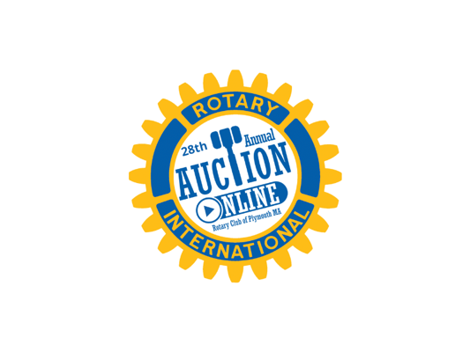
Dear Friend of Rotary,
The Rotary Club of Plymouth is excited to announce that our 28th Annual Rotary Auction will occur between March 1 and March 19, 2023. And once again we will be holding the auction virtually, on the Bidding Owl Platform, with a limited live broadcast on PACTV on March 19th. Although our first 25 auctions were held in person over a period of 3 days, 2 years ago we switched to an online forum. Much to our delight, we were able to reach a wider audience and raise over $50,000 that will be disbursed throughout the upcoming year to various organizations, non profits and causes- locally, nationally, and internationally. Your contributions have enabled us to support over 60 grants, including:
Greater Plymouth Food Warehouse Plymouth Area Coalition for the Homeless
Plymouth Public Library Kingston Public Library
The Plymouth YMCA camperships Scholarships to the three area high schools
The Fragment Society Cranberry Hospice
Hydrae for Heroes BID Plymouth Hospital
Brain Aneurysm Foundation Shelter Box USA
Pilgrim Hall Children’s Programming Plymouth Center for the Arts
If you have donated to our previous auctions, we thank you and ask that you continue to support the Rotary Club of Plymouth. Your contribution was and will be truly impactful. If you haven’t donated in the past, we hope that you will consider making a difference in the lives of many in our community by making a contribution of a service, a new item, or a gift certificate valued at $25.00 or more.
For information on how to donate items or questions regarding the auction, please contact us via email at plymouthmarotaryauction@gmail.com. Otherwise, a Plymouth Rotary Club member will be contacting you shortly.
Sincerely,
Jeff Cohen
Vice President and 2023 Auction Chair
Rotary Club of Plymouth, Inc.

