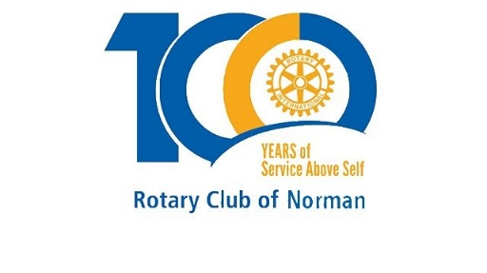**Norman Rotary COVID-19 Crisis and Response**

**Saturday, March 28, 2020**

**1pm via zoom**

Thank you to all of our Rotary club members who joined us for our first zoom virtual meeting Saturday at 1pm, we had around 40 members join us for this special meeting update on COVID-19 and our own Rotary community leaders on the front lines shared how we can help and refer help to others:

Norman Public Schools: Superintendent Dr. Nick Migliorino:

* School is now providing free meals weekly, instead of just daily, to students 18 or younger regardless of whether they attend NPS from 11am to 2pm every Monday at each NPS school site via drive through style car lines. Some exceptions apply for older students can receive free meals.
* The “Teacher Parades” are a national movement and a big hit in Norman says Rotarians, parents and students seeing teachers, principals and staff driving around their respective neighborhoods honking, waving and holding up signs. Many of us were very so moved by this!
* Any other updates or info visit: <https://www.normanpublicschools.org/health>

Norman Regional Health System - Kyle Hurley, Systems Manager of Emergency Depts

Oklahoma State Department of Health website for the latest on COVID-19 resources, hotline and data. <https://coronavirus.health.ok.gov/>

NRH Foundation, Erin Barnhart, Director

In response to COVID-19, the Norman Regional Health Foundation is seeking community support to mitigate a pending nationwide shortage of personal protective equipment for our healers at Norman Regional Health System. The safety and well-being of our patients and NRHS healers are our top priority. To learn more visit: [www.NRHFoundation.org/care2020.org](http://www.NRHFoundation.org/care2020.org)

**Financial Support**

To support the health system and our front-line healers during COVID-19, financial contributions can be made at: [CARE2020 Online Gifts](https://app.mobilecause.com/form/PSKlkA?vid=2sjua). These gifts are restricted to the fight against COVID-19.

**Product Donations**

**At this time, we are asking our generous community to assist in any way possible with a donation of the following items listed in order of priority:**

* PAPR Hood 3M Model S-133S-5
* N95 Masks
* Surgical/Isolation Masks
* Protective Isolation Gowns/Ponchos
* Super Sani-Cloth Germicidal Disposable Wipes by PDI Model Q55172
* Temporal Scanner Thermometers
* Protective Eyewear
* Mini-tipped Swabs:  Submitted in UTM or VTM only, Individually packaged as sterile, DNA free, and RNA free
* Virex Plus Diversey
* Germicidal Bleach4 Clorox
* Face Shields/Clear & Protects Face
* Hand Sanitizer 70% Alcohol

**Product donations can be dropped off at Cleveland County Fairgrounds on Monday/Wednesday/Friday between 3:00pm-5:00pm. Cleveland County Fairgrounds,** Southside of Arena, 615 E Robinson

The Foundation is also going viral to fight this virus! We asked several popular Oklahomans to create handwashing videos and then challenge others to do the same. Check out Norman Regional or the Norman Regional Foundation Facebook page to see these videos and share. The first familiar face is OU Women’s Basketball Coach Sherri Coale, then we have Dr. Kate Cook, Dr. James Bond and Norman’s own Coach Press Taylor. Stay tuned for more! [https://www.facebook.com/NormanRegionalFoundation](https://www.facebook.com/NormanRegionalFoundation/?__tn__=kC-R&eid=ARCal0v_xlkViX4-IL5fd5Kz5aY_J2pLXDidkP1COTroOb3EyKXNTGY0SBrD4OtfzCUjxmF-Qv8E7RmE&hc_ref=ARS0lHg3Lr-6o_oez_NArnS3UBvIWoGZ6VeSymAtUj0s4LXQXTsjkk_VyPj0ZV9RId0&fref=nf&__xts__%5B0%5D=68.ARDdGnCw5YxyS4bmUm2znrL4qAU_Y5WFkyXcdT1J060ZdbiB1YY75JfEwikOOsvOFPKA2VDuBHajVwtRR8mkap7KIYSv168uZKzmW1ySWFetbVtSMqIToqeN0NYf_jJ1AmcCcNQT_m5nvCem0AKIVIWVpQg-Iv7wRg6lqU4b6RoY9OF2TqpkFuzjcXnKzrFzlWQ0pn6Eq3yRFot3AnuWEWwrAUYWyS2KDymlSOFVLO9yQDRvtKztPaGvrXHbKsFqUZu562sgG_wbtsVHPwK2XDtagWhnUT8pI5VtNRWFKT8UeEkAP_yaSiqJR9J6jHGP85Wp01GsCTYrHLiTyYtC1mXKgs2MiE9p0u7bQ0AQAzc62mUkDmIoGYcAJPHlaXDbYNw0sislvp5rm11T-qianMCwWTgpgMGRFq25QkjGFkE383tXn0Qk_fa0K2oqZIZI22AMGi-2mjRb5hJMmAx9Fif9EyOL3gNo5vQsdolbXK9aDXffw2gB3Wx18tDgfKQ8DjTU)

**Sing your favorite Rotary tune and wash away!** Tag your video and challenge other Rotarians:  #StopTheSpread  #FlattenTheCurve  #WashYourHandsOK  #NRHFoundation

**Please call the Foundation at 405-307-1077 with any questions.**

United Way of Norman, Daren Wilson, President & CEO

* **UNITED WAY OF NORMAN COVID-19 RESPONSE AND RECOVERY FUND -**Financial help is now available for people who are struggling to pay their rent and utility bills due to COVID-19. United Way of Norman is partnering with Food & Shelter to distribute funds collected through the United Way of Norman COVID-19 Response and Recovery Fund.  Donate or visit: <https://www.unitedwaynorman.org/covid19>
* If you are in need of assistance, you can also contact 2-1-1. This information referral line has the latest information on the resources available in our community. You can also find information on the 2-1-1 website below.  **Call** 2-1-1, **Text** Your zip code to 898211, **Online Chat** [**Click here for online chat with 2-1-1**](https://home-c11.incontact.com/inContact/ChatClient/ChatClientPatron.aspx?poc=b18c7721-96d2-4f8a-8f36-05b650ef7221&bu=4594083) **Online Resource Guide** [**https://211oklahoma.org/**](https://211oklahoma.org/)

Cleveland County Commissioner, Darry Stacy

Get farm fresh goods, and support local businesses and farmers - The weekly Norman Farm Market is closed to walk up business but customers are able to pick up orders placed in advance. For more information on how to place orders and to see a list of participating farms, go to [www.clevelandcountyfair.org](http://www.clevelandcountyfair.org)  or search Norman Farm Market on social media. A list of participating vendors also is available at <https://www.canva.com/design/DAD2zw6v2fE/view>.

The Virtue Center, Teresa Collado, Director

**Free, Local, Confidential Help is just a phone call away!** Your Mental Health Matters! 405-321-0022. Speak to a supportive professional during this difficult time.  Available Mon – Thurs. 8am – 6:30pm, Friday 8am – noon. After Hours: call Reach Out Hotline toll free 800-522-9054

Griffin Memorial Hospital, Hank Hartsell, CEO

In response to the COVID-19 virus, ODMHSAS has streamlined hiring processes.

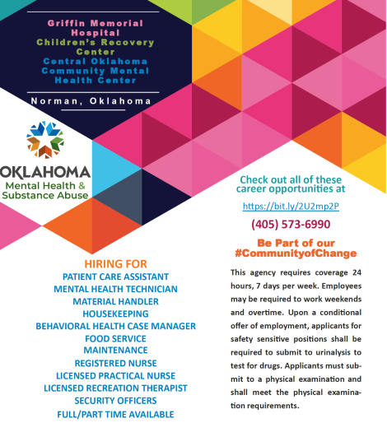

Public Health Institute of Oklahoma – Jill Hazeldine, Director

* Oklahoma COVID-19 Data: Get access to live, county-level COVID-19 map for Oklahoma
* <http://publichealthok.org/covid-19/>
* PHIO is offering county health coalitions across the state to be facilitator so they can hold their meetings virtually using the zoom platform.

Norman Rotary Club updates:

In alignment with Rotary International’s mission to help eradicate infectious viruses and help mitigate the spread of the corona virus, along with government official’s orders and recommendations, and most importantly in the best interest of our member’s health and safety, the Norman Rotary Club will not be meeting in person in April. WE WILL however be convening via Zoom virtual meetings each Thursday at 12noon and able to do so with most of our already scheduled speakers.  Bueno Brunch is postponed for now. More information coming soon!

Thank you, Rotarians, for your service to help us through this crisis. We are in it together and lucky to have such great community leaders and Rotarians work together. Stay Safe!  #LoveNormanRotary.

