Club History and the Annual Report
The following shows how to navigate to the 2019-20 annual report from our homepage.
First select “History” from the “Members Only” menu
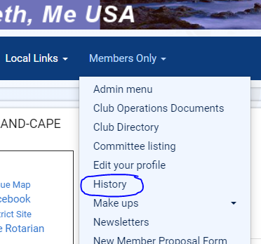
Here everything is organized by Rotary year. Work is ongoing, board reports, including financials are available from 2009 to 2016, as well as 2020-21. Reports for 2016-17 are in hand and will be added soon. After that the gap from 2017 to 2020 will be closed.
So select 2019-2020
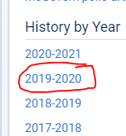
Two items to note. First is the bulletins are listed, and second the link to the board documents, which is circled. Note that when you select the board documents you will need to log into the system, this material is restricted to members.
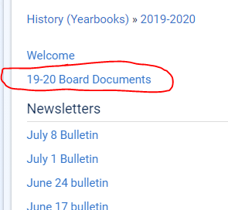
After selecting the board documents you will see
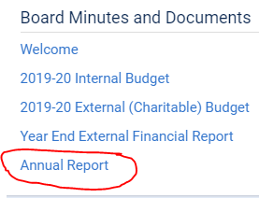
Click on Annual Report to view it.

