Boys & Girls Clubs of Southern Maine
50 Year Anniversary Recognition

The framed award looks like this:
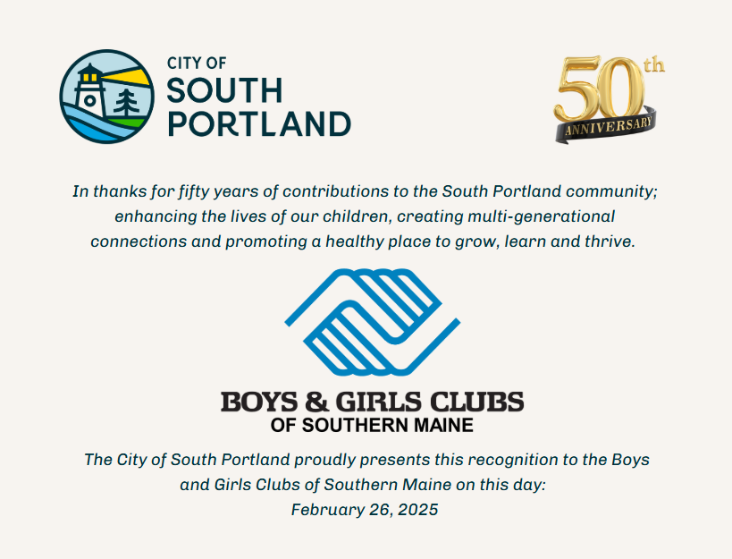

Please limit your introduction and talking points to approximately 3 to 4 minutes - this is approximately 500 words depending on speaking speed.
Your speech is on the next page for ease in use for the presentation.

The Boys & Girls Clubs of Southern Maine, South Portland location, was founded 51 years ago in 1974. In a moment, you will hear from the CEO, Brian Elowe on the history, current programs and future projects of this important community organization.
The Rotary Club of South Portland-Cape Elizabeth became involved with the Boys & Girls Club in South Portland from its very beginning. During the initial construction and start up phases, there was a funding shortage. Our Rotary Club came up with an initial contribution of $5,000 to get the ball rolling. Additional contributions were solicited by Club members and others. Club President Dick Kilroy, his brother Bill and Bill’s good friend Sam DiPietro, of DiPietro’s Market, helped lay the management groundwork. DiPietro’s Market is still a supporter of the Club today. Rotary and others purchased the initial travel van, and later helped fund another one.
The Boys & Girls Clubs of Southern Maine is vital to the community, by providing services to children of all ages and backgrounds, including those from disadvantaged families. It provides an opportunity for young folks to gather together for education, arts & music, leadership training, and meals.
Rotary clubs have been instrumental in supporting the Boys & Girls Clubs of Southern Maine by partnering with local businesses to provide backpacks and other essential back to school items during a fall collection for our participants.
Rotary also initiates donations from other leading Maine businesses, like Lamey Wellehan which provides much needed winter boots to anyone in need. My Rotary club provides Christmas toys from Santa in Biddeford and periodically delivers food from the So Po Food Cupboard.
From 2020 - 2023, Maine FoodScapes, a local non-profit which improves community food security and well-being throughout Southern Maine, brought together Coastal Care Solutions, a home care agency serving older adults and seniors, and the Boys & Girls Club of South Portland. Coastal Care Solutions will be recognized tonight. Rotary supported and participated in this program.
These organizations created a multi-generational "Grow With Me" gardening program that promoted social connection, confidence and relationship building, while acquiring gardening skills, and learning to become good environmental stewards.
This program provided outdoor space to gather and socialize throughout much of the pandemic. It was extraordinary to watch plants & people grow together, sharing, caring, and learning how truly interconnected we are in the world, and the community.
Without further ado, I am pleased to invite Brian Elowe, Chief Executive Officer, to share more about the Boys & Girls Club’ programs and benefits.
(Upon Brian’s completion of presentation, return to the podium present the recognition plaque)
Thank you Brian. We are excited to hear about the great things coming from the Boys & Girls Clubs of Southern Maine! It is my pleasure to present this recognition plaque honoring the first 50 years of service to our South Portland community. We look forward to the next 50!

