WELCOME TO
ROTARY

A HANDBOOK OF INFORMATION FOR NEW AND

PROSPECTIVE ROTARIANS

OF

The Rotary Club of

South Portland-Cape Elizabeth
Maine, USA

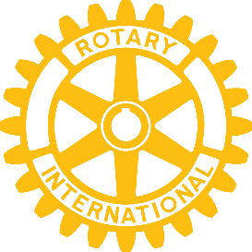

What is Rotary?

Rotary is a worldwide service organization of business, community, and professional leaders who conduct humanitarian projects, encourage high ethical standards in all vocations, and work toward world understanding and peace.

Together, we see a world where people unite and
take action to create lasting change — across the
globe, in our communities and in ourselves.

What is the “Four-Way Test”?

Rotarians are asked to guide their daily lives with The Four-Way Test.

Of the things we think, say or do:

- Is it the TRUTH?
- Is it FAIR to all concerned?
- Will it build GOODWILL and BETTER FRIENDSHIPS?
- Will it be BENEFICIAL to all concerned?

You’ll frequently find clubs adding a fifth test:

- Is it FUN?

As of January 2025, there were more than 1.2 million Rotarians in more than 35,000 clubs in 170 countries. Rotary welcomes people of all backgrounds, cultures, experiences, and identities.

Paul Harris founded Rotary in 1905, gathering four businessmen in Chicago on February 23rd to start the first club. Rotary got its name because these early founders “rotated” their meeting place among their places of business.

As their first project these Rotarians lead a campaign to install comfort stations in Chicago's City Hall — hardly pretentious, but it set a precedent for service to the community.

Rotary's motto is “Service Above Self.”

In Rotary, thoughtfulness of others is regarded as the basis of service and helping others as its expression. Rotary is not a secret organization. It does not seek to supplant or to interfere with any religious or political organization. But it does serve others, locally and worldwide.

Our club meets most Wednesday nights for just over an hour to discuss and plan how to serve others. We usually meet on the campus of Southern Maine Community College. Members and guests can attend in person or by Zoom. Those who attend in person can come earlier and have dinner together in SMCC’s award-winning dining hall.

Why should anyone become a Rotarian?

Rotary will give you opportunities to better your community and the world around you; to make lasting friendships with others who believe in service; to develop leadership skills in yourself and others, and to promote high ethical standards in young and old. We advance international understanding and goodwill, including hands-on international service projects. We serve the less fortunate locally and globally, and learn more about our community through our interesting guest speakers and by networking with members of our club and other clubs. You will be welcome at more than 35,000 Rotary clubs around the world!

As a caution, no one should join Rotary just to generate business! Even though new business may result from your membership, it shouldn't be your primary motivation for joining.

What else can you tell me about the South Portland-Cape Elizabeth Rotary Club?

We are a club of about 60 people, founded in 1962. For current meeting details look at our website, spcerotary.org.

Our meeting begins with the Pledge of Allegiance and inspirational opening words. We introduce guests and visiting Rotarians, and have some quick reports on our current activities. We introduce interesting speakers, hold a raffle, and open the floor for “happy dollars.” During “happy dollars,” members can make an announcement or relate a brief story.

In the course of our year, we raise money to contribute to the community, and to Rotary projects worldwide. Our major annual fundraiser, since 1962, is the sale of Christmas trees and wreaths at Mill Creek Park in South Portland.

The money we raise goes to scholarships, soup kitchens and food pantries, substance abuse programs, playgrounds, homes for the elderly, local theater, the Special Olympics, schools and libraries, homeless veteran support programs, and a wide variety of other community and international efforts. We donated the funds needed to plan the Children's Garden at Fort Williams.

Some of our “hands-on” efforts have included building the skating shelter at Mill Creek Park and Little League bleachers in Cape Elizabeth, painting Portland Head Light, maintaining and restoring Bug Light, building nature trails, and selling food and beverages during Cape Fest and Art in the Park.

What is expected of individual members?

The honest answer is “as much as you can do.” We take pride in selecting people who will be active, helpful and caring. The club will expect you to attend most meetings when you are able to do so and that you will remain regularly engaged in its projects and activities.

More specifically, Rotarians are expected to:

- do their fair share to help with club projects and activities
- be active on at least one or more of our committees
- deliver inspirational opening words at the start of one meeting per year
- take six 2 hour shifts each Christmas season selling trees (or other roles related to the sale if you are physically unable to work on the lot)
- donate a raffle prize ($25 - $30 or so) about once a year

We also ask members present at a meeting to help conduct the raffle, collect “happy dollars,” set up and take down the meeting room, and set up and run the OWL (allowing other members to actively participate in the meeting by Zoom).

How much time does Rotary take?

Those of us who have been in the club for a while don’t think of it as “taking time,” particularly given the friendships and camaraderie, as well as the rewards from actively participating in community activities.

The time commitment involves service on committees or projects. Typically, with two or three hours of service per month from each member, we can contribute a lot to our community. Add to that a 12-hour commitment to the tree sale (our largest fundraiser and community activity), which begins the day after Thanksgiving and ends when the trees sell out.

Some members have responsibilities that require more time, such as club officers, directors and committee chairs.

How is Rotary structured?

Rotary International (RI): This is the association of Rotary clubs throughout the world. Our international headquarters is in Evanston, Illinois. RI and The Rotary Foundation (RI's charitable foundation) administer Rotary and its charitable programs worldwide.

The PolioPlus program is Rotary's flagship international program. Through PolioPlus, Rotary seeks to eradicate the polio virus worldwide.

When Rotary began its effort to eradicate polio worldwide in the 1980s, more than 350,000 children were coming down with polio each year. Many of the children suffered from lifelong paralysis and other hardships, and others died. In recent years, fewer than 100 children per year have been afflicted and the complete eradication of the polio virus is in sight.

Two of our club members, Mike McGovern and Dan Mooers, have served on Rotary International’s Board of Directors. Mike also served as RI's Vice President (the third highest position in all of Rotary) and as chairperson of the committee to choose the RI president, and as Rotaries global leader in the fight to eradicate polio.

Rotary Districts: The Rotary world includes more than 500 districts, each headed by a district governor. The primary purpose of a district is to help its clubs. Our club is proud to claim six past district governors as well as other district officers and chairs. Our district, RI District 7780, has 39 clubs and approximately 1400 members in southern Maine and coastal New Hampshire.

Rotary Clubs: Every Rotarian belongs to a Rotary club. The clubs are the heart of Rotary and the other levels are there to help the clubs. Our club has a board of directors made up of its President, President-Elect, Vice President, Secretary, Treasurer, five Directors and a Director-at-Large (the immediate past president). We also have several committees, each of which falls within an area of service, discussed below.

Committees - in what ways could I serve?

At the club level, our primary “Avenues of Service” include Club Service, Community Service, Youth Service, Vocational Service, and International Service.

• Club Service - the internal heartbeat of the club, responsible for its administration.
• Community Service - our link to the community and to worthwhile community projects.
• Youth Service - our link to the schools and to youth through our scholarship programs, our Rotary Youth Leadership Awards (RYLA) program at Camp Hinds, our high school Interact and college-age Rotaract sponsorships, and other efforts.
• Vocational Service - our efforts to promote recognition of the dignity and value of all useful work, and to encourage the highest ethical standards.
• International Service - our efforts “to encourage and foster the advancement of international understanding, goodwill, and peace through service.” We often contribute financially as a club to worthy international projects and some of our members also choose to engage in hands-on service projects internationally.

Ask our president, any board member, or the chairperson of a committee you're interested in, and they'll be glad to talk with you about what they do. Join committees that are relevant to you personally.

Are there attendance requirements?

While we do not strictly enforce an attendance requirement, we ask that members be “engaged” in the club. Our bylaws charge our secretary with tracking the general engagement of members and identifying when a member has become disengaged.

Engagement takes many forms. We encourage members to attend at least 50 percent of our meetings, to serve on committees, and to help in our charitable activities. Some members attend nearly every meeting in person. Some attend meetings by Zoom, whether for health reasons, because they live away for all or part of the year, or just because it is more convenient for them to attend a particular meeting that way. Rotarians also can engage in district and international activities, and we are welcome to attend meetings at other clubs throughout the world when we travel.

How much will it cost me to be a member of The Rotary Club of South Portland-Cape Elizabeth?

The annual dues are $200 per year, which includes local club dues, as well as district and international dues and a subscription to Rotary International's award-winning magazine, The Rotarian.

You will spend about $16 if you choose to come early to have dinner, $25 or so per year for a raffle prize; and (optionally) a few dollars at meetings for raffle tickets and “happy dollars.” You also may choose to contribute to our charities and to The Rotary Foundation.

The club reimburses members up to $50 per year from our charitable funds when they see someone in need in the community, and they fill that need. Examples: This program has been used to help someone who couldn’t afford repairs to their wheelchair, or another person who couldn’t afford bus fare to go to a hospital in Boston for needed treatment.

How can I learn more about Rotary?

There's plenty of information, covering virtually every aspect of Rotary and being a Rotarian at rotary.org and spcerotary.org. We encourage you to visit these sites to learn more. We'll also be happy to answer as many questions as you may have. Meanwhile, we hope this brief introduction will help you in your decision to consider becoming a Rotarian or, if you’re already a new member, give you enough information to get you started on a journey that is certain to enrich your life and the lives of others.

We feel we have a very special Club ... and special people ... in The Rotary Club of South Portland-Cape Elizabeth. We look forward to getting to know you.

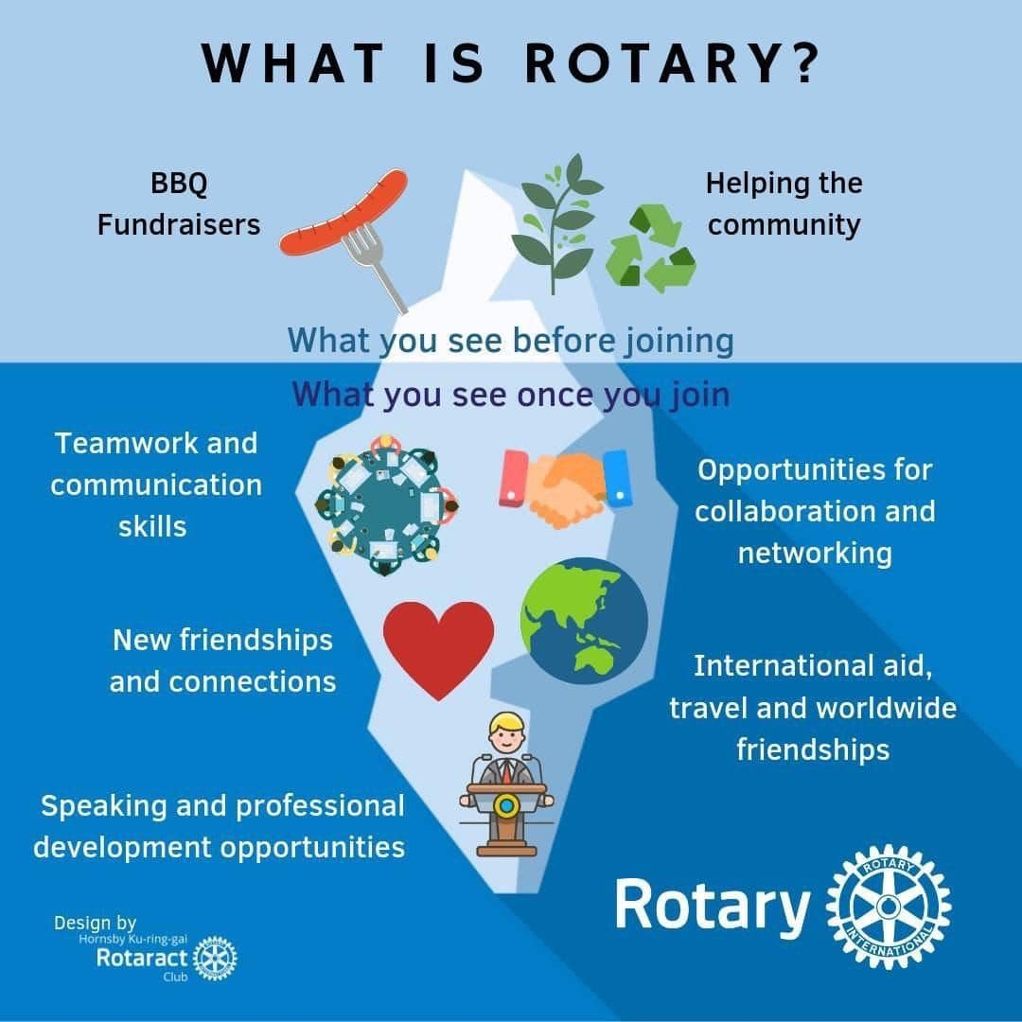
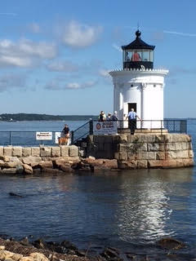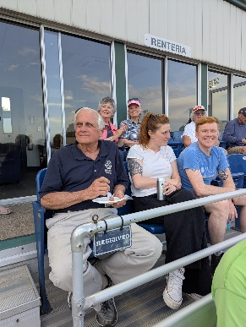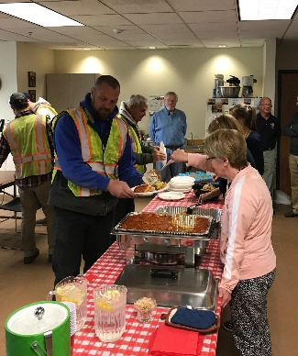
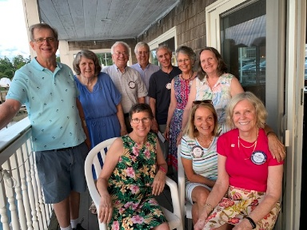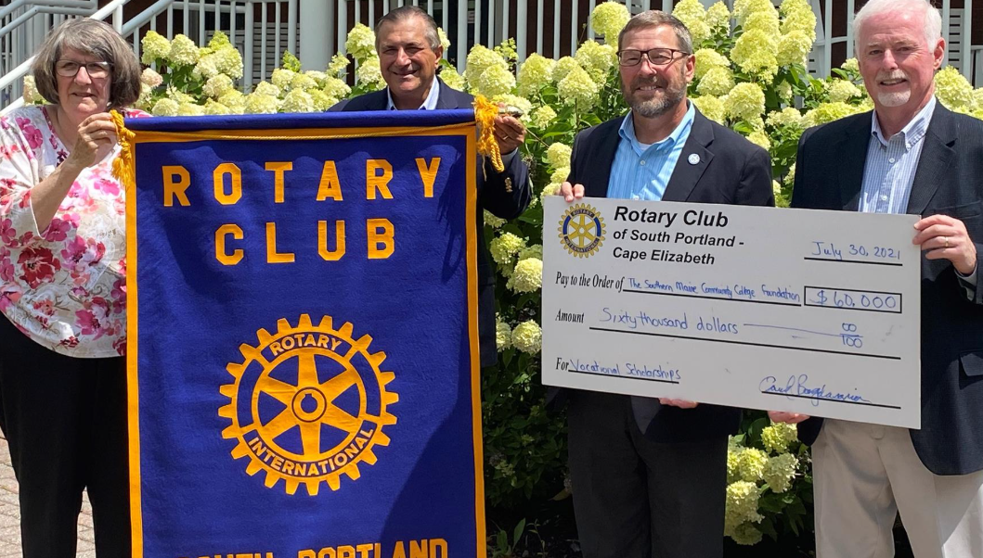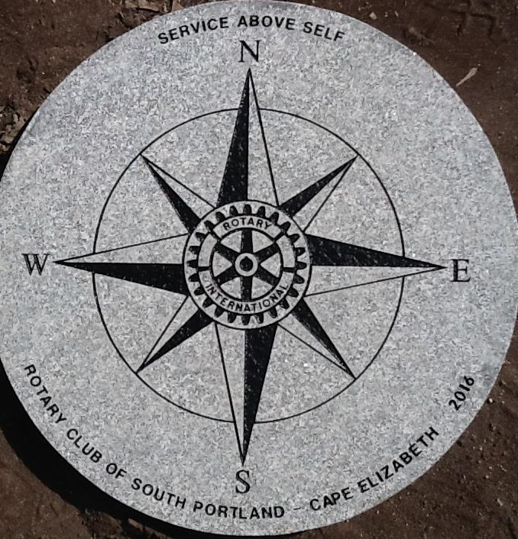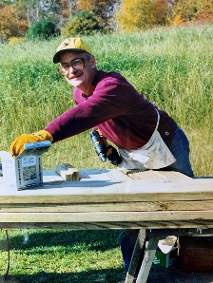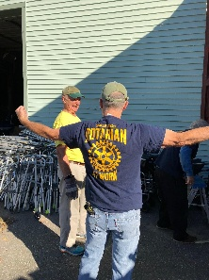
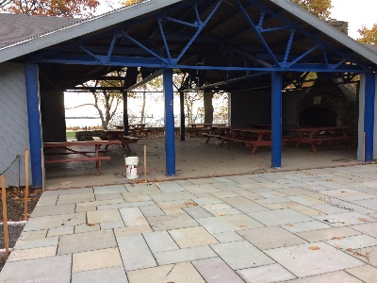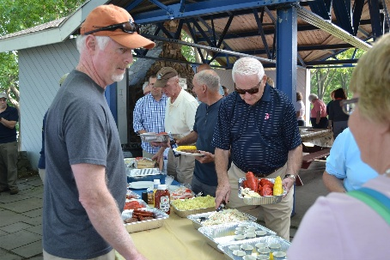
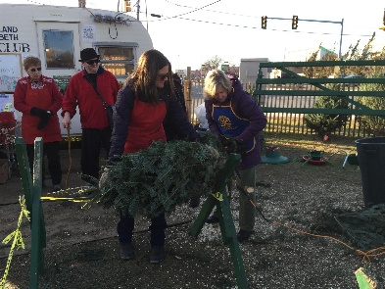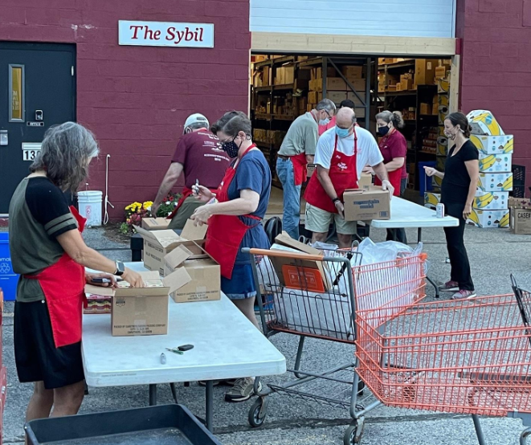

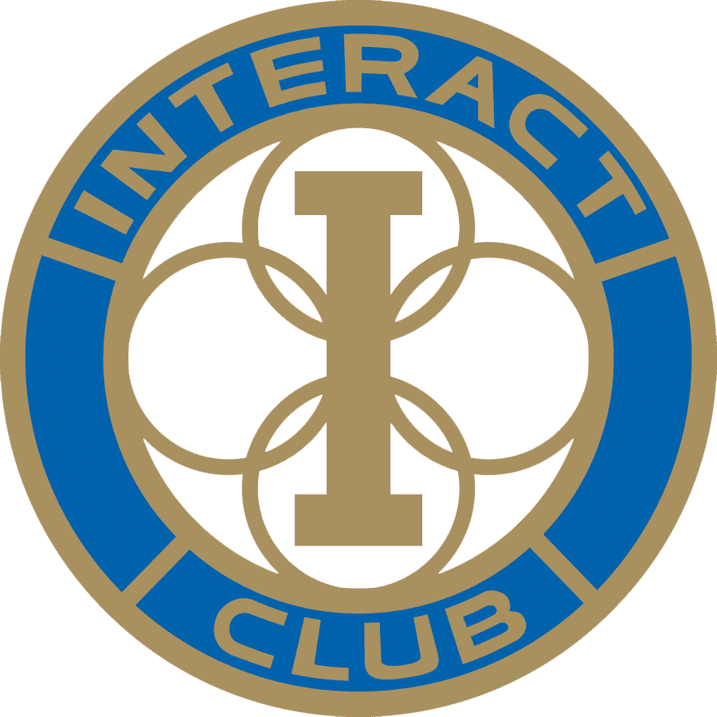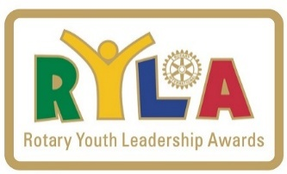

Rotary Club of South Portland-Cape Elizabeth, Maine

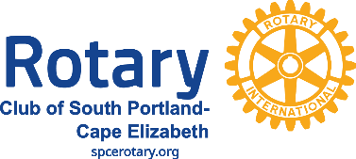
spcerotary.org Facebook

Original version prepared by Dan L. Davidson
2025 Edition (09.01)
SP/CE Rotary Club © 2025

