Empty Bowls has raised more than
$1.2M in its 20 years
By Lara Bockenstedt - Mar 6, 2019 - www.swnewsmedia.com

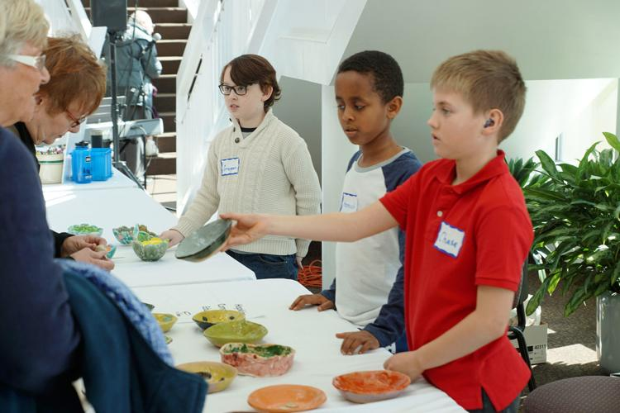
Elementary students help attendees pick out their bowls at the 2018 Empty Bowls event. Several hundred of the handcrafted bowls are made by Hopkins Public Schools students.
Image courtesy of Hopkins Public Schools

HOPKINS — With 1,000 handmade ceramic bowls and a host of volunteers, the Empty Bowls fundraiser has raised more than $1.2 million for the ICA Food Shelf and ResourceWest.
Its 21st event is planned for Tuesday, March 12. At the event, attendees will experience live music, soup and bread, and a silent auction, said Communications Specialist Monika Salden. Attendees will be able to select a “free-will offering” bowl made by community artists and Hopkins Public Schools students.
The fundraising goal for this year’s event is $80,000. The event usually raises between $60-80,000. The money helps the students who are eligible for free or reduced-price lunch, and those who visit the ICA Food Shelf.
The soup menu rotates through the day, with donated options from Thirty Bales, Mainstreet Bar and Grill, Tuttle’s, Wild Boar, Maynard’s, Gold Nugget and others. Some 30 restaurants are donating soup.
Salden said there are typically classical options, such as chicken wild rice, beer cheese and chicken noodle soup. There is usually a vegan or gluten-free option as well.
Elementary school students volunteer to bring water and bus tables. They are among the 350 volunteers who take part in the event; Salden’s favorite part of the event is seeing attendees recognize one another.
“I love watching people see all the people they know,” she said. “It feels super neighbor-y and it’s a really lovely community.”
The City Councils of Hopkins and Minnetonka have declared March 12, 2019, “Empty Bowls Day.” Both the Minnetonka Rotary and SuperValu sponsor the event, along with 100 other businesses, community organizations, schools and people.
“It’s just such a wonderful day,” she said. “It’s one of our favorite days because it’s the best parts of our community and everybody should come.”
The event website is hopkinsemptybowls.org.

