Rotary Club of Aggieland Chicken Scratch Bingo
October 4, 2024, First Friday Courtyard across from Blackwater Draw Brewing Co.
6:00 – 7:00 PM

Welcome to our 7th Annual Chicken Scratch Bingo Fundraiser. This year’s event will take place at the Downtown Elixir’s Courtyard, on Friday October 4, 2024, from
6-7 p.m. as part of the October’s Downton Bryan First Friday celebrations.

Sponsorships
Title Sponsor - $5000 ∙ Gold - $3000 ∙ Silver - $1000 ∙ Bronze - $500

Squares
Purchase a square for $100 or 3 for $250 - for a chance to win up to $2000 at our Chicken Scratch Bingo Event!

The event will be livestreamed on Facebook.

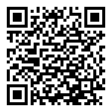
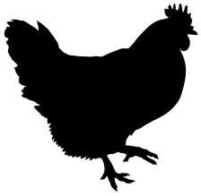

Instructions
Scan the code, enter your information and make your selections. Sponsorship information is listed with each option.

For more information contact Jennifer Reiley at jreiley13@gmail.com.
Visit us at aggielandrotary.org

