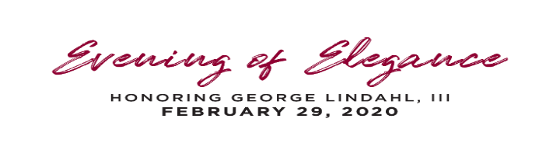

**Special Thanks to our Sponsors**

*February 29, 2020*

**SERVICE ABOVE SELF**

George and Kristi Lindahl

Thank you for supporting the 2020 Rotary Evening of Elegance Gala!  With your help, we raised over $250,000!  Here is a link to the Gala photos:   [https://spaces.hightail.com/space/0nIrcG588A](https://nam11.safelinks.protection.outlook.com/?url=https%3A%2F%2Fspaces.hightail.com%2Fspace%2F0nIrcG588A&data=02%7C01%7C%7C4e54152174ea49d1e91c08d7c43df366%7C84df9e7fe9f640afb435aaaaaaaaaaaa%7C1%7C0%7C637193643515750375&sdata=3nzlFy4vPhT%2FEdhym8m8tqfrieSfyiDwxDPlHsIZkfA%3D&reserved=0)

**ROLL OF FAME**

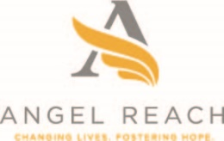





Mary and Norman Parrish

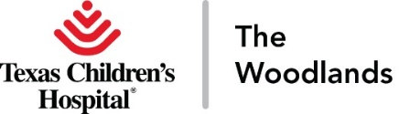

**FOUR WAY TEST**

Ralph Daigle

Friends of George II

Gracepoint Homes/TD Cox Homes, LLC

Knighton & Stone PLLC

M.D. Anderson Cancer Center

Memorial Hermann The Woodlands

Rhame and Gorrell Wealth Management

Schroeder & Associates

Spirit of Texas Bank

Woodforest National Bank

**PAUL HARRIS**

Adcetera

Avion Wealth

Briggs & Veselka Co.

CHI St. Luke’s Health - The Woodlands Hospital

Cynthia Woods Mitchell Pavilion

Jeff Early/Ron Rogers

Friends of George I

Friends of Koinonia

Dr. Guy Facial Plastic Surgery

HCA Houston Healthcare

Houston Methodist The Woodlands Hospital

Howard Hughes Corporation

Paul Ikard, CPA

Julie Martineau/Adria Salas

Mellisa Ray Insurance/Stewart Title

Soules Insurance

Starfox Financial Services

Stephen Bauer/United Capital

T. Ross Brown & Associates Insurance

The Mike Seder Group

Strike, LLC

The Wolford Group

The Woodlands Christian Academy

Veritas Title Partners/Rivela Plastic Surgery

Will Warren and Lisa Platt

Woodforest Development

Yes to Youth

**ENTERTAINMENT SPONSOR**

Theresa Wagaman – Abby Realty

**RECEPTION SPONSOR**

Lone Star College

**WINE & SPIRITS PULL SPONSOR**

Lisa and Fred Koetting

**PHOTOGRAPHY SPONSOR**

Great American Title