# **.**

**RCC Calendar of Events**

***Saturday, December 3rd - Santa Breakfast***

The Rotary Club of Parker and the RCC of Parker are hosting Santa’s Breakfast for the Parker Senior Center. This breakfast is free and open to seniors and their families with an **advance registration only.** RCC MEMBERS are needed at 8:00 a.m. to help set up and greet visitors OR come at 9:00 a.m. for breakfast and help clean up.

**Santa’s Breakfast is a GIFT to the Parker Senior Center from the Rotary Club of Parker and the RCC of Parker!** EVERYONE, ***including you*** must have a reservation in **ADVANCE** to attend and how many people are in your group. Limited seating!

**Monday, December 12th - Adopt A Family**

In place of our regular meeting – Adopt A Family for the Parker Task Force from 5:30 – 7:00. We will meet in the Deli area/fresh fruit. We’ll shop, wrap and deliver the gifts to the Parker Task Force. We will need parents to help wrap! PLEASE rsvp to [kamiebreitenbach@gmail.com](mailto:kamiebreitenbach@gmail.com) so we know how many RCC members to expect. **Please donate $5 to help cover the cost of wrapping paper, etc. NO DINNER TONIGHT.**



**Beginning in January we will be holding our monthly meetings at Village Inn! Meeting will be on the second MONDAY of the Month from 5:30 – 6:30. Cost will be $10 if you want to eat and we’ll have the same menu as before.**

**Monday, January 9, 2017 -**

Discussion on what members want to do this next year!

 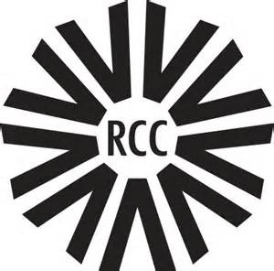 https://www.rotary.org/sites/default/files/styles/rotary_responsive_280/public/T1617_EN_0.png?itok=lKFOQZ9j



**Follow us on Facebook – www.facebook.com/RCCParker**

RCC Connect Newsletter

|  |  |  |
| --- | --- | --- |
| Rotary Community Corps of Parker | **12/1/2016** | Sponsored by the Rotary Club of Parker |