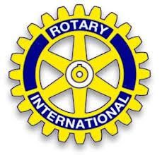

Lyon Area Rotary Club

Lyon Area Rotary’s most improved student awards program.
The Lyon Area Rotary Club has found that this program has given our club and the high school a way to give recognition to students in the school that have demonstrated the ability to change their life in a meaningful manner. The way the program works is that we ask the school counselors to select 10 students that they feel have shown the most improvement in the last year. This improvement may be for anything not necessarily scholastic, but attitude, attendance, hygiene, etc. It should include 9th 10th and 11th grades.
After being selected each student is invited with his or her parents or guardian to attend our Rotary Club lunch. At this lunch meeting we have your school counselors or teachers (whoever wants to do the presenting) call up each student individually. At that time the counselor will talk about the student and tell why the student is being honored. Then at the end of each student presentation our Rotary Club President thanks the student for their accomplishments and presents the student with a $100.00 check.
It is a fairly simple program, but it works great, the student is rewarded and acknowledged, the parents are proud to see their child rewarded and the teachers and counselors are given a chance to acknowledge a student that they have seen change in. The Rotary Club covers the checks and lunch cost and is rewarded with having been involved with a community project that may change a student’s life.
The Lyon Area Club meets On Tuesday for lunch at Abbey Park at Mill River, 28413 Abbey Lane, New Hudson, Michigan, 48165.
For more information about this program feel free to contact Lyon Area Rotarian Mary Knauer @ 248-935-9595 or email her at mfk214@yahoo.com.
PS. We don’t tell student about the check until the luncheon. They can use the money for whatever they choose.

