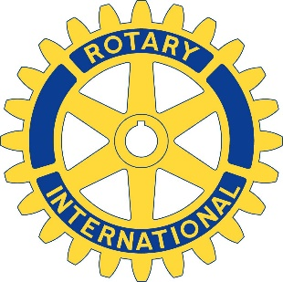

The Rotary

Club of Arlington

The Rotary Club of Arlington is pleased to announce a Minority Business Awareness program. This recognition will be extended to minority businesses in the city of Arlington that have demonstrated the core values of the 4-Way test through integrous leadership in business practices, community service and engagement.

Eligibility
- Open to any minority -owned business located in Arlington
- Minority businesses must be at least 51% minority-owned, operated and controlled
- Minority group member(s) is an individual who is at least 25% Asian, Black, Hispanic, or Native American. *(as defined by NMSDC0) Women owned are eligible.
- Nominated businesses should have at least one year of in business in Arlington
- Nominations may be submitted by any member of the Rotary Club of Arlington
- Rotarians from other clubs may suggest businesses but the official nomination must be made by a Rotary Club of Arlington member
- Nominations must answer all questions in the nomination form.
- Nominations must be received by the first day of each month
- Applications will be taken on a rolling basis
- Submit applications to:vmckissic@cbcarlington.org

Recognition
- Business owner will be invited to a regularly scheduled meeting
- Provided a lunch by the nominating member
- A brief presentation of the value of the business to the community shared with the club
- Business owner is presented with a certificate of recognition
- Picture with club president and brief write up about the business is placed in the Hubcap
- Invitation to attend the Centennial Celebration

Rotary of Arlington Minority Business Awareness

Application Form

Name of Nominee | First | Last
Business Name |  |  |  | How long have they been in business?
Address of business
Phone Number
Email
Name of Nominator |  | Phone number

Four Way Questions about the Business Nominee. Answer descriptively.

#1
How does this business demonstrate truth and integrity in business?

#2
How does this business relate fairly to all its patrons?

#3
How does this business build goodwill and better relationships for Arlington?

#4
What benefit does this business bring to the city of Arlington?

